Part 1 - Taking Charge of Excel
- WATCH THIS FIRST
- Describe key components of the Excel user interface
- Operate essential navigational controls
- Perform the basics of data entry in Excel
- Explain basic Excel terminology

Taking Charge of Excel
- Opening Excel
- Interface (ribbon: tabs, groups, command).
- Open, save, close.
  - Open W1V1.
  - Quick access toolbar.
  - Formula bar
  - Workbook, worksheet, row, column, cell, name box.
  - Status bar.

Test!

Question 1
- Excel is an example of what type of software?
- Presentation Package
- Spreadsheet Software
- Word Processor

Question 2
- Which of the following is NOT part of the Ribbon?
- Home
- Insert
- Tools
- Data

Question 3
- My Ribbon has disappeared - how can I get it back??
- (One or more answers are possible. Partial credit will be awarded)
- Right-click on one of the tabs and untick Collapse the Ribbon.
- Switch to another worksheet.
- Close Excel and open it again.
- Double-click on any of the ribbon tabs.

Question 4
- Clicking on the File tab takes you to the Backstage View. From here you can
- (One or more answers are possible. Partial credit will be awarded)
- Close a file.
- Set up Excel options.
- Create a blank workbook.
- Open a file.

Question 5
- The tools on the far right of the status bar (at the bottom of the screen) allow you to
- (One or more answers are possible. Partial credit will be awarded).
- Access the Backstage View.
- Toggle between different View Options.
- Use the zoom slider.
- Set a specific zoom percentage.

Navigating and Selecting
- Scroll bar.
- Arrow keys.
- Pgup, PgDwn
- Ctrl + Home. Ctrl+ End. Ctrl+ arrows
- Moving between sheets.
- Active cell. Cell Name
- Cell icons:
  - Select.
  - Move.
  - Fill
- Shift+ Click. Shift + arrows?
  - Challenge: select a whole row of data using the keyboard!
- Select non-contiguous data.
- Select all?, clicking at the row/column name.
- Tab?, Enter?, Shift+tab, Shift+Enter?

Test

Question 1
In Excel, the following mouse pointer will allow us to
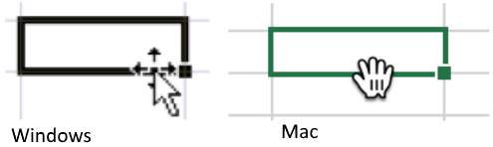
- Delete data
- Copy data
- Move data
- Select data

Question 2
In the following graphic, which is the Active Cell?
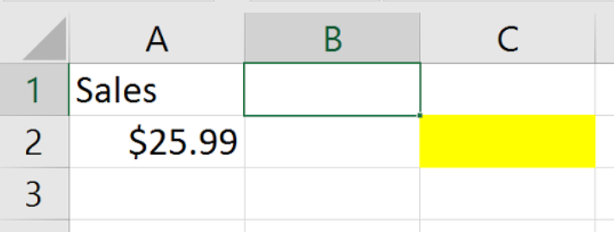
- A2
- C2
- A1
- B1

Question 3
To select the whole of column B, we ...
- Click and drag from B1 down to B1000
- Click on B
- Double-click on the cell B1
- Click File, Select Column

Question 4
What is the shortcut key to select all the data in a data block?
- Ctrl+O
- Ctrl+A
- Ctrl+Home
- Ctrl+F

Question 5
How do we select two blocks of data that are not next to each other (non-contiguous)?
- Hold down the Shift key, select the first block, and then still holding Shift, select the second block.
- Select the first block, hold down the Shift key and select the second block.
- Hold down the Ctrl key (Cmd on Mac), select the first block, and then still holding Ctrl, select the second block.
- Select the first block, hold down the Ctrl key (Cmd on Mac) and select the second block.

View Options
- Zoom Slider,
- View options
  - Normal
  - Page Layout
  - Page break
- View tab:
  - Split
    - Double click to cancel a split.
  - Freeze panes
    - Freeze the top three rows and the first three columns (the cell to the right and below).

Test:

Question 1
- After entering data into a cell, which option(s) will move your cursor into the next cell underneath your active cell?
- (One or more answers are possible. Partial credit will be awarded.)
- Press Enter.
- Press Tab.
- Click the mouse pointer into the cell underneath.

Question 2
- Which tool should we use to help keep headings visible when we scroll through a large workbook?
- Split
- Page Break Preview
- Headings
- Freeze Panes

Question 3
- You are going to use the Freeze Pane function.
- 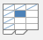
- Take a look at the screenshot below. Which cell do you need to click in order to freeze columns A and B as well as rows 1-4? If you are finding this tricky - why don't you download the workbook and have a play?
- 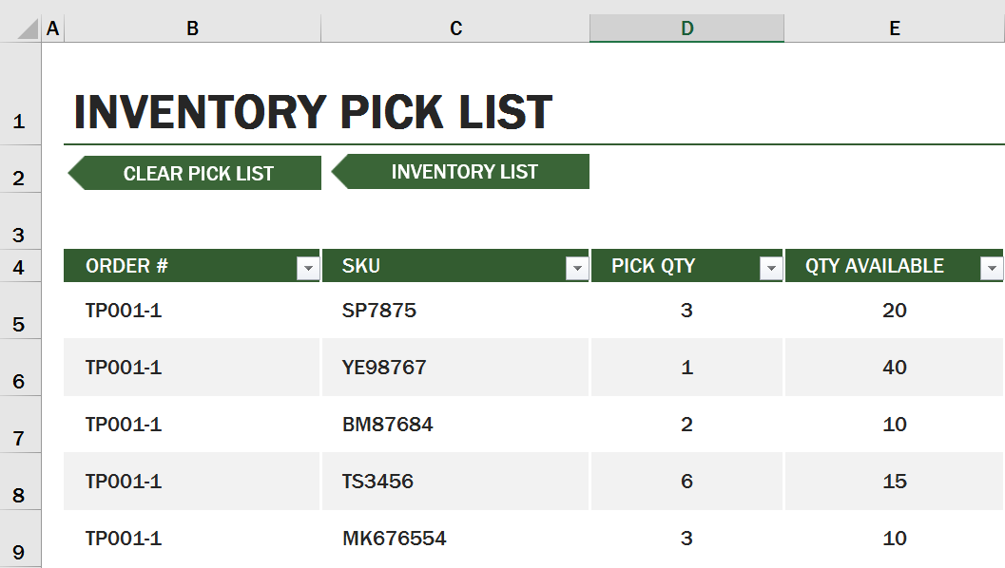
- Warehouse inventory1.xlsx
- D5
- C5
- B5

Question 4
- How do you switch between different workbooks inside Excel?
- Click on the View tab and select this tool:
- 
- Click on the tab that you want to navigate to.
- 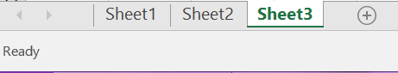
- Use the View Options in the Status Bar.

Question 5
- Which tool was used here to produce the view below?
- 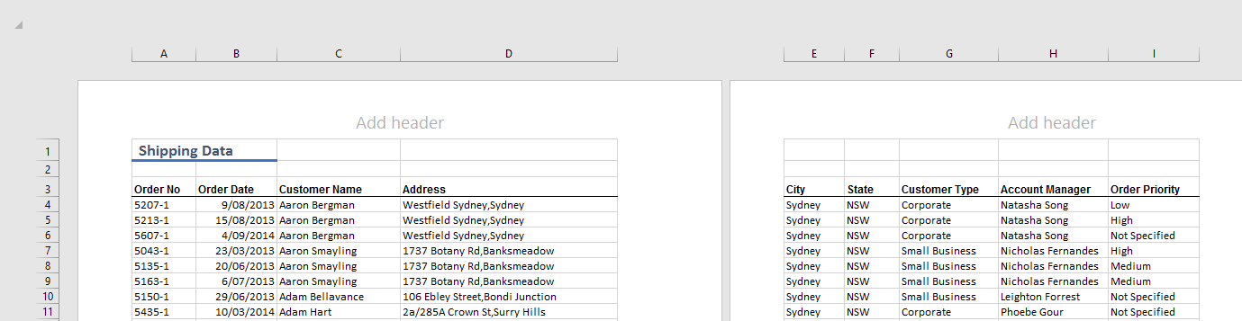
- Print Preview
- Page Layout View
- Page Break View

Data Entry, Data Types, Editing and Deleting
- New workbook (create a blank workbook).
- Type “expenses” in A1 and press enter two times.
- Type “item” and press tab and write “cost” then press enter!?
- Type “train” then tab and type “6.3” then enter.
- Type “coffee” and press tab and type “3.5”
- Type lunch and put 12.
- Write juice.

Now we do changes:
- Delete juice. (What is the difference between the delete in keyboard and in the ribbon?)
- Change the value of lunch to 15.
- Edit the value of “coffee” to “coffee shop” (formula bar, double click, F2).
- If you do not want to make the change, escape!

Add the date:
- In B2 insert the date. (follow the format in your computer – D/M/Y or M/D/Y)
- Find the total expenses.

Test:

Question 1
- Which of the following will Excel recognize as a date? (One or more answers are possible - partial credit will be awarded)
- 5 9 2016
- 05 Sept 16
- 05/09/2016

Question 2
- To clear the contents of a cell (without affecting the surrounding cells), single-click on the cell and...
- (You might want to try this out in Excel. One or more answers are possible. Partial credit will be awarded)
- Click Delete on the Home tab in the Ribbon.
- Press the Delete key on your keyboard (Fn+Delete on Mac).
- Click No Fill on the Home tab of the Ribbon.
- Press Backspace then Enter on your keyboard (Delete and Return on Mac).

Question 3
- Before you can enter data in an empty cell you must double click on the cell.
- True
- False

Question 4
- Which of the statements below are correct regarding Excel's behaviour when you enter data into an empty cell?
- (One or more answers are possible. Partial credit will be awarded.)
- Numbers and text entered together are automatically aligned on the right.
- Any text entered is automatically aligned on the left
- Any number entered is automatically aligned on the right.
- Any number entered is automatically aligned on the left.

Question 5
- Sean used a tool to create the contents of cell B7. Which one did he use?
- 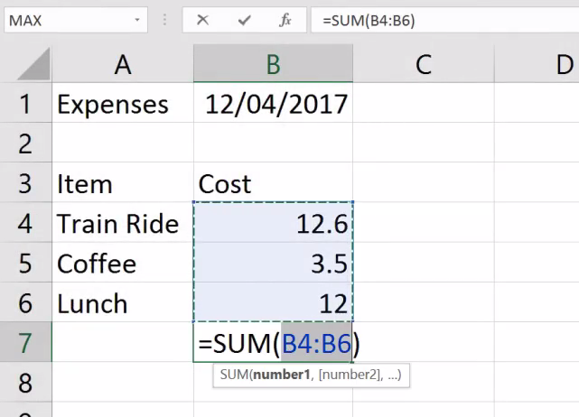

Fill Handle
- Open W01-V05-Fill Handel.xlsx.
- Fill handle can help us the do the followings:
  - Copy (fill the branch)
  - Fill a series (fill the Record ID).
  - Fill the date (double click fill).
  - Fill the days.
  - Can it be even faster?
  - Fill hours.
  - Fill shift
    - Autofill options (shift No and Days).
  - Fill cumulative Hrs (Fill patterns).
  - Fill email (flash fill).

Test

Question 1
- What is one of the main purposes of the fill handle that we have demonstrated?
- To easily fill the background color of a large range of cells.
- To automatically create a series based on existing data.
- To automatically enter data into an empty spreadsheet.

Question 2
- What does your mouse cursor need to look like in order to activate the fill handle?
- A thick, white plus sign
- Four black, crossed arrows
- A bold, black plus sign

Question 3
- Take a look at the screenshot below. Sean needed to separate the first names from Column C. This would normally take quite a long time but he managed to fill Column D within seconds. How did he do that?
- 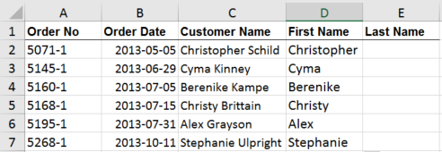
- If you are not sure, download the workbook below and have a go yourself. You can figure it out!
- First names.xlsx
- NOTE: This question refers to a feature in Excel that is not available in the Mac version of Excel. However, you can still answer the question by watching the Practice Video on the Fill Handle in this week.
- Sean typed "Christopher" into cell D2, then he dragged the fill handle to D7. He changed the tool option to Flash Fill.
- He selected cell C2, then he dragged the fill handle to D7. All the first names appeared automatically.
- Sean selected cell D2, then he dragged the fill handle to D7. All the first names appeared.

Question 4
- How do you activate the fill functionality? Remember, if you are not sure, head over to Excel and explore!
- (One or more answers are possible. Partial credit will be awarded.)
- You select a range of cells and click on this icon in the Home tab.
- You right-click on your active cell and choose Fill handle from the context menu.
- You hover over the small square in the bottom right-hand corner of your active cell until you see the thick black cross, then click and drag.

Question 5
- Take a look at the screenshot below. What do you expect to see in the cells A3, B3, C3 and D3 when you drag the fill handle all the way down to D6?
- 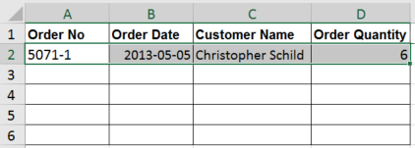
- If you are not sure, download the workbook below and give it a go in Excel.
- Fill handle.xlsx
- A3: 5071-2
- B3: 2013-05-06
- C3: Christopher Schild
- D3: 6
- A3: 5071-2
- B3: 2013-05-06
- C3: ######
- D3: 6
- A3: 5071-1
- B3: 2013-05-06
- C3: Christopher Schild
- D3: 7

Part 2 Performing calculations

Learning Objectives
- Explain the syntax of basic formulas and functions
- Use formulas and functions to perform simple calculations
- Describe the difference between relative and absolute cell references

Formulas
- + - * /
- =
- Open W02-V01

Test

Question 1
- A calculation has been used in cell A3. Which of the following was entered in A3?
- 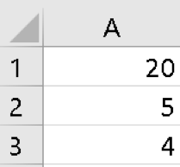
- =A1/A2
- =A1*A2
- =A2/A1
- =A2:A1

Question 2
- For the data shown, which of the following formulas will NOT give the result 2?
- 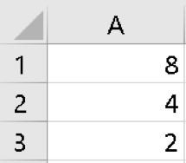
- =A1-A2/A3
- =(A1-A2)/A3
- =A1/A1*A3
- =A2/A3

Question 3
- What is the result of this simple calculation entered into the formula bar in Excel? =7+3*4
- 40
- 19
- 44

Formulas in Context
- Open ()
- Calculate profit margin (profit = Price – cost)
- Calculate sub total (sub total = price * quantity)
- Calculate discount (discount= sub total * discount amount).
- Calculate order total (Order total = sub total – discount + shipping cost).

Test

Question 1
- A small business buys second-hand goods and then re-sells them at a local market. Which formula typed into C2 will help them calculate the profit made on item they bought for $10 and sold for $29.99?
- 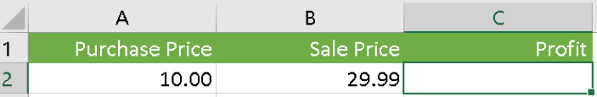
- =A2-B2
- =B2-A2
- =SUM(B2-A2)
- =A2*B2

Question 2
- A customer has spent $3296.99 but we wish to give them a 5% discount. Which formula will calculate the correct amount of discount?
- 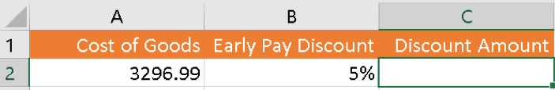
- =A2-B2
- =A2*B2
- =A2/B2
- =A2*B2/100

Question 3
- Payroll has to calculate the tax for each employee. First they must add the base salary to the commission and then calculate the tax on the total. Which formula does this correctly?
- 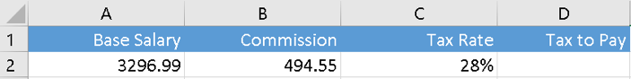
- If you are not sure how to answer this question, head straight over to Excel and experiment!
- =A2+(B2/C2)
- =(A2+B2*C2)
- =(A2+B2)*C2
- =A2+B2/C2

Functions I: SUM and AUTOSUM
- Open W02-V03
- Move to (sales 2016 sheet)
- Formulas and functions (what are the differences).
- Calculate the total using auto sum. (logic of auto sum).
- Calculate total (row) using auto sum.

Functions II: AVERAGE, MIN, MAX
- Open W02-V04
- Calculate Average (DO NOT INCLUDE THE TOTAL)
- Calculate best (MAX) and worst (MIN).

Absolute cell referencing
- Open W02-V05
- Calculate commission
- Absolute vs. Relative referencing

Functions III: IF
- Open W02-V06
- Use IF to find eligibility where the account managers with an experience of 3 or more years are eligible to get the bonus.
- Calculate the 7% bonus for the eligible account managers. Moreover, leave a blank cell if the account manager is not eligible.

Functions IV: COUNT, COUNTA, COUNTBLANK, COUNTIF
- Open W02-V07
- Use ------------ to find the number of account managers.
- Use ------------ to find the how many bonuses we have paid.
- Use ------------ to find how many managers are not eligible for the bonus.

Count IF
- Count how many accounts manager is having more than 4 years of experience.
- How many accounts manager is not eligible?

Test

Question 1
- Select the formula that correctly and efficiently adds all cells from B3 to B6 (also known as a range).
- =SUM(B3,B6)
- =SUM(B3:B6)
- =SUM(B3+B4+B5+B6)
- =SUM(B3-B6)

Question 2
- Before pressing AutoSum you must type "=".
- True
- False

Question 3
- Sean used AutoSum to create the calculation in D2 as shown. He then used the fill handle to copy it down to D4. What calculation is now in D4?
- 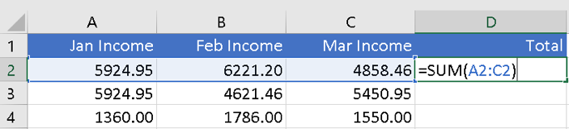
- =SUM(A4:C4)
- =SUM(A2:C4)
- =SUM(A2:C2)
- =SUM(C4:C4)

Part 3 Formatting

Learning Objectives
- Give examples of key formatting tools and their uses in Excel
- Modify spreadsheets with Excel styles and themes
- Explain the use of number formatting in Excel
- Format a raw data set using Excel formatting tools

Formatting
- Font group.

Borders
  - More borders
  - Delete borders

test

Question 1
- To add borders to a large block of data just select one cell in the data set.
- True
- False

Question 2
- Which Border option should we use to get the following result:
- 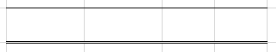
- All Borders
- Top and Bottom Border
- Top and Thick Bottom Border
- Top and Double Bottom Border

Question 3
- How do you remove borders while minimizing changes to the data? (If you are unsure - head on over to Excel and experiment before you answer the question)
- Click on the cell(s) and press delete.
- Click on the cell(s), go to borders and choose No Borders.
- Click on the cell(s) and press backspace.
- Click on the cell(s), go to Clear, choose clear all formats.

Alignment Tools
- Vertical and horizontal alignment
- Wrap text
- Merge and center.
- Text orientation.

Test

Question 1
- To get a heading sitting exactly in the middle of several columns which tool should we use?
- 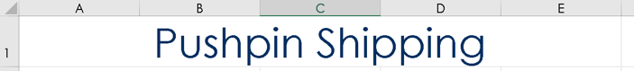
- Is this the right tool?
- Would you choose this tool?
- Is this the correct answer?

Question 2
- Which of the alignment options below match the text in this screenshot?
- 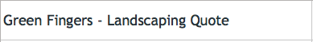
- Horizontal alignment: Left; Vertical alignment: Bottom
- Horizontal alignment: Center; Vertical alignment: Top
- Horizontal alignment: Left; Vertical alignment: Center
- Horizontal alignment: Center; Vertical alignment: Centre

Question 3
- The text entered into a cell doesn't fit and part of it is cut off. Which of the following will make all of the text visible without affecting the layout of your report?
- Widen the column.
- Decrease the font size.
- Click on 'Wrap Text'.

Format painter
- Format a heading
- Format a style
- Border and background color.
- Copy a table format.
- Clear formatting

Test

Question 1
- Which of the following formats does the Format Painter copy? (One or more answers are possible - partial credit will be awarded)
  - Text alignment
  - Cell background fill
  - Borders
  - Font size
  - Number format
  - Font type

Question 2
- Sean has created a great looking table and has decided to format one of his other reports in just the same way. How can he do this?
  - 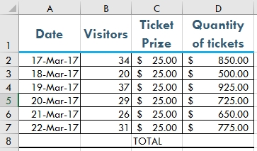
  - If you are not sure, why don't you try it out in Excel? That's the best way to learn. Download the workbook here.
  - tickets.xlsx
  - He needs to select his entire worksheet, single-click on the Format Painter and then click on cell A1 or the first cell of his new worksheet.
  - He needs to select his entire worksheet, single-click on the Format Painter and then click anywhere in the new worksheet to paste all of the different formats.
  - He can use the Format Painter but only in stages because of the different formats throughout the data. First he has to do the headings, then the main data and then the totals row.

Question 3
- What are banded rows and how can we create them?
  - Banded rows alternate in colors to improve readability of spreadsheets. They can only be set up manually by selecting every other row and then changing the background fill. The format painter can then be used to transfer this to other worksheets
  - Banded rows alternate in colors to improve readability of spreadsheets. They can be set up by manually filling the background of one row and then select that row and the next one with no fill. Now you use the format painter and drag those rows in which you want to see the banded rows.
  - Banded rows are linked together by their formatting. They can be set up under Borders formatting.

Question 4
- What happens when you select a section of your spreadsheet, click this drop-down and select the first option?
  - It will clear the number formatting from my data.
  - It will put a red highlight on my data.
  - It will undo my last action.
  - It will clear everything from that entire selection.

Number format
- Open W3-V5-number format.
- General number format.
- Currency.
- Accounting.
- Percentage.
- Date
  - Problems with date.
- Custom number format.
- Clear formats (it can clear the number format as well).

Test

Question 1
- Sean applied number formatting to cells D4 to D10. What formatting did he apply?
- 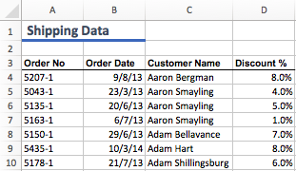
  - Number, 1 decimal place
  - Percentage, 1 decimal place
  - Number, no decimal place
  - Percentage, 0 decimal place

Question 2
- Sean made some more changes to the number format of his data. What format did he apply in Column B?
- 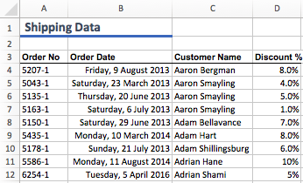
  - He changed the number format to Short Date format.
  - He changed the number format to Long Date format and then added the weekdays manually.
  - He changed the number format to Long Date format.

Question 3
- What is the main difference between the Accounting and the Currency number format in Excel? If you are not sure, head on over to Excel and have a play with some numbers before you attempt to answer this question.
  - In the Currency format, negative values are automatically displayed in red
  - The main difference is that in the Accounting format, the currency symbol is left aligned, away from the number.
  - In the Accounting format, decimal points are aligned in a column.

Styles and Themes
- Open W3V6
- Styles
- Themes
  - Note: non theme color and font will not be affected.

Test

Question 3
- The color settings in Cell Styles on the Home tab can only be changed by selecting preset Excel themes.
  - True
  - False

Question 2
- Choosing a different theme will override all previous formatting.
  - True
  - False

Question 3
- When changing the theme on any worksheet in a workbook, all sheets will be affected.
  - True
  - False

Part 4 Working with Data

Learning Objectives
- Manage rows, columns and worksheets
- Identify, retrieve and change data in spreadsheets
- Explain how to operate Conditional Formatting in Excel
- Use the conditional formatting tool to highlight specific data

Managing Rows and Columns
- Open W4.V1
  - Delete raw 1 and 2 (move up).
  - Delete column D (shift right to left).
  - Insert a column (always to left)
    - Insert Average cost after customer name.
  - How to add multiple columns or raw?
  - The use of hide/unhide.

Test

Question 1
You can insert a column on the left of an existing column by ... (One or more answers are possible — partial credit will be awarded)
- On the Home tab, selecting Insert, then Insert Sheet Columns
- Selecting a column and pressing the Insert key on your keyboard.
- Right-clicking on the column header and selecting Insert.

Question 2
Sean wants to delete the contents of cells O3, O4, P3 and P4. He right-clicks and select Delete... from the context menu. Can you explain what's happening? Is he on the right track? (One or more answers are possible — partial credit will be awarded)
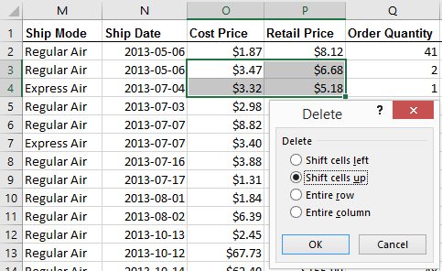
- Sean got mixed up with the ways to delete content of cells versus deleting rows and columns. The correct way to do it would have been to select the cells and then navigate to the Home tab, press Clear, then select Clear Contents.
- What he has done is fine. He just needs to click OK now and then the content of his cells will disappear. The rest of his data will stay intact.
- Sean got mixed up with the ways to delete content of cells versus deleting rows and columns. If he hits OK, he will create a mess on his worksheet.

Question 3
Sean needs to add a new account manager to his table but he wants to keep the same sorting and formatting. How will he add Robert Demarko to his spreadsheet without losing the current alphabetical listing? (One or more answers are possible — partial credit will be awarded)
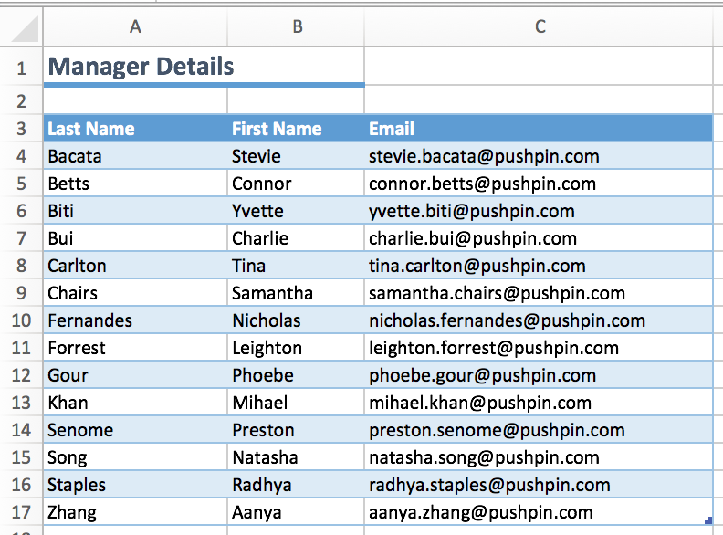
Not 100% sure? Prefer to try out rather than guess? Download the spreadsheet here and work on it in Excel.
manager-details.xlsx
- Single-click into A10 and add a new cell.
- Single-click in row 10 of the table and use the keyboard shortcut CTRL + SHIFT + =.
- Right-click on the Row 10 symbol and select Insert.
- Right-click on the the Row 9 symbol and select Insert.
- Single-click anywhere in row 10 and navigate to the Insert tool on the Home tab, select Insert Sheet Rows.

Find and Replace

Open W04.V02.

Find all the records of Cyma Kinney (C6)

Find (Sydney Fish Market, Bank Street, Sydney ) with (Sydney Fish Market, Bank Street, Pyrmont)

Filtering

Open W4.V3

Quick filter

Find all the records of Christy Brittain and show them in one sheet.

Clear filter

Do the following:
Show only Sydney city, for the year 2016 where the total is more than 2000$
Auto Filter
Filter city by Sydney.
Filter order data to show the year 2016.
Filter total to show orders more than 2000$.
Filter to show the top 20 order total.
Make sure to clear filter once done.

Sort
- Open W04V04
- Select one cell in the data and click sort.
- Make sure to highlight my data have headers.
- Sort according to account manager.
- Add level?
  - Sort again by total (largest to smallest)
  - Sort again by order data (latest to oldest)

Test

Question 1
Sean wants to sort his data set by Order Quantity. He single-clicked on the column letter Q to select the column and presses Sort & Filter on the Home tab and selects Sort Largest to Smallest. Which of the options below shows what his spreadsheet will look like next?
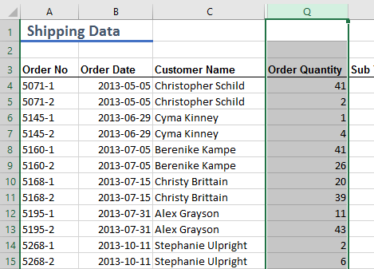
- Should he expect to see this result on his screen?
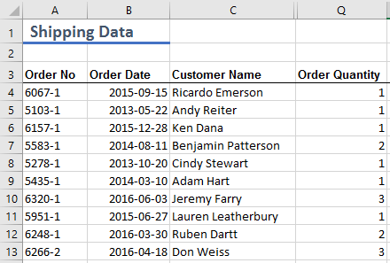
- Is this what his screen will look like?
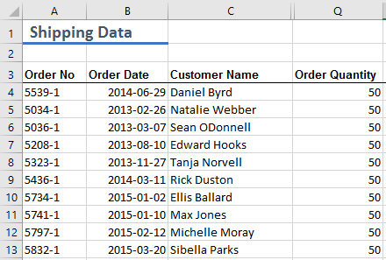
- Is this what he will see?
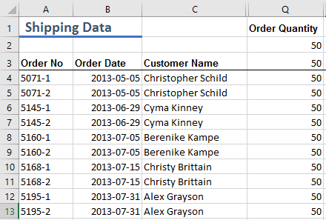

Question 2
You need to sort a large and rather untidy data set that you just received from a different department. It contains entries such as dates, numbers and text. Before you use the Sort tool, what should you do first? (One or more answers are possible - partial credit will be awarded)
- Create borders and change font colours.
- Add headers to the data set.
- Make sure that the number format for each of the columns is consistent, e.g. Currency, Accounting, Percentage.

Question 3
Sean wants to order a subset of his data by Order Priority. He wants to see the Critical items first, followed by High, Medium, Low and then Not Specified. However, there might be a slight problem - can you guess what it is?
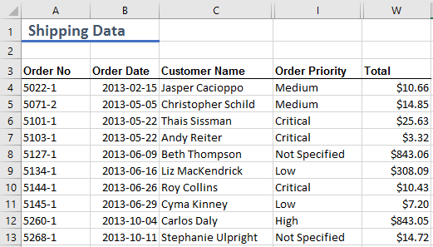
- No idea. He should be able to sort the Order Priority column easily by using descending sort.
- No idea. He should be able to sort the Order Priority column easily by using ascending sort.
- Excel does not understand text on a conceptual level, in other words, it will sort this column in the following order: Critical, High, Low, Medium, Not Specified.

Question 4
Sean has been asked to sort the Name column of his data set in ascending order. What does that mean given that his column contains text, not numbers?
- Ascending order means that he needs to sort his data from Z to A.
- When sorting text, it is never referred to as ascending/descending order but in alphabetical order instead.
- Ascending order means that he needs to sort his data from A to Z.

Conditional Formatting
- Open W04V05
- Highlight Total which is more than 100 with red text.
- Clear Rules.
- Highlight the account manager in which the name khan is highlighted with blue color.
- Data bars, color scales, icon sets.

Challenge:
- Highlight the order quantity to show the orders below 25 with red color and 25 or more with green color.
- Highlight the top 11 order total.
- Sort the order total to put the highlighted cells to the top.

Test:

Question 1
What can we use Conditional Formatting for? (One or more answers are possible - partial credit will be awarded)
- To identify trends, variances and similarities in a range of data.
- To discover and visualise behaviour of data - especially in large sets.
- To automatically highlight cells when certain conditions are met.
- To improve the design of our spreadsheet.

Question 2
In order to apply conditional formatting to a worksheet, you can click into any cell.
- True
- False

Question 3
In the workbook order-priority.xlsx, Sean wants to highlight any cells under "Order Priority" that are marked as "Critical" with Yellow Fill and Dark Yellow Text. Can you guide him on how to do this with the Conditional Formatting? Practice makes permanent, so why don't you download the worksheet below and step through the process and then select the correct answer below. (One or more answers are possible - partial credit will be awarded)
order-priority.xlsx
- Single-click on one of the cells containing Critical, click on Conditional Formatting - Highlight Cell Rules - Text that Contains ..., type in "Critical", select Yellow Fill with Dark Yellow Text from the drop down menu and hit OK.
- Select any cell in the worksheet, click on Conditional Formatting - Highlight Cell Rules - Text that Contains ..., type in "Critical", select Yellow Fill with Dark Yellow Text from the drop down menu and hit OK.
- Select the range I4:I54, click on Conditional Formatting - Highlight Cell Rules - Text that Contains ..., type in "Critical", select Yellow Fill with Dark Yellow Text from the drop-down menu and hit OK.
- Select the range I4:I54, click on Conditional Formatting - Highlight Cell Rules - Equal to ..., type in "Critical", select Yellow Fill with Dark Yellow Text from the drop-down menu and hit OK.

Data Validation

Part 5 Charts

Learning Objectives
- Describe basic chart types in Excel
- Define key terminology of charts in Excel
- Produce basic charts in Excel
- Modify charts in Excel

Basic Chart Types: Pie, Column and Line Charts
- Pie Chart
  - Open W05V01
  - Highlight the data to insert a chart.
  - Highlight raw 3 and 4 and insert a 2D pie chart.
  - Highlight account managers and Qtr 1 and add a pie chart.
  - Delete the chart.
  - Highlight the table and insert a pie chart.
  - PIE CHART CAN REPRESENT A SINGLE SERIES OF DATA.
- Column Chart
  - Create a column chart for account managers and their Qtr 1 and Qtr 2.
  - Add the rest of the quarters to the chart.
    - Click on the chart to see the data highlight and fill handles.
    - Drag the fill handle to add Qrt 3.
    - Add Qrt4 as well.
- Time series
  - Select the data of Aanya Zhang and insert a line chart.
  - Line chart works better with large time series.
  - Go to the monthly sales.
  - Insert a line chart for the monthly sales to show the trends.
  - Who can define the best and worse time in terms of our sales?

Move and Resize Charts
- Open W05V02
- Click on a chart and it will be highlighted.
- Moving the mouse over the chart the move courser will appear and you can move it around.
- You can copy/cut the chart to move the chart to another sheet.
- You can move the chart to another sheet by the move chart action in the design tab.
- Moving the chart to a (chart sheet).
- Resize the chart by using the handles in the corners of the chart.

Change Chart Style & Type
- Open W05V03
- Once you select a chart, new tabs will appear (Design, Format).
- Click on act manager 2016 chart.
- Click on the design tab and change the quick layout.
- Change colors.
- Quick Styling.
- Go to customer chart sheet and change the chart type to a column chart.

Modify Chart Elements
- Open W05V04
- Select Act mangers 2016 sheet.
  - Go to design tab and select add chart elements.
  - Add a chart title.
  - Add axis titles (vertical and horizontal).
- Select the chart and click on the three icons on the top right corner.
  - The plus sign is similar to the add element.
  - The brush icon helps us with changing the style and color.
- The funnel is helping us to filter the chart.
- You can also modify the chart is to double click on it.

Part 6 Printing

Learning Objectives
- Identify the key printing tools and options in Excel
- Optimise a spreadsheet for printing
- Create a spreadsheet for printing with repeating elements

Print Preview:
- Open W06V01
- Ctrl + P to print, How many pages?
- Print Selection.
- Margins, Orientation, Page Size.

Orientation, Margins and Scale
- Open W06V02.
- Page Layout view.
- Page Layout tab.
- Try to print Sales 2016
  - Play with margins.
  - Custom margins.
    - Center on page.
- Select orders sheet.
  - Change to page layout view.
  - How many pages?
  - Change the orientation (landscape), the margins (narrow).
  - Use scale to fit (make the width fit to two pages wide)
  - The scale should be below 75% for a better view.
  - Make sure to always check the scale as it does not go back to 100% once you cancel the scale.

Page Breaks
- Open W06V03
- In order tab, sort the data by state.
- Each state should be in different pages.
- In the page layout view.
  - Insert a page break to separate the states.
  - Page breaks are inserted above selection.
- Go to the total column (X).
  - Sort (A to Z)
  - We want each indicator to be in a different pages.
  - Tab on the page break view.
  - The blue lines are automatic page breaks (they can be moved).
  - Move to the page layout view to check the results.

Print Titles
- Open W06V04
- Freeze panes?
- Page layout, Print titles.
  - Print area.
  - Rows to repeat.
  - Columns to repeat.

Headers and Footers
- Open W06V05
- Select the page layout view.
  - Add a page number to the first section of the header.
  - Add a total number of pages.
- Add a picture in the second part of the header.
- Add current date to the last part.
- Add the workbook name to the middle part of the footer.
- Check the print perview.

