Lecture 3
Integumentary system
Newroz Ghazi Aziz

Objectives
- Anatomy and physiology of integumentary system
- Define terms related to primary and secondary lesions of the skin.
- Obtain complete health history related to the integumentary system.
- Perform physical examination for the patient's integumentary system.
- List the diagnostic studies done to diagnose skin diseases.

Anatomy and physiology
- The skin and the accessary structure ( hair, nail, sweat gland, and sebaceous glands) form integumentary system Functions of the system:
- Protect the body from invasion of microbial and foreign substance
- Protect the internal body structure from minor physical trauma.
- Retain body fluid and electrolyte
- Providing sensory input about environment

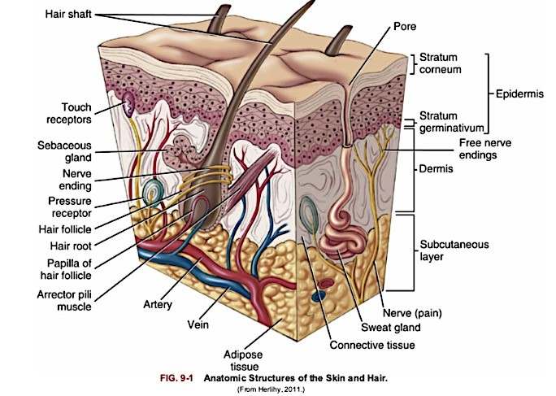
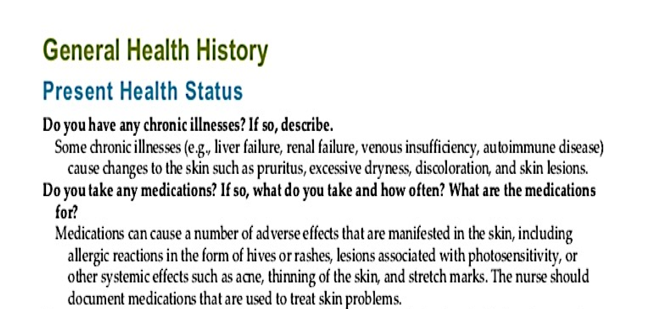

- Have you noticed any changes in the way your skin, hair, nail look or feel? Any changes in the sensation of your skin? If, so where?
Describe?
- What type of work do you do? To your knowledge are you exposed to any chemical at work or at home? If please describe?

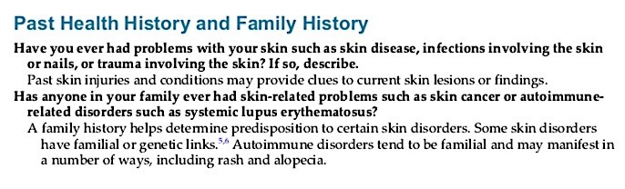

Past medical history
- Renal and hepatic disease
- Collagen and other connective tissue diseases
- Trauma or previous surgery
- Food, drug or contact allergies

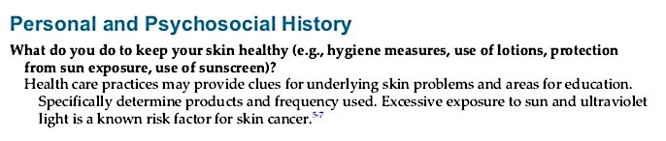

Family medical history
- Diabetes mellitus
- Allergic disorders
- Specific dermatologic problems e.g. psoriasis or skin cancer.

Use of medications
- Steroids
- Antibiotics
- Vitamins
- Hormones Chemotherapeutic drugs

Disorders of the integumentary system
- Primary lesion is one that appears in response to some change in the internal or external environment of the skin and is not altered by trauma. It includes:
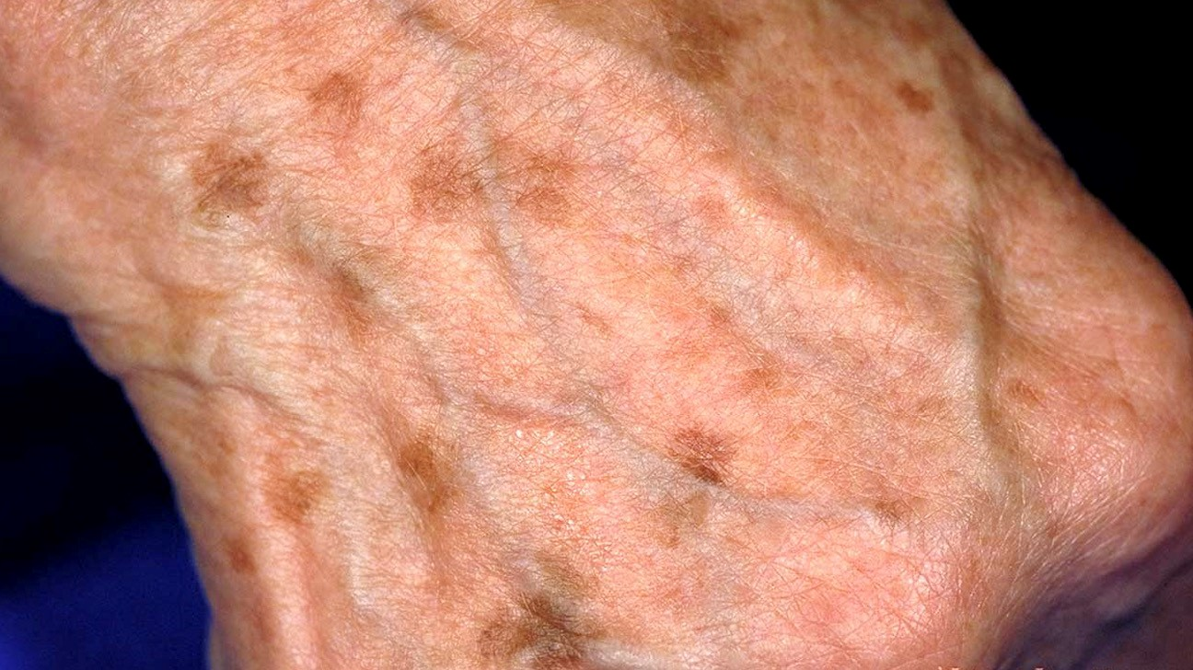
- Macule is a small flat spot or lesion with color change that is not palpable and is <1 cm in diameter.
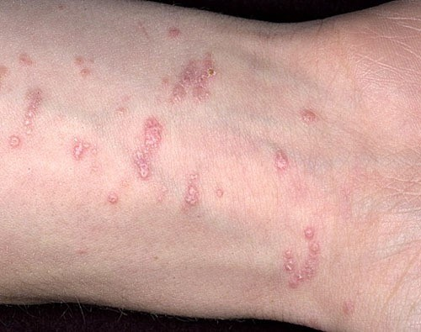
- Papule is a small (<1cm) superficial, solid elevated that may be pink, tan, red (wart, and mole).
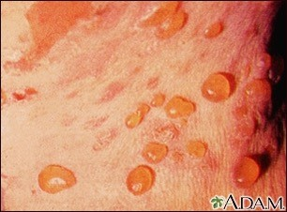
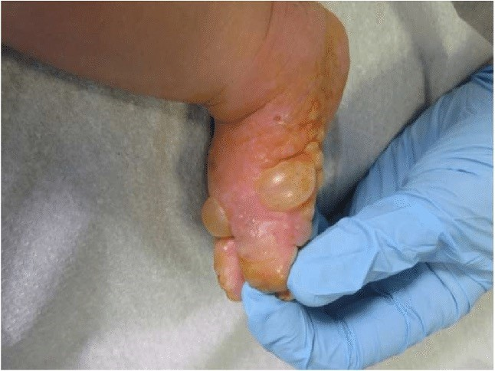
- Vesicle or blister is a small fluid-filled bubble that is usually superficial and is <1 cm, (seen in chicken pox, herpes simplex, herpes zoster, 2nd burns).
- Bullae (large vesicle) is a large fluidfilled bubble containing serous or seropurulent fluid that is superficial or deep and is equal or >1 cm.
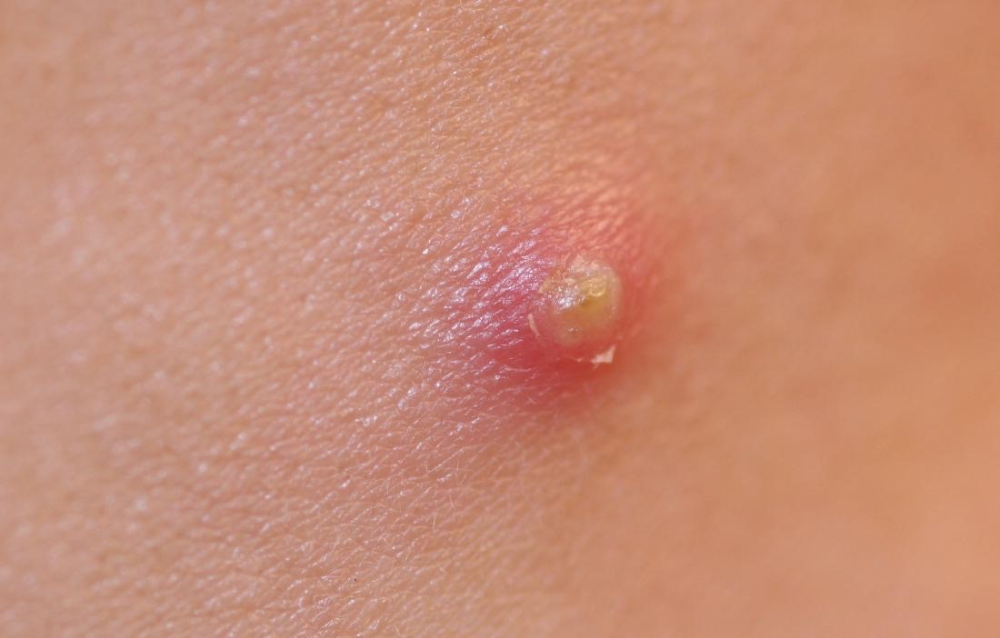
- Pustule is pus containing bubble, less than 1cm (acne).
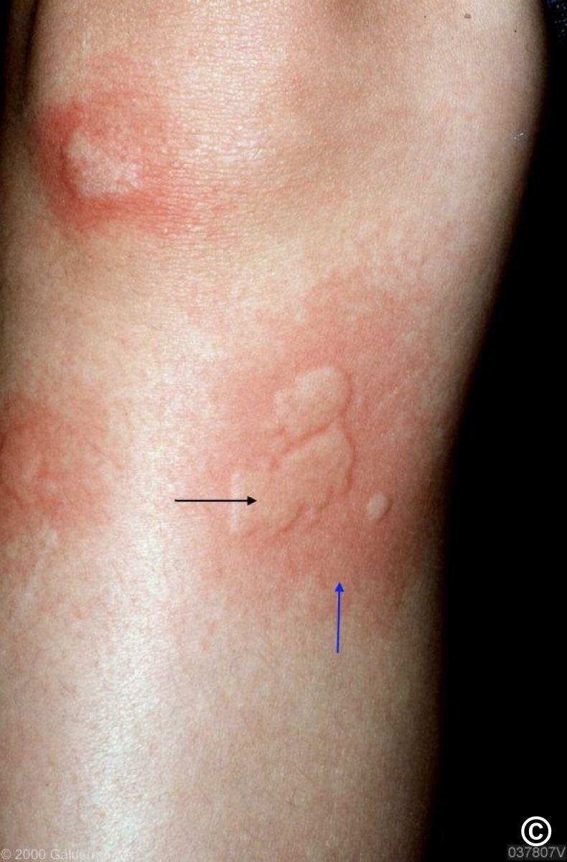
- Wheal is a firm, elevated and white to pink edematous lesion of irregular shape, (seen in mosquito bite).

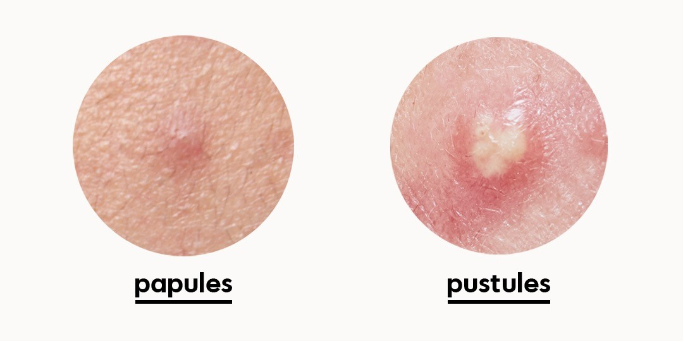

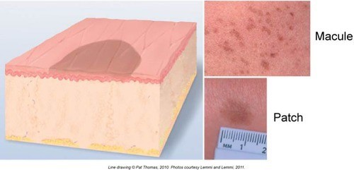
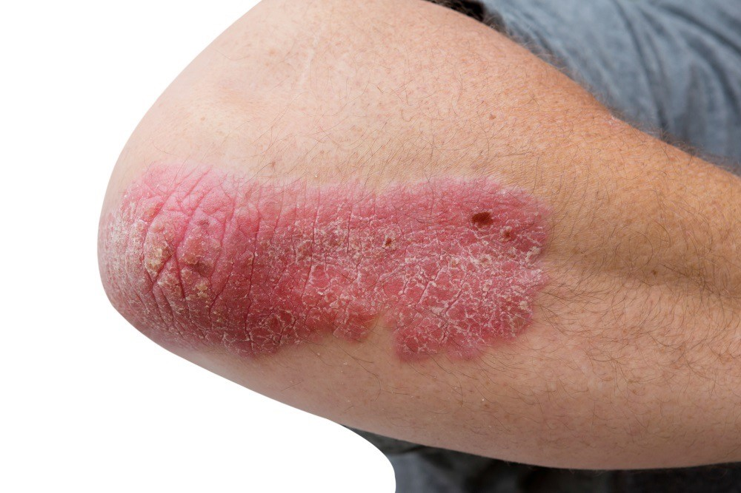
- Patch is a large spot that is not palpable and that is > 1 cm.
- Plaque is a large superficial, solid bump that is elevated (>1cm), seen in psoriasis.
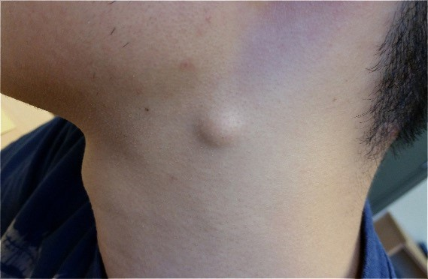
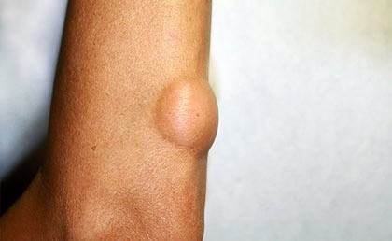
- Lipoma: Single or multiple tumors of different sizes and comprising fat cells are commonly found on the back of the neck, torso, arms, and legs.

Secondary lesions of the Skin
- Secondary lesions may result from changes in primary lesions, or be caused by external sources such as trauma, infection and scratching. It includes:
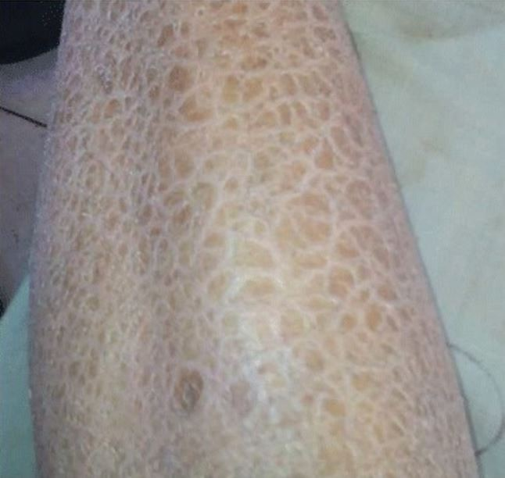
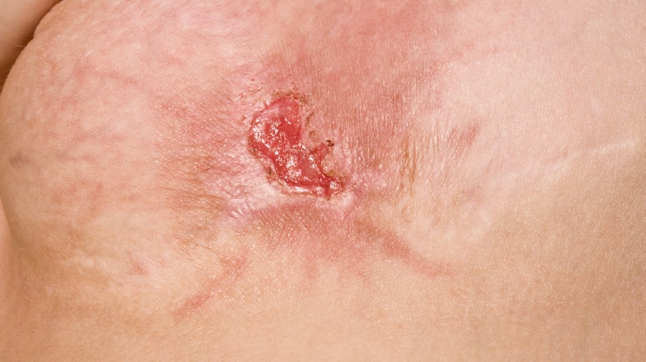
- Scale is fishlike scales that are easily rubbed off the skin‘s surface or the accumulation or excess shedding of dead skin (Seen in psoriasis and eczema).
- Ulcer is destruction and partial or complete loss of epidermis, dermis, and possibly subcutaneous layers (seen in pressure ulcer).

Vascular Skin Lesions
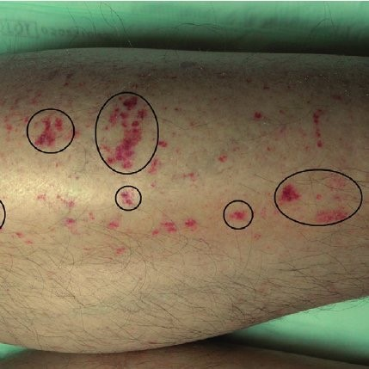
- Petechiae is a tiny pinpoint reddish purple macule, caused by hemorrhage in the superficial layers of the skin, associated with bleeding tendencies. (Seen in purpura and must be reported immediately).
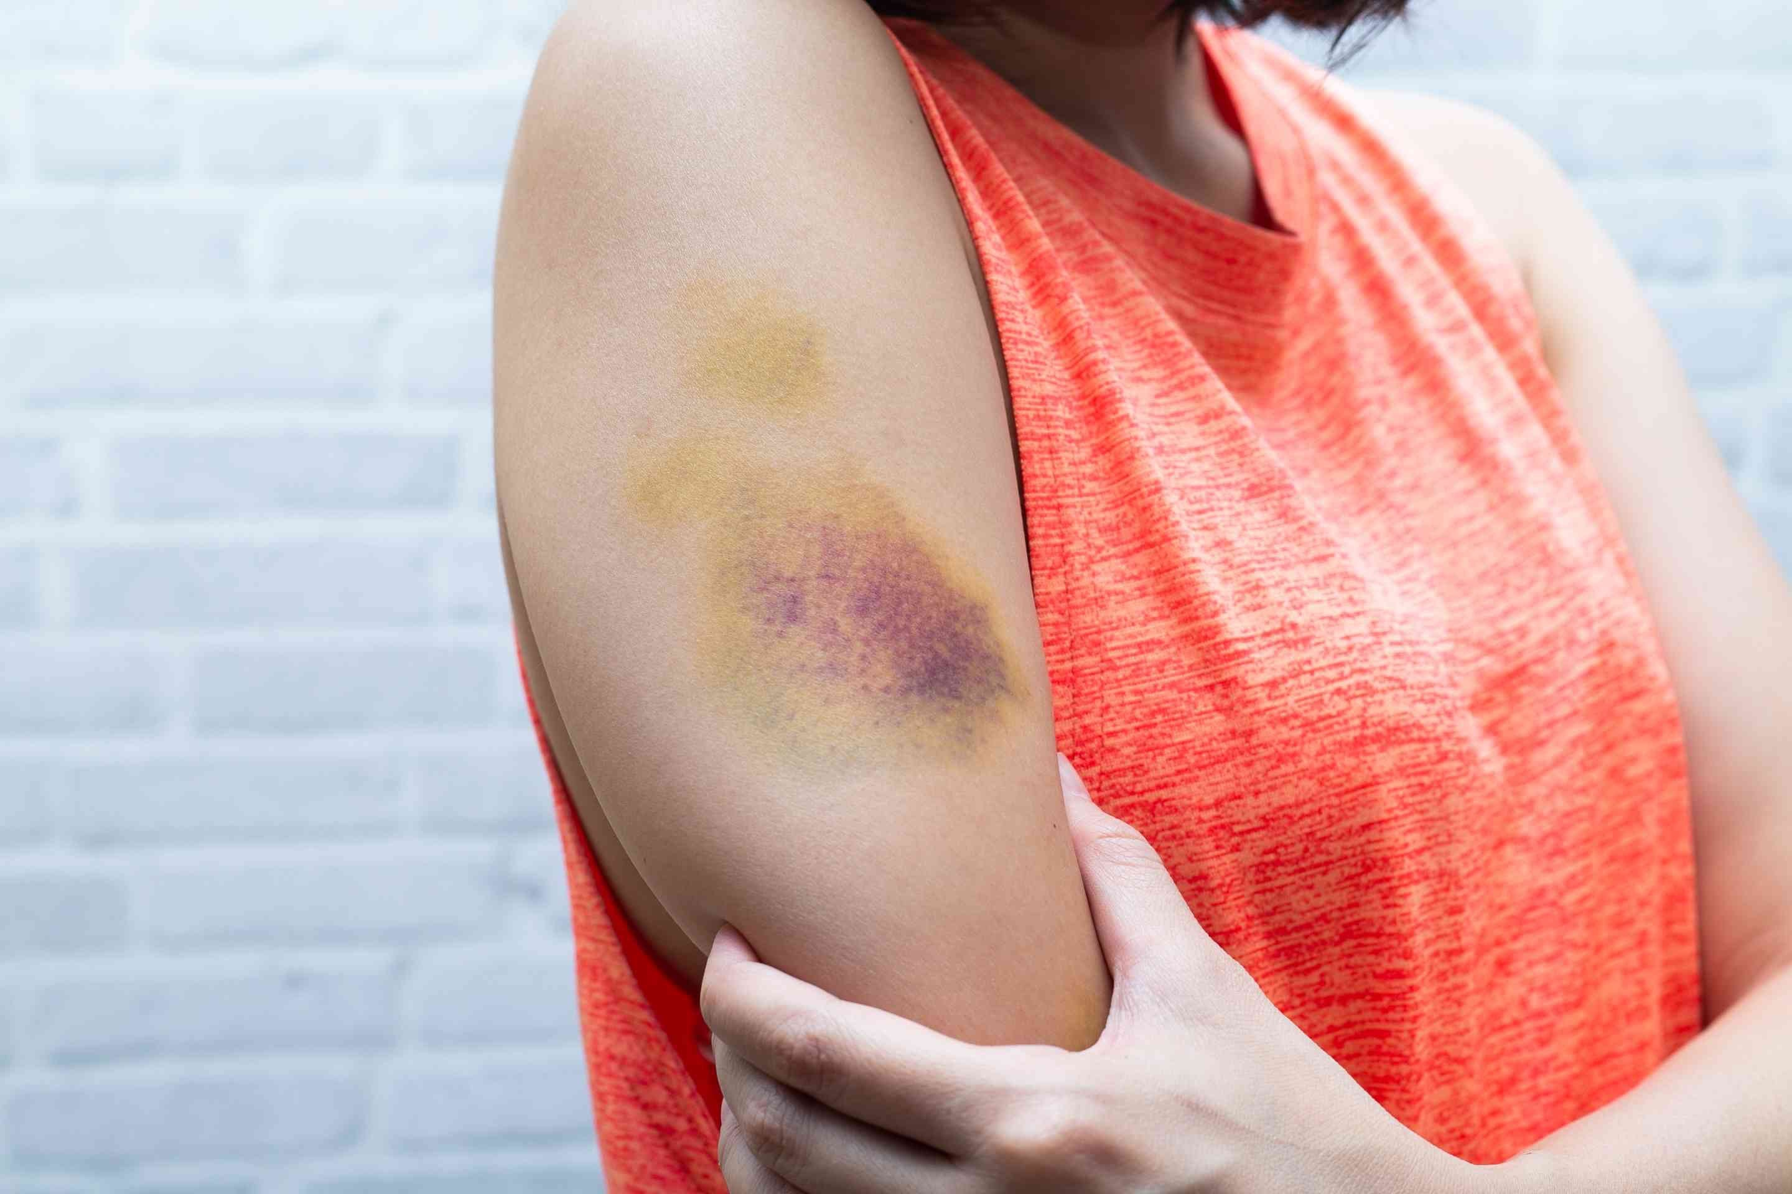
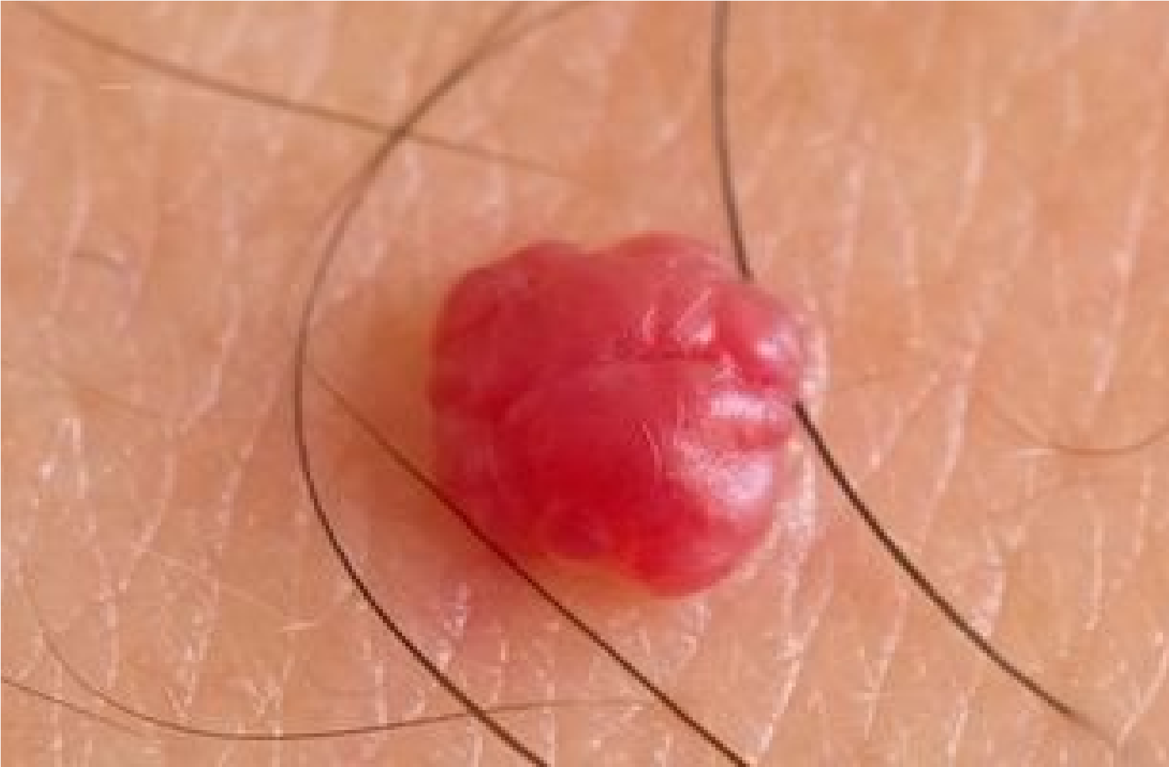
- Ecchymosis is a round or irregular flat purplish bruise beneath the skin (>1 cm), its color changes from black, yellow and green. It is associated with trauma and bleeding tendencies.
- Cherry Angioma is a round, red or purple, may blanch with pressure and a normal age-related skin alteration.
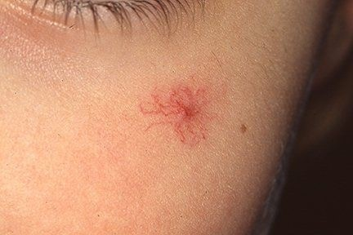
- Spider Angioma is a spider-like net of tinny blood vessels, appearing under the skin. It is commonly seen on face, neck, arms and trunk. It is associated with liver disease, pregnancy and vitamin B deficiency.

Nail problems: Nail fungus/ anemia/ vitamin deficiency
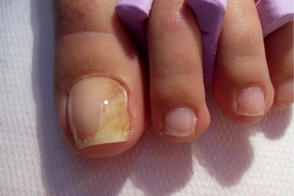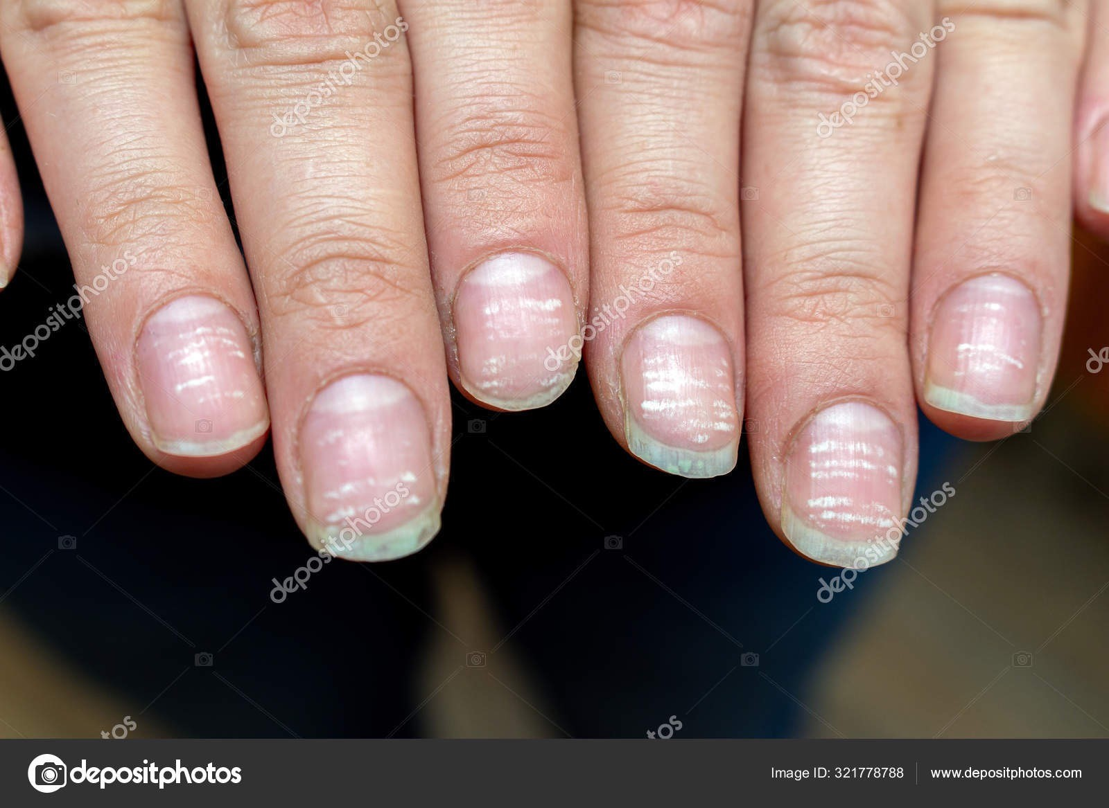

Hair problem: Dandruff/ hair loss
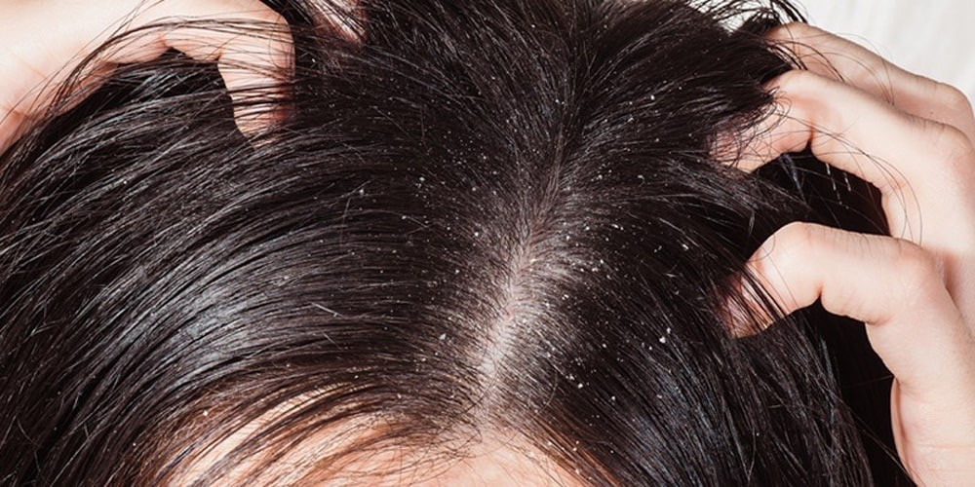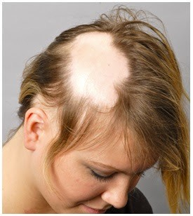

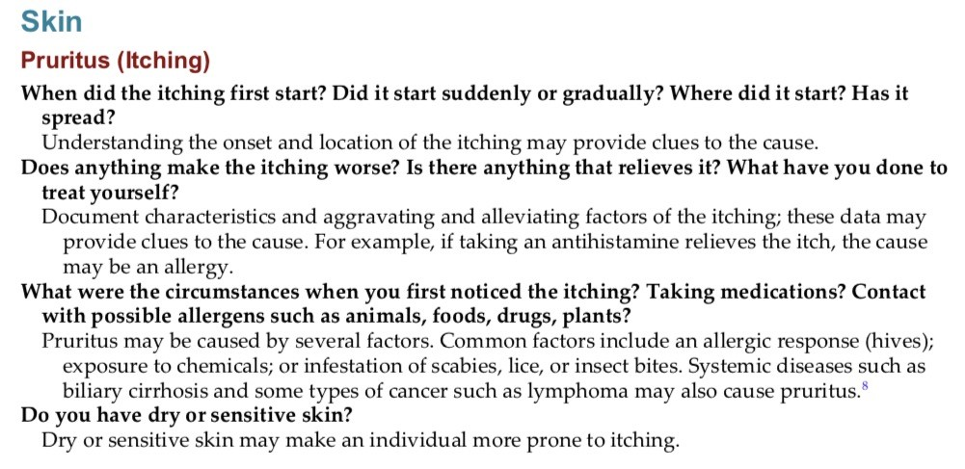

Physical examination
What you need:
- Patient medical file/chart
- Light source
- Magnifying if needed
- Gloves
- Physical assessment of the skin begins with a general inspection then palpation followed by a detailed examination .

Inspection
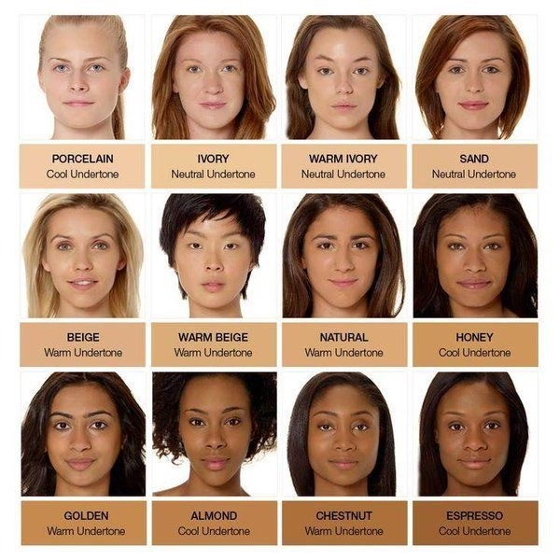
- Inspect skin color (Normal skin pigmentation ranges ivory or light pink to ruddy pink in white skin from light to deep brown or black in dark skin.
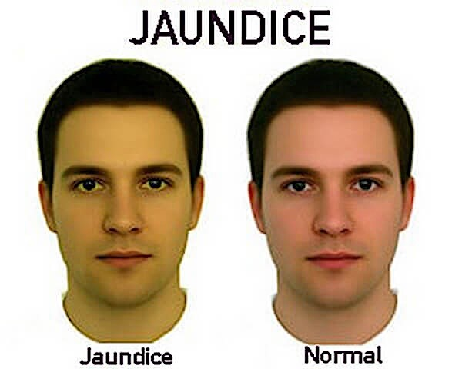
Abnormal findings may be:
- Pallor
- Hypopigmentation or white– vitiligo
- Hyperpigmentation
- Redness /Erythema
- Jaundice
- Cyanosis
- Observe for presence of scars:
- Inspect for lesions:
- Assess skin odder
- Assess nails: Check for nail bed color, clubbing, and assess capillary refill.
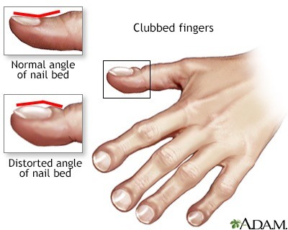
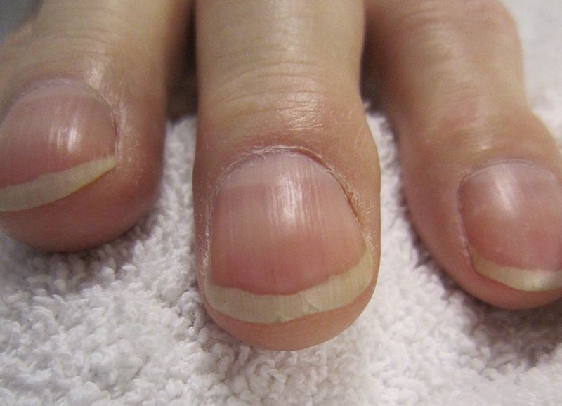
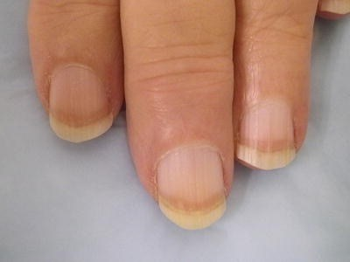
- Nail cyanosis and/or finger clubbing, are signs of chronic tissue hypoxia.
- Chronic renal problems can cause the lower half of the nail bed to turn white while the top half remains pink.
•

Hair
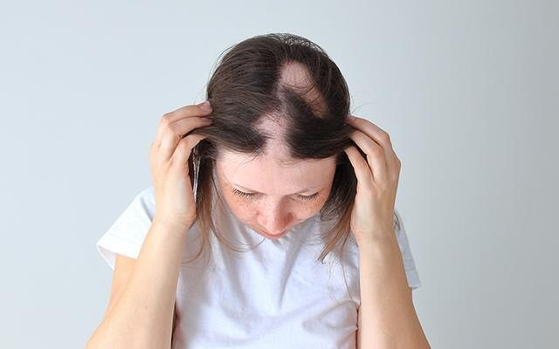
- Assess hair: color, distribution, quantity and general condition. Presence of brittle hair or alopecia.
- Presence of dandruff, lice and general hygiene

Palpation
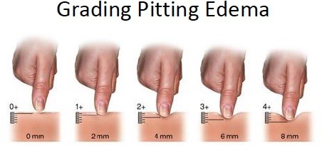
- Palpate for presence of edema (Edematous skin also appears stretched and shiny.
- Palpate edematous areas to determine mobility and consistency. When pressure from your finger leaves an indentation in the edematous area, it is called pitting edema.
- Moisture: (Moisture refers to wetness and oiliness).
- Use ungloved fingertips to palpate skin surfaces and observe for dryness, crusting, and flaking
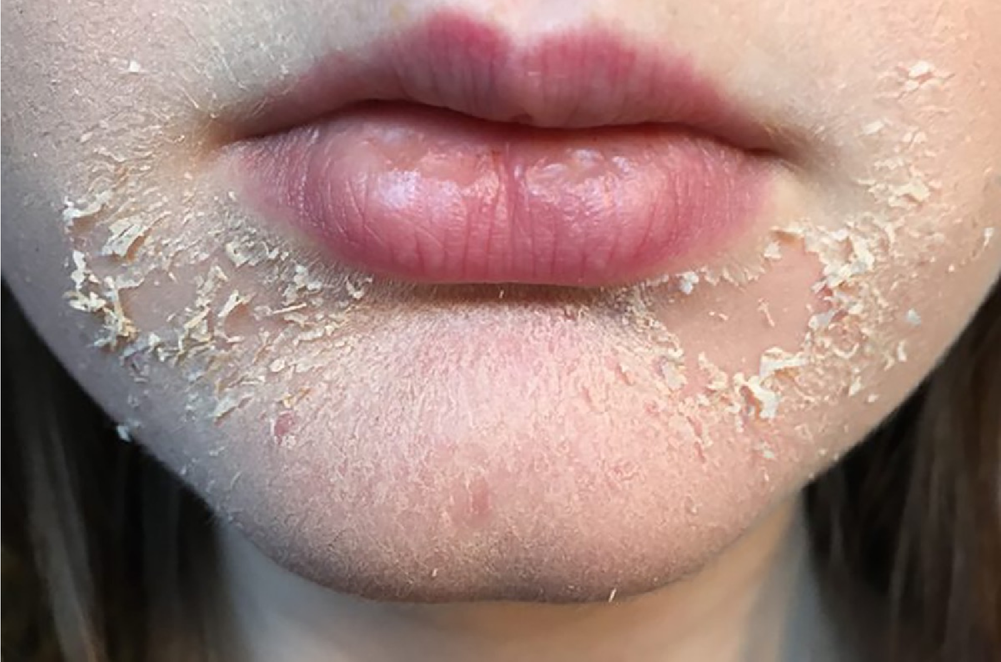
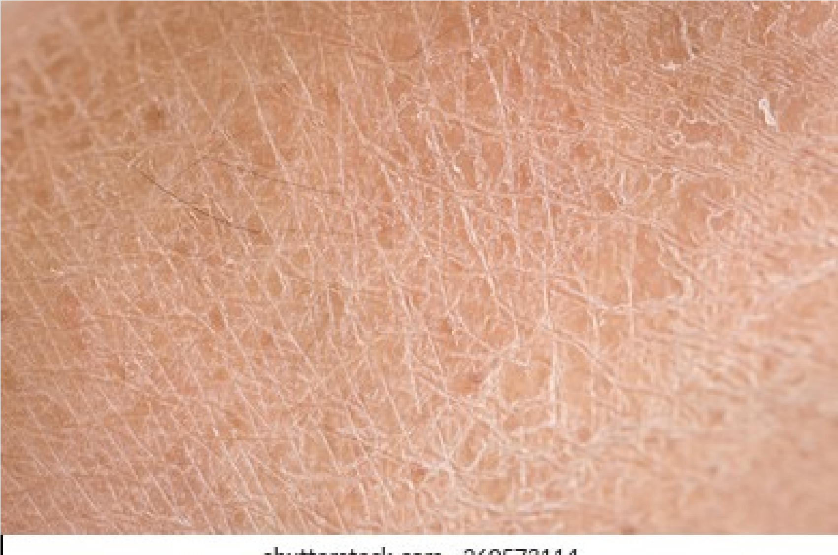
- Increased perspiration is associated with activity, warm environments, obesity, anxiety, or excitement.
- Dry skin is normally found in elderly people. - Excessively dry skin can be caused by irritating soap, excessive bathing, or hypothyroidism.
- Temperature: Use the back of the hand to assess skin temperature for coolness or warmth.
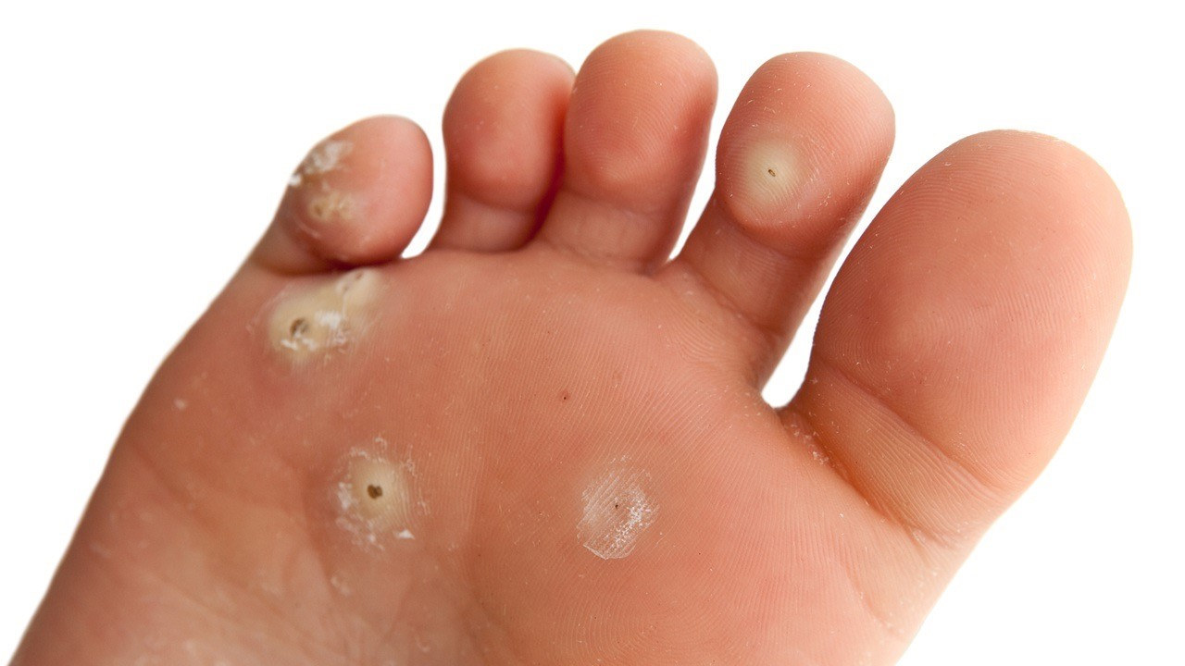
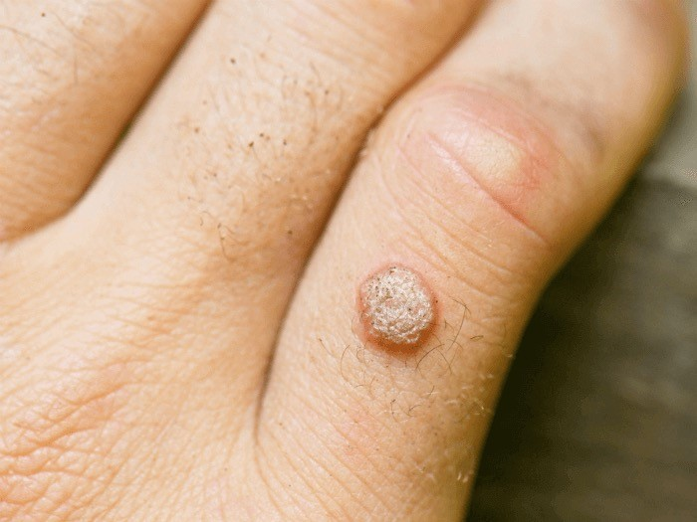
- Lesions: Lightly palpate any lesions to detect tenderness, firmness, and depth. Measure length, width, and depth
- Texture:
- ■ Macules are smooth.
■ Warts are rough.
■ Psoriasis is scaly.
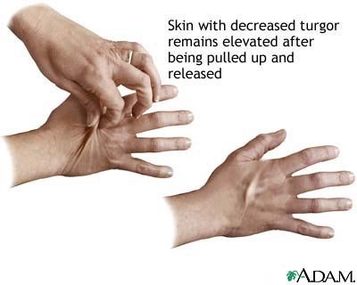
- Turgor: It is the skin‘s elasticity. It diminishes with edema and dehydration.

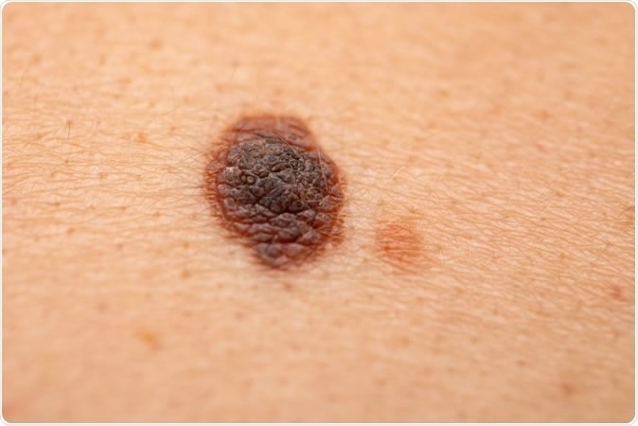
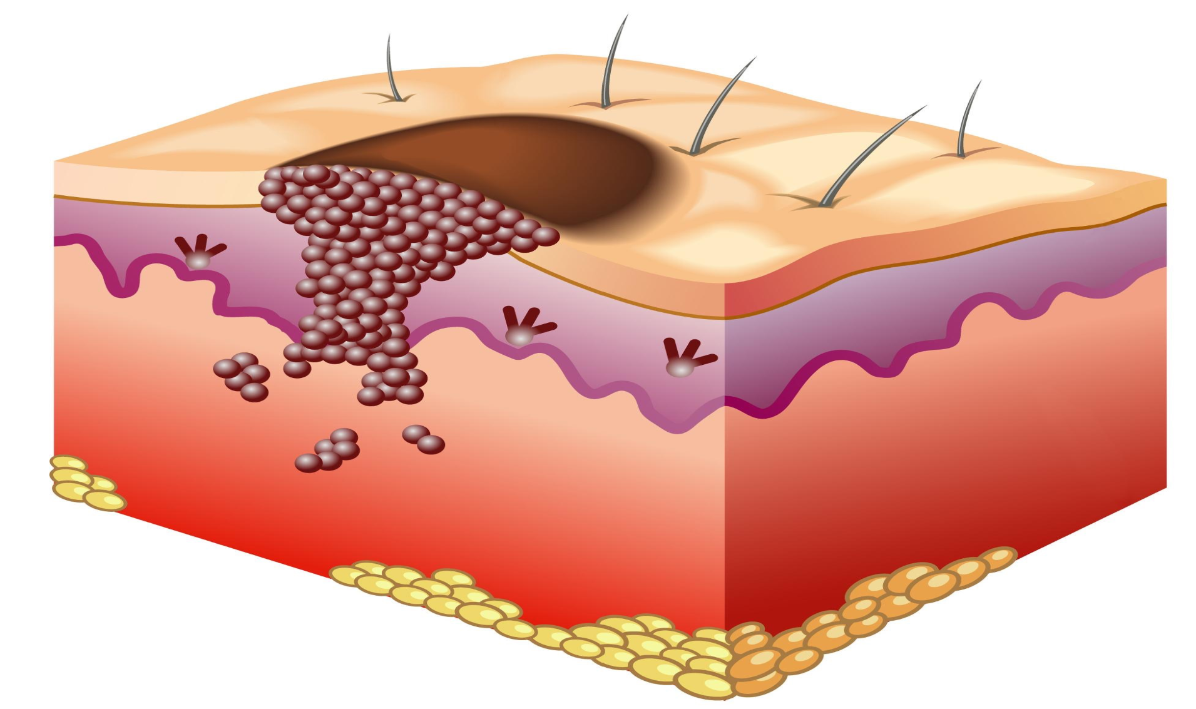

Laboratory / Diagnostic Studies:
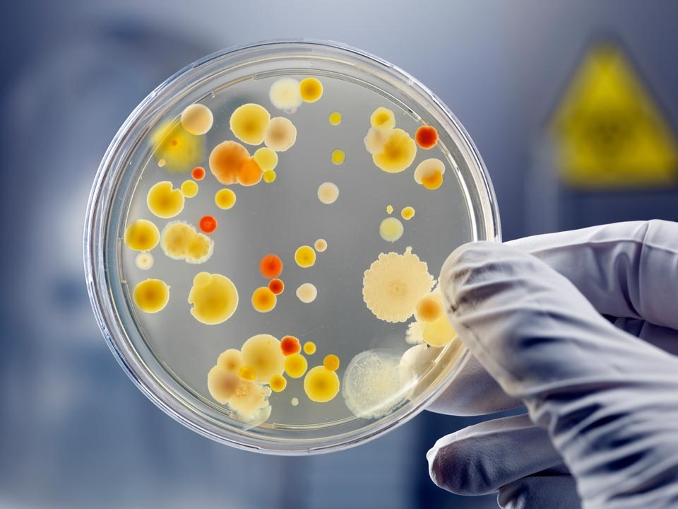
- Blood chemistry / electrolytes: calcium, chloride, magnesium, potassium, sodium
- Hematologic studies
- Skin culture or biopsy Skin testing

