First lecture: Health assessment / Health history
By: Newroz Ghazi Aziz

Introduction
Health assessment is "a dynamic and continuous process of collecting, verifying, and organizing information about a person within a particular context for the purpose of planning patient centered care."

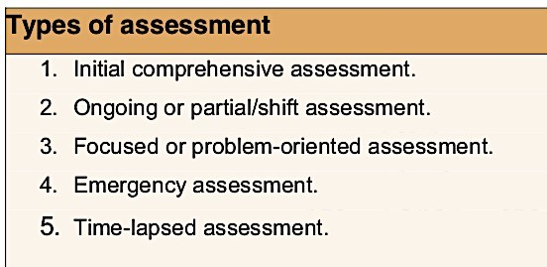

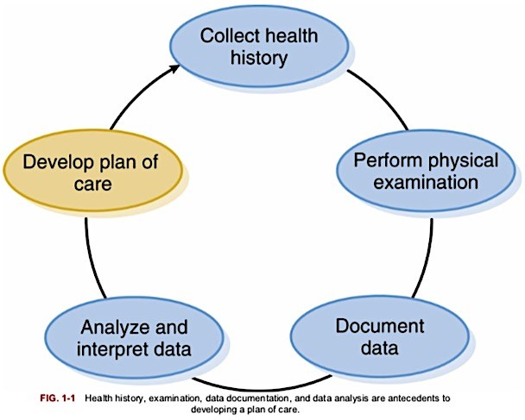
Component of health assessment
Health History
A health history consist of the subjective data collected during an interview
Components of health history:
- Review of systems
- Demographic information
- Lifestyle practices/Nutrition
- Reason for seeking health care
- Current medication
- History of the present illness
- Psychological history
- Past health history
- Sociocultural history • Family medical history
General Guidelines for Interviewing to Obtain Health
History
- Greeting client, introduce self and establishing rapport. Use appropriate title Quickly review the patient's chart (to provide you with an idea of the patient and will avoid asking repetitive questions).
- Setting goals for the interview.
- Improving the environment. It should be private, quiet and uninterrupted.
- Taking Notes.
- Inviting the Patient’s Story. Begin with open-ended questions that allow full freedom of response, e.g.―What brings you to the hospital?ǁInquire how client is feeling; watch for signs of discomfort such as evidence of pain or anxiety.
- Listen actively for important symptoms, emotions, events and relationships. Be empathetic and caring
- Be professional- nonjudgmental, concerned and informed.
- Reactions as disapproval, impatience (nonverbal behaviors) block communication.
- Assure confidentiality.
- Assure clients that the information you collect will be shared only with the health care team

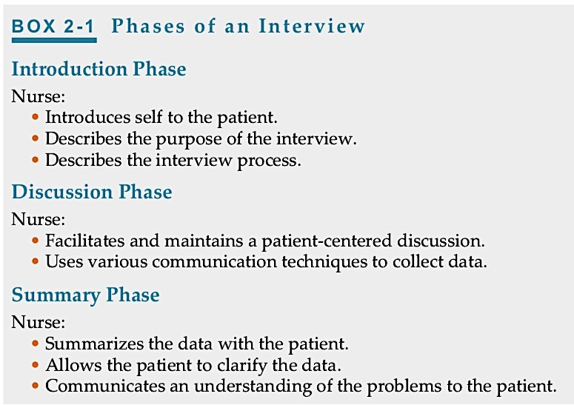
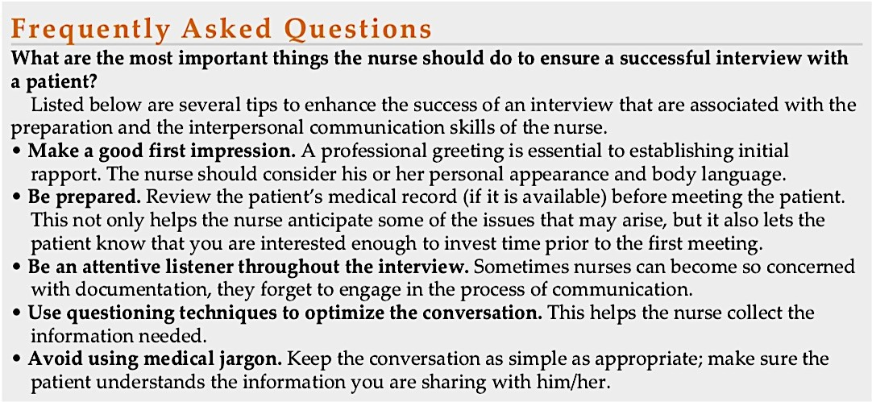
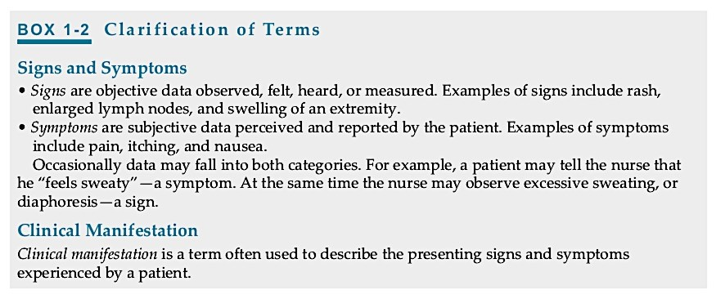

1- Demographic information
- Name
- Gender
- Address
- Type of health insurance
- Date of birth • Race
- Occupation
2- Reason for seeking health care/ chief complain
• It is important to get the chief complaint in the patient‘s own words.

History of the present illness/ COLDSPA
C- Character (the quality of feeling or sensation, e.g. sharp, dull, and stabbing).
O- Onset/Timing (onset, duration, frequency, and precipitating factors of the symptoms).
L- Location (area of the body in which symptom is felt).
D- Duration
S- Severity/Intensity (the severity or quantity of the feeling). P- Pattern (Aggravating/Alleviating factors/activities or actions that make the symptom better or worse).
A- Associated factors/How it affects the client (What other symptoms occur with it? How does it affect you?)

Past health history
- Major illnesses or previous hospitalizations and surgical procedures.
- Allergies (food, drug, and airborne allergies).
- Previous injuries/Fractures.
- Childhood diseases/Immunizations (history of polio, measles, mumps, and rubella).

Family medical history
- Diabetes mellitus.
- Allergic disorders.
- Cardiovascular problems and race.

Review of systems
- A brief account from the client of any recent signs or symptoms associated with any of the body systems.
  - It reveals data related to present illness.
  - The review of systems checklists are often used to ask about:
General: Usual weight, recent weight change. Weakness, fatigue, or fever.
Skin: Rashes, lumps, sores, itching, dryness, color change, changes in hair or nails.
Head: Headache, head injury, dizziness.
- Eyes: Vision, glasses or contact lenses, redness, excessive tearing, double vision, blurred vision, flashing lights, glaucoma, cataracts. Ears: Hearing, tinnitus, vertigo, earaches, infection, discharge. If hearing is decreased, use of hearing aids.
- Nose and sinuses: Frequent colds, nasal stuffiness, discharge, or itching, nosebleeds and sinus trouble.
- Throat (or mouth and pharynx): Condition of teeth, gums, bleeding gums, dentures, sore tongue, dry mouth, frequent sore throats, and hoarseness.
- Neck: Lumps, ―swollen glands,ǁ goiter, pain, or stiffness in the neck.
- Breasts: Lumps, pain or discomfort, nipple discharge
- Respiratory system: Cough, sputum (color, quantity), hemoptysis, dyspnea, wheezing, pleurisy, last chest x-ray.
- Cardiovascular. Heart trouble, high blood pressure, rheumatic fever, chest pain or discomfort, palpitations, dyspnea, orthopnea, and or edema.
- Gastrointestinal system: Heart burn, appetite, trouble swallowing, nausea, change in bowel habits, rectal bleeding hemorrhoids, abdominal pain, constipation, diarrhea, passing of gas, food intolerance and/or excessive belching.
- Urinary system. Frequency of urination, polyuria, nocturia, urgency, burning or pain on urination, hematuria, incontinence; reduced force of the urinary stream, hesitancy and/or dribbling of urine in males.
- Genital. Male: Hernias, discharge from or sores on the penis, testicular pain or masses.
- Female: Age at menarche; regularity, frequency, and duration of periods; amount of bleeding, last menstrual period; dysmenorrhea, number of deliveries, age at menopause, menopausal symptoms, postmenopausal bleeding.
- Peripheral Vascular: leg cramps, varicose veins, past clots in the veins.
- Musculoskeletal system: Muscle or joint pains, stiffness, arthritis, gout, and backache. Presence of any swelling, redness, pain, stiffness, weakness, or limitation of motion or activity; include timing of symptoms (e.g. morning or evening)
- Neurologic system: Fainting, blackouts, seizures, weakness, paralysis, numbness or loss of sensation, tingling, tremors or other involuntary movements.
- Hematologic: Anemia, easy bruising or bleeding, past transfusions and/or transfusion reactions.
- Endocrine: Thyroid trouble, heat or cold intolerance, excessive sweating, excessive thirst or hunger, polyuria.
- Psychiatric: Nervousness, tension, mood, including depression, memory change.

Lifestyle practices/Nutrition
- Hygienic practice
- Skin exposure
- Habits (the use of alcohol, drugs caffeine and tobacco use).
- Activities of daily living (ADL‘s) [bathing, toileting, transfer, eating, dressing].
- Eating pattern.

Current medication
• Steroids, antibiotics, antihypertensive drugs, hypoglycemic drugs, vitamins, hormones or chemotherapy.

Psychological history
- The assessment of dimensions as self-concept and self-esteem.
- Sources of patient's stress and ability to cope.
- Sources of support for clients in crisis, such as family, significant others, religion, or support groups.
- Community involvement: Church involvement, volunteer work, employment, hobbies, group memberships, social and/or recreational programs, classes.

Sociocultural history
- Economic status: Amount and/or source of income, type of health insurance coverage, perception of adequacy of income to meet needs
- Home environment.
- Client‘s role in the family.
- The cultural aspects of the client‘s lifestyle, health beliefs, and health practice

