Lecture 2 Physical assessment
Lect: Newroz Ghazi Aziz
10/19/21

Objectives
- Define physical assessment. • Differentiate between different
- Discuss general guidelines for ^{percussion sounds.}
physical examination. • Mention types of palpation.
- Identify equipment used in physical • State guidelines for palpation.
^{examination.} • Mention types of percussion.
- Discuss techniques of physical examination.

Physical examination
- It is the techniques used to gather objective data about the body from head to toes".
Preparation for physical assessment:
- Provide a warm, comfortable, private environment with natural lighting, if possible.
- The room should be quiet. Eliminate distractions and disruptions (because excessive environmental noises may make detection of some physiological sounds difficult).
- Introduce yourself to the client by name and title if you have not already met the client.
- Approach the client calmly and confidently.
- Explain the purpose of each step of the examination to the patient (to alleviate anxiety and secure the patient’s cooperation).
- Ask the client to undress and wear a patient's gown if a complete physical assessment is to be performed (to facilitate the examination).
- The person is also asked to void before examination.
- Wash your hands and wear gloves if the patient has drainage wound, bleeding and/or vomiting (to prevent spread of infection).
- Warm your hands and instruments before touching the client‘s skin.
- Drape the client well, exposing only those areas that are being examined.
- Be aware of your nonverbal communication during the examination; avoid
- frightening or embarrassing the client.
- Arrange the needed equipment and supplies, and check equipment for proper functioning.
- Warn the client when any part of the examination may be uncomfortable.
- Be as gentle as possible.
- Be systematic and organized when assessing the client. (Inspection, then palpation, percussion and auscultation).
- If a client is seriously ill, assess the systems of the body that are more at risk.
- Perform painful procedures at the end of the examination.

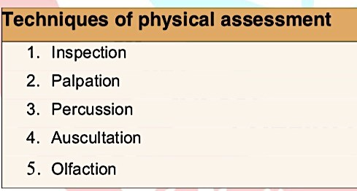

Inspection
- Inspection is" a systematic visual examination of the patient done in a deliberate manner".
or "The use of sight to gather data".
- Inspection should begin with general observation of the patient progressing to specific body areas.
- Through inspection we can observe patient's gait, posture, personal hygiene, grooming and mental status.
- Visual inspection of a patient‘s respiratory status, for example, might reveal a rate of 38 breaths per minute and cyanotic nail beds.
- Describe what you see not what you think (e.g. swollen joints, not arthritis).
- The otoscope, ophthalmoscope, and penlight enhance inspection abilities

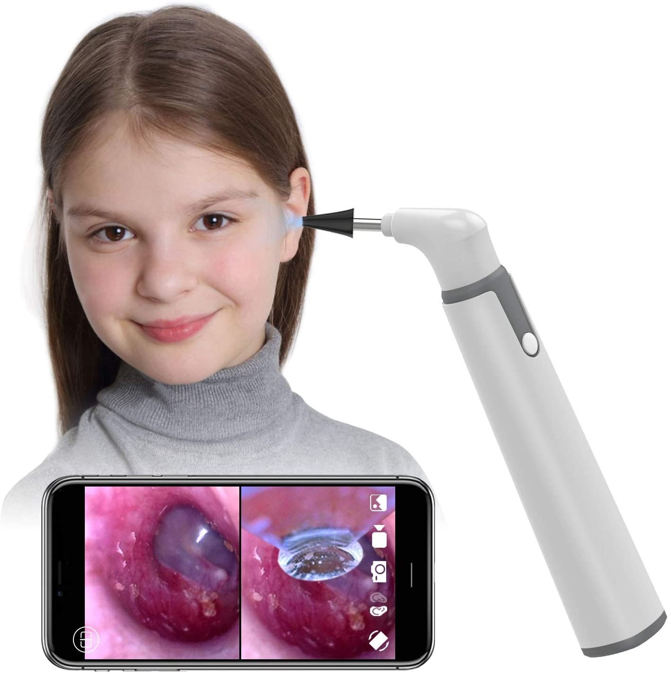

Palpation
- Palpation is "the examination using the sense of touch by hand for determining the following characteristics: texture (rough /smooth), temperature (hot/warm/cold), moisture (dry/moist/wet), mobility (fixed/ movable/ still/ vibrating), consistency (soft/ hard /fluid filled), strength of pulses (strong/weak/thready/bounding), size (small/medium/large), shape (well defined/irregular), degree of tenderness, symmetry of body parts and presence of thrills"
- (Thrills are fine vibrations and can sometimes be felt over aneurysms or stronger heart murmurs).
Sensitivity of Parts of the Hands:
- Fingertips: for pulsation.
- Palm of hand: for vibratory sensation.
- Back or dorsum of the hand: for temperature.
- Grasping (all hand): for position and consistency.
- The finger pads: are useful in assessing fine tactile discrimination, skin moisture, and texture; the presence of masses, pulsations, edema, crepitation; and the shape, size, position, mobility, and consistency of organs.

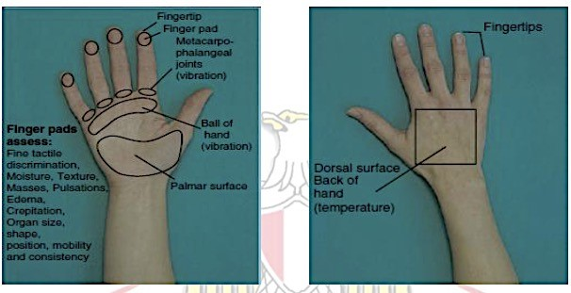

Guidelines for Palpation:
- Instruct patient to relax during palpation. Advice the client to take slow deep breath to enhance muscle relaxation.
- Palpation requires touching with different parts of the hand and with varying degrees of pressure to determine characteristics of pain, temperature, size, shape, moisture, and/or texture.
- Explain reason for touch to client.
- Warm hands.
- Use light palpation before deep palpation.
- Use palms of hand to assess vibrations.
- Use pads of fingers (most sensitive part) to identify texture, size, shape, or
- movement (e.g., pulse).
- Use dorsum of fingers for temperature assessment.
- Gently pinch skin to assess turgor.
- Use deep palpation gently and briefly to assess areas such as pelvis and
- abdomen for body organs and masses.
- Palpate painful areas las

PERCUSSION
- Percussion is "striking or tapping of the body surface in order to elicit characteristic sound".
It is used to:
- Determine the location, size, and density of underlying structures.
- Detect the presence of air or fluid in a body space; and elicit tenderness.

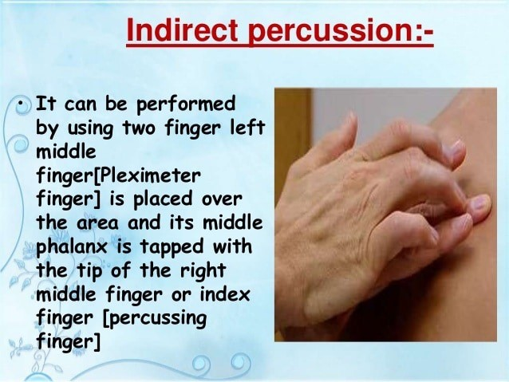
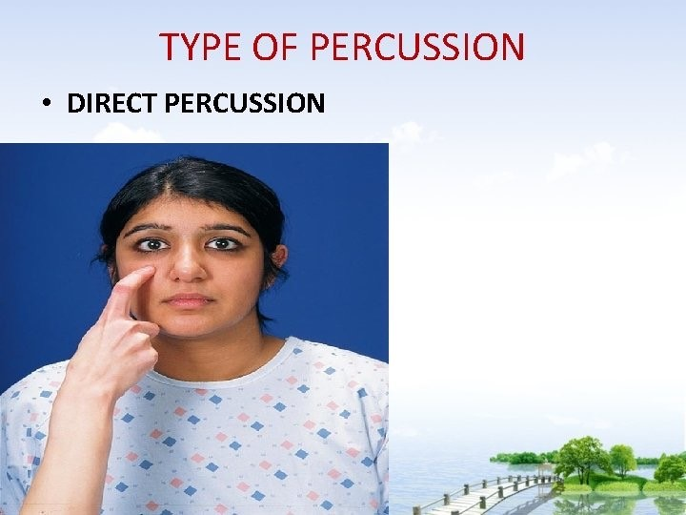

Percussion sound
- Tympany – Loud, musical, drum like sound heard over low density such as stomach or intestine filled with air (abdominal distension with gas).
- · Hyperresonance – Loud, echoing, hollow sound, lower pitched than resonance, heard over areas with mixed density such as over-aerated lung tissue found in COPD. Hyperresonance sound lies between tympany and resonance.
- Resonance– Loud, hollow, low-pitched sound heard over areas with mixed density such as structures containing air e.g. the normal lungs and abdomen.
- Dullness– Quiet, thudding sound, heard over solid organs with high density such as the heart, liver, spleen or a distended bladder.
- Flatness–Short, quiet, flat sound heard over very dense tissue e.g. bone and muscle.
AUSCULTATION
- Auscultation is "the use of hearing sense to listen to sounds produced inside the body to determine presence and quality of heart, lung, and bowel sounds". or "It is the use of hearing to gather data".
- Types of auscultation:
- Direct auscultation is listening without using an instrument (e.g. hearing wheezing or chest congestion without the use of a stethoscope).
- Indirect auscultation is listening with the help of a stethoscope.
- The stethoscope has two end pieces, the diaphragm and the bell.
- High-pitched tones are best heard with the diaphragm of the stethoscope. (e.g., lung sounds, normal heart sounds and bowel sounds).
- Low-pitched tones are best heard with the stethoscope‘s bell (e.g., abnormal heart sounds and bruit).

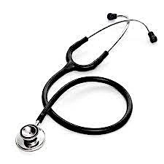

Olfaction
- Olfaction is "the use of the sense of smell to gather data about patient's health".
- E.g. If the client‘s breath has a ―fruityǁ or ―acetoneǁ odor, you would suspect ketoacidosis.
- -You should assess the urine for ketones.
- -You would also ask the client about dietary patterns, because a high protein, highfat, low-carbohydrate diet can cause a buildup of ketones in the blood.

