Lecture 4 health assessment
Assessment of the respiratory system
By Newroz Ghazi Aziz

Objectives
- Obtain complete respiratory system health history.
- Perform respiratory system physical assessment.
- Describe the abnormal lung sounds.
- Differentiate between different percussion sounds detected on the normal and
- abnormal lung.
- Define the different terms related to abnormal respiratory characteristics.
- Mention the diagnostic studies used for respiratory system assessment.

Health history
Present
health status
Past health
history
Family
history
Personal and
psychosocial
history
Home
environment
Occupational
environment
Travel
Problem
based history
Physical
examination

Present health status
- Ask about presence of any of the following respiratory symptoms:
cough, sputum production, dyspnea, hemoptysis, chest pain, wheezing and sleep apnea.
Sleep Apnea: is the cessation of airflow for more than 10 seconds more than 10 times a night during sleep. It is caused by airway obstruction (e.g. obesity with upper narrowing, enlarged tonsils, pharyngeal soft tissue changes in acromegaly or hypothyroidism).
Do you have any chronic illness?
Including heart disease or renal disease (pulmonary edema )
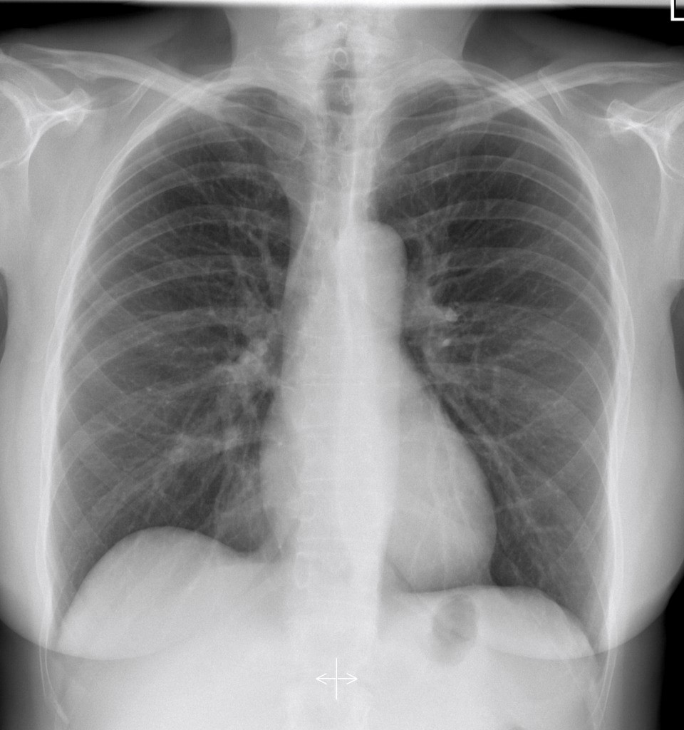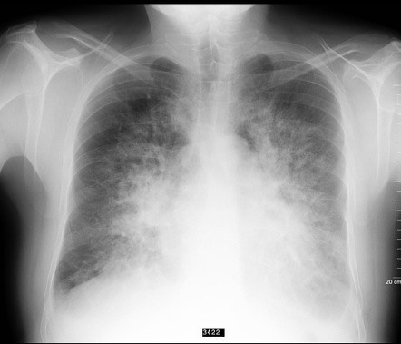
- Do you have allergies? Describe
- Do you have difficulty breathing during activities?
- Do you have difficulty breathing lying flat?
- Are you currently taking any oral medication for respiratory problems?
- Do you use inhaler? Which medication is in the inhaler? Does it help you?
- Do you use oxygen at home? How often do you use it? How much oxygen do you use? Is it effective?

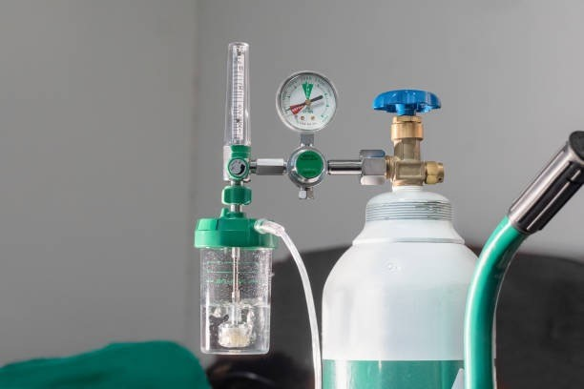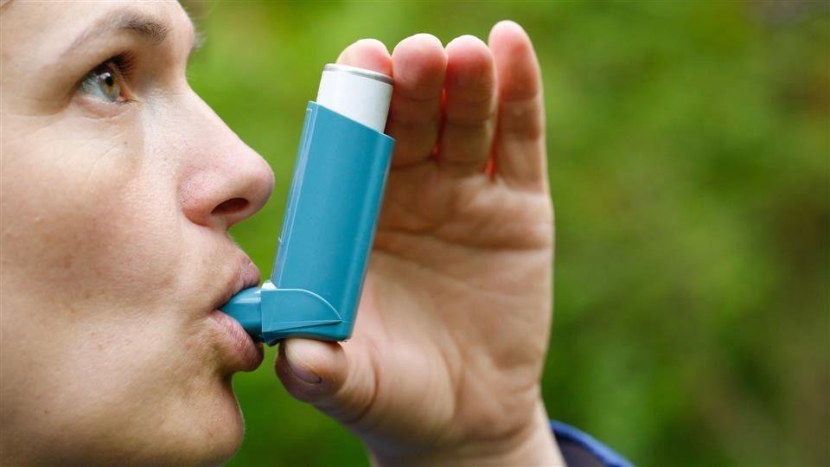

Past health history
- Have you ever had any problems with your lungs or breathing? If yes, describe.
- Asking this question may encourage individuals to describe symptoms they may be experiencing.
- These symptoms may or may not have been diagnosed and treated in the past.
- Have you been diagnosed with a respiratory disease such as asthma, chronic bronchitis, cystic fibrosis, emphysema, lung cancer, or pneumonia? If yes, please describe.
Background information regarding respiratory problems tells which types of problems the person is likely to experience and which clinical findings to anticipate.
- Have you ever had an injury to your chest? Surgery to your chest? If yes, describe.

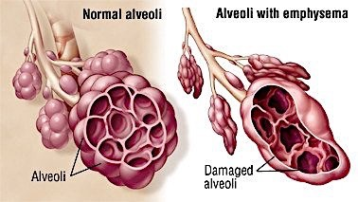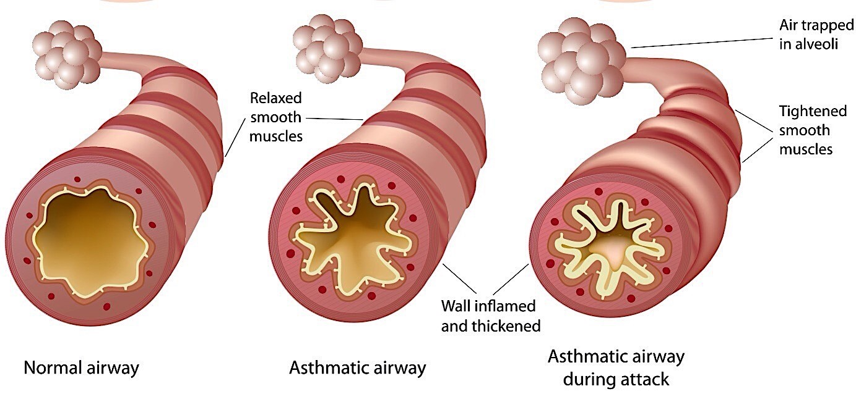

Family history
• Do you have a family history of asthma, tuberculosis, lung cancer, chronic bronchitis, emphysema, or any other lung disease?

Personal and psychosocial history
• Do you smoke or have you been a smoker in the past? If yes, what do
(did) you smoke (cigarettes, cigar, pipe)? How long have you smoked (did you smoke)? How often do you (did you) smoke? About how many cigarettes do you (did you) smoke each day? Have you ever tried to quit smoking? If yes, describe. What helped you quit? Why do you think your attempt was unsuccessful?

Home environment
Are there environmental conditions that may affect your breathing at home? If yes, what are they and how do they affect your breathing? Common things to consider include the following:
- Air pollution (near factory, on a busy street, new construction in area)
- Possible allergens in home such as pets
- Type of heating or air conditioning, including filtering system, humidification, and ventilation
- Hobbies: Woodworking, plants, metal work
- Exposure to the smoke of others in your home

Occupational environment
• Are you frequently exposed to to respiratory irritants at work?
Chemical? Dust? Asbestos? Paint fumes? Vapors? Known allergens?
•

Travel
- Have you traveled recently to the any areas in the country or outside of the country?
- Travel to the other areas of the country or world may expose people to infection to which they have little or no resistance, increasing their susceptibility to infection

Problem-based history
Cough |  | Shortness of breathing
Chest pain with breathing

Cough
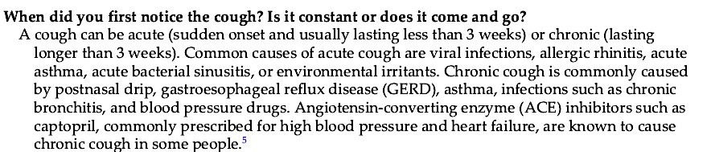
- Describe your cough, is it dry? Productive cough?
Dry (viral pneumonia) productive cough ( bacterial pneumonia)
- How often do cough up sputum? How much sputum do you cough up? Bronchitis: increased sputum in the morning lung abscess: sputum increase with change position
- What is the color of the sputum?
White or clear sputum may occur with cold, viral infection, or bronchitis. yellow or green sputum may occur with bacterial infections;
- Black sputum may occur with smoke or coal dust inhalation; or rustcolored sputum may occur with tuberculosis or pneumococcal pneumonia.
Hemoptysis is the expectoration of sputum containing blood.
What is the consistency of the sputum (thick, thin, frothy)?
- The consistency of sputum may be described as thin, thick, gelatinous, sticky, or frothy.
- Pink, frothy sputum with dyspnea is associated with pulmonary edema.
- Thick sputum is commonly associated with cystic fibrosis.
- Have you noticed if the sputum has an odor?
Foul-smelling (fetid) sputum is typically associated with bacterial pneumonia, lung abscess, or bronchiectasis.
- Are there any factors that aggravate the cough?
Avoiding aggravating factors may help relief the cough. Breathlessness during exercise and singing may aggravate cough.
- What alleviates the cough?
Encouraging these actions may help relieve the cough. For example staying hydrated, drinking warm liquids, and increasing humidity by using a humidifier or a steamy shower may help relieve a cough.
- Have you noticed any other symptoms accompanying the cough such as shortness of breath, chest pain or tightness with breathing, fever, stuffy nose, noisy respiration, hoarseness, or gagging? Does the cough tire you out? Does it keep you awake at night?
- A cough may be a symptom of pulmonary problems, or it may exist in conjunction with other problems. Related signs and symptoms are important factors to assess when determining the underlying cause of the cough. For example, a cough associated with a fever, shortness of breath, and noisy breath sounds may indicate a lung infection; whereas tightness of the chest associated with shortness of breath and a nonproductive cough is more likely to be associated with a problem such as asthma.
- What have you done to treat the cough such as medications, fluids, or a vaporizer? Have these measures been effective?
Determining what has been used to relieve symptoms may help you understand the problem and may guide current treatment strategies.

Common breathing abnormality
- In a healthy adult, a respiration is regular, between 12 and 20 times per minute).
- Tachypnea is rapid, shallow breathing
- Bradypnea is a slow respiratory rate than normal,
- Hyperpnea or hyperventilation is a rapid deep breathing, occurs as a result of physical exercise, anxiety, and metabolic acidosis.
- Kussmal respiration: It is characterized by deep breathing, occurs in patients with diabetic acidosis and coma.
- Cheyne-Stokes respiration occurs when there are periods of deep breathing alternating with periods of apnea. It may be seen in a patient with heart failure, drug-induced respiratory depression, uremia, or brain damage.
- Orthopnea is inability to breathe in laying position.
- Central cyanosis: Blue discoloration seen in the tongue present in COPD patient with massive pulmonary embolism due to abnormal amount of deoxygenated hemoglobin in arteries.
- Peripheral cyanosis: Blue discoloration seen in the lips mucous membrane, occurs when oxygenated blood supply to a certain part of body is reduced. It is seen with all causes of central cyanosis, with exposure to cold, left ventricular failure and shock.

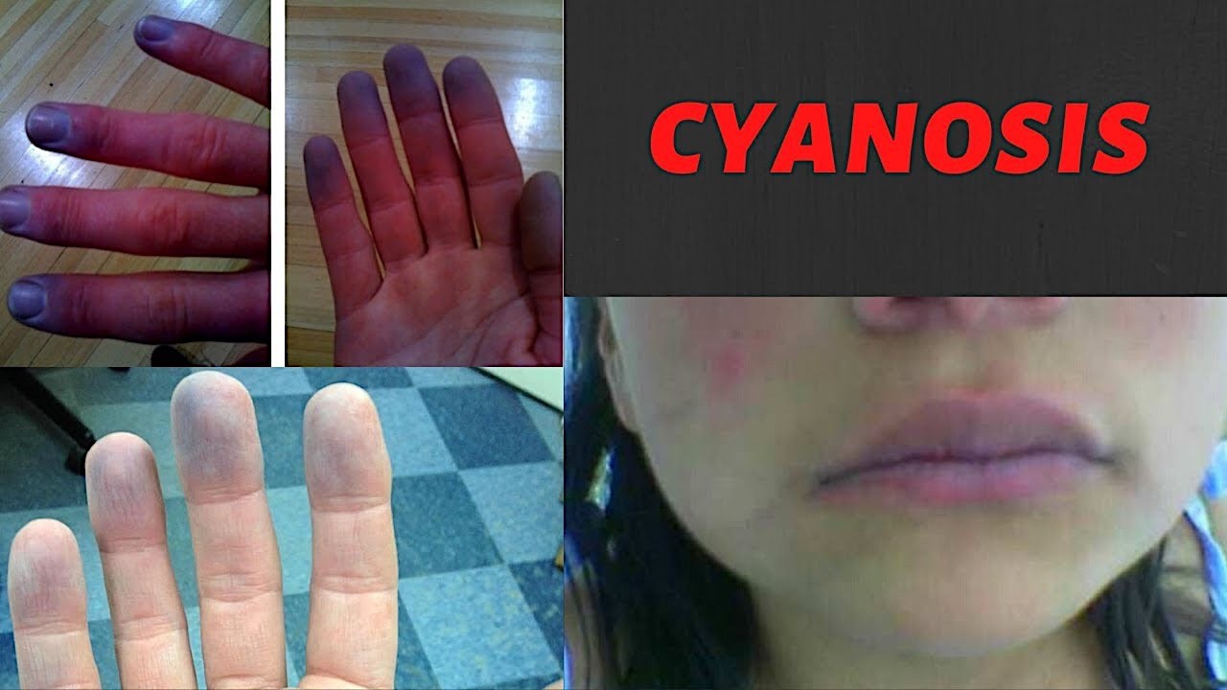

Clubbing fingers is a sign indicating hypoxia as seen in COPD
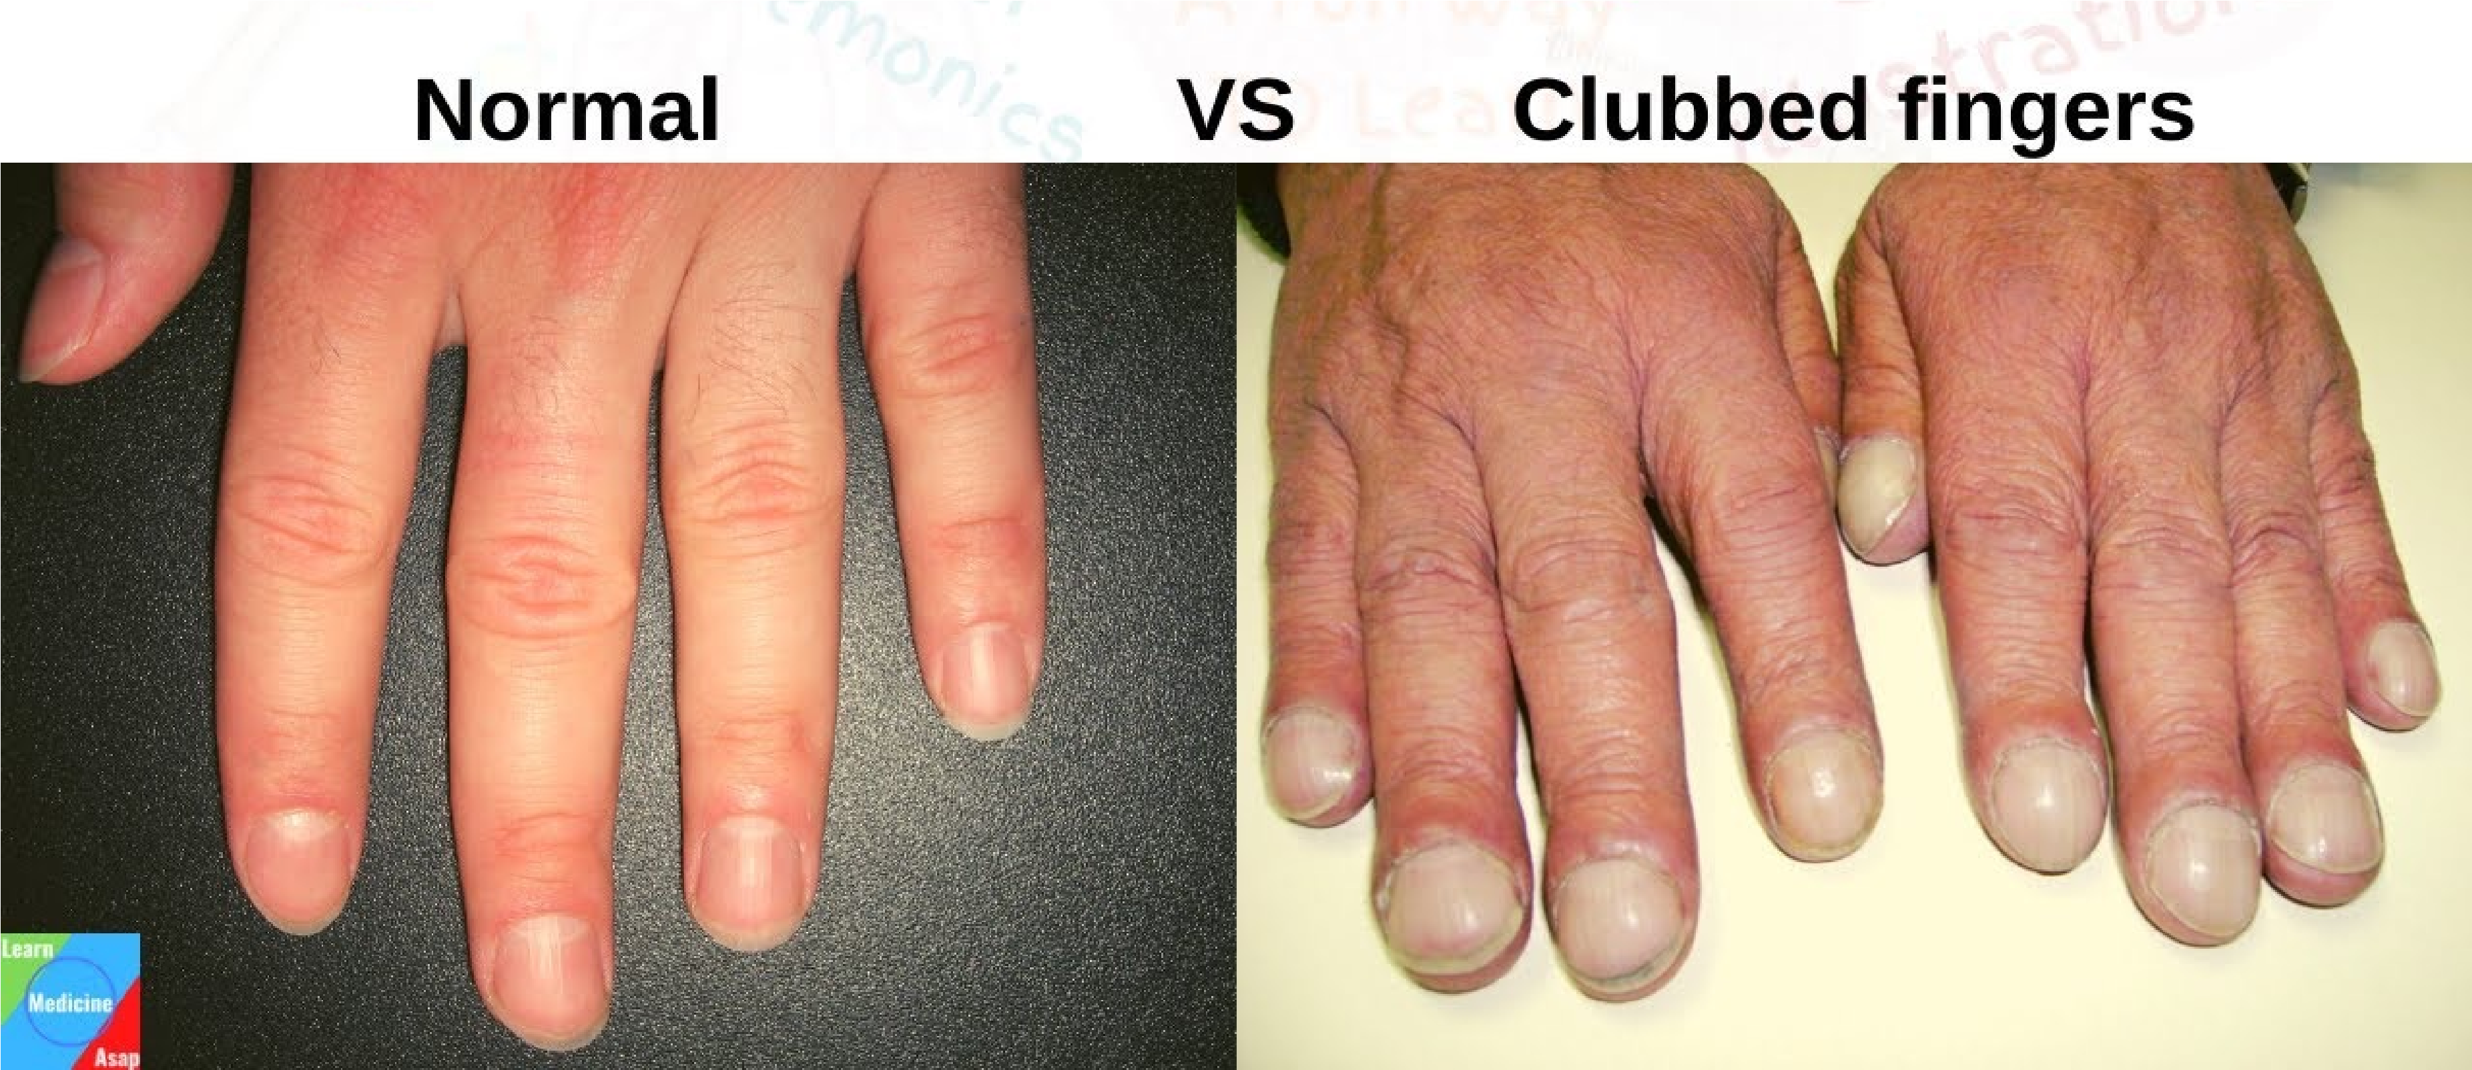

Diagnostic Studies of Respiratory System
- Sputum examination
- Chest X-ray
- Skin Test: to test for allergic reactions or exposure to TB bacilli or fungi.
- Computed Tomography (CT Scan)
- Magnetic Resonance Imaging ( MRI )
- Oximetry: Normal SpO2 = 95% - 100%
- Bronchoscopy
- Biopsy of the Lungs
- Arterial Blood Gases (ABGs)
- Pulmonary Function Tests: measure lung volumes and airflow.
- Pulmonary Angiography: Used to visualize pulmonary blood vessels and locate obstruction or pathologic conditions (e.g., pulmonary embolus).
- Thoracentesis: It is the insertion of a large-bore needle through the chest wall into the pleural space to obtain specimens for diagnostic evaluation.

