Drugs for Angina Pectoris
- Angina Pectoris is defines as sudden pain beneath the sternum, often radiating to the left shoulder and arm.
- Anginal pain is precipitated when the oxygen supply to the heart is insufficient to meet oxygen demand.
Most often, angina occurs secondly to atherosclerosis of the coronary arteries.
Drugs for Angina Pectoris
- Drug therapy of angina has two goals:
- Prevention of myocardial infarction (MI) and death and
- Prevention of myocardial ischemia and anginal pain.
- Two types of drugs are used to decrease the risk of MI and death: cholesterol-lowering drugs and antiplatelet drugs.
Our focus is on antianginal agents: organic nitrates (e.g., nitroglycerin), beta blockers (e.g., propranolol), and calcium channel blockers are discussed at length in precious chapters; hence, consideration here is limited to their use in angina.
Organic Nitrates
- The organic nitrates are the oldest and most frequently used antianginal drugs.
- These agents relieve angina by causing vasodilation.
- Nitroglycerin, the most familiar organic nitrate, will serve as our prototype for the family.
Nitroglycerin has been used to treat angina since 1879.
This drug is effective, fast acting and inexpensive.
Despite the availability of newer antianginal agents, Nitroglycerin remains the drug of choice for relieving acute anginal attacks.

Vasodilation Actions
Nitroglycerin acts directly on vascular smooth muscle (VSM) to promote vasodilation.
At usual therapeutic doses, the drug acts primarily on veins; dilation of arterioles is only modest.
The process begins with uptake of nitrate by VSM, followed by conversion of nitrate to its active form: nitric oxide .
As indicated, this conversion requires the presence of sulfhydryl groups.
Nitric oxide activates guanylate cyclase, an enzyme that catalyzes the formation of cyclic GMP.
Through a series of reactions, cyclic GMP decreases intracellulae calcium levels.
Since calcium is required for VSM contraction, the reduction in calcium results in vasodilation.
For our purpose, the most important aspect of this sequence is the conversion of nitrate to its active form- nitric oxide- in the presence of a sulfhydryl source.
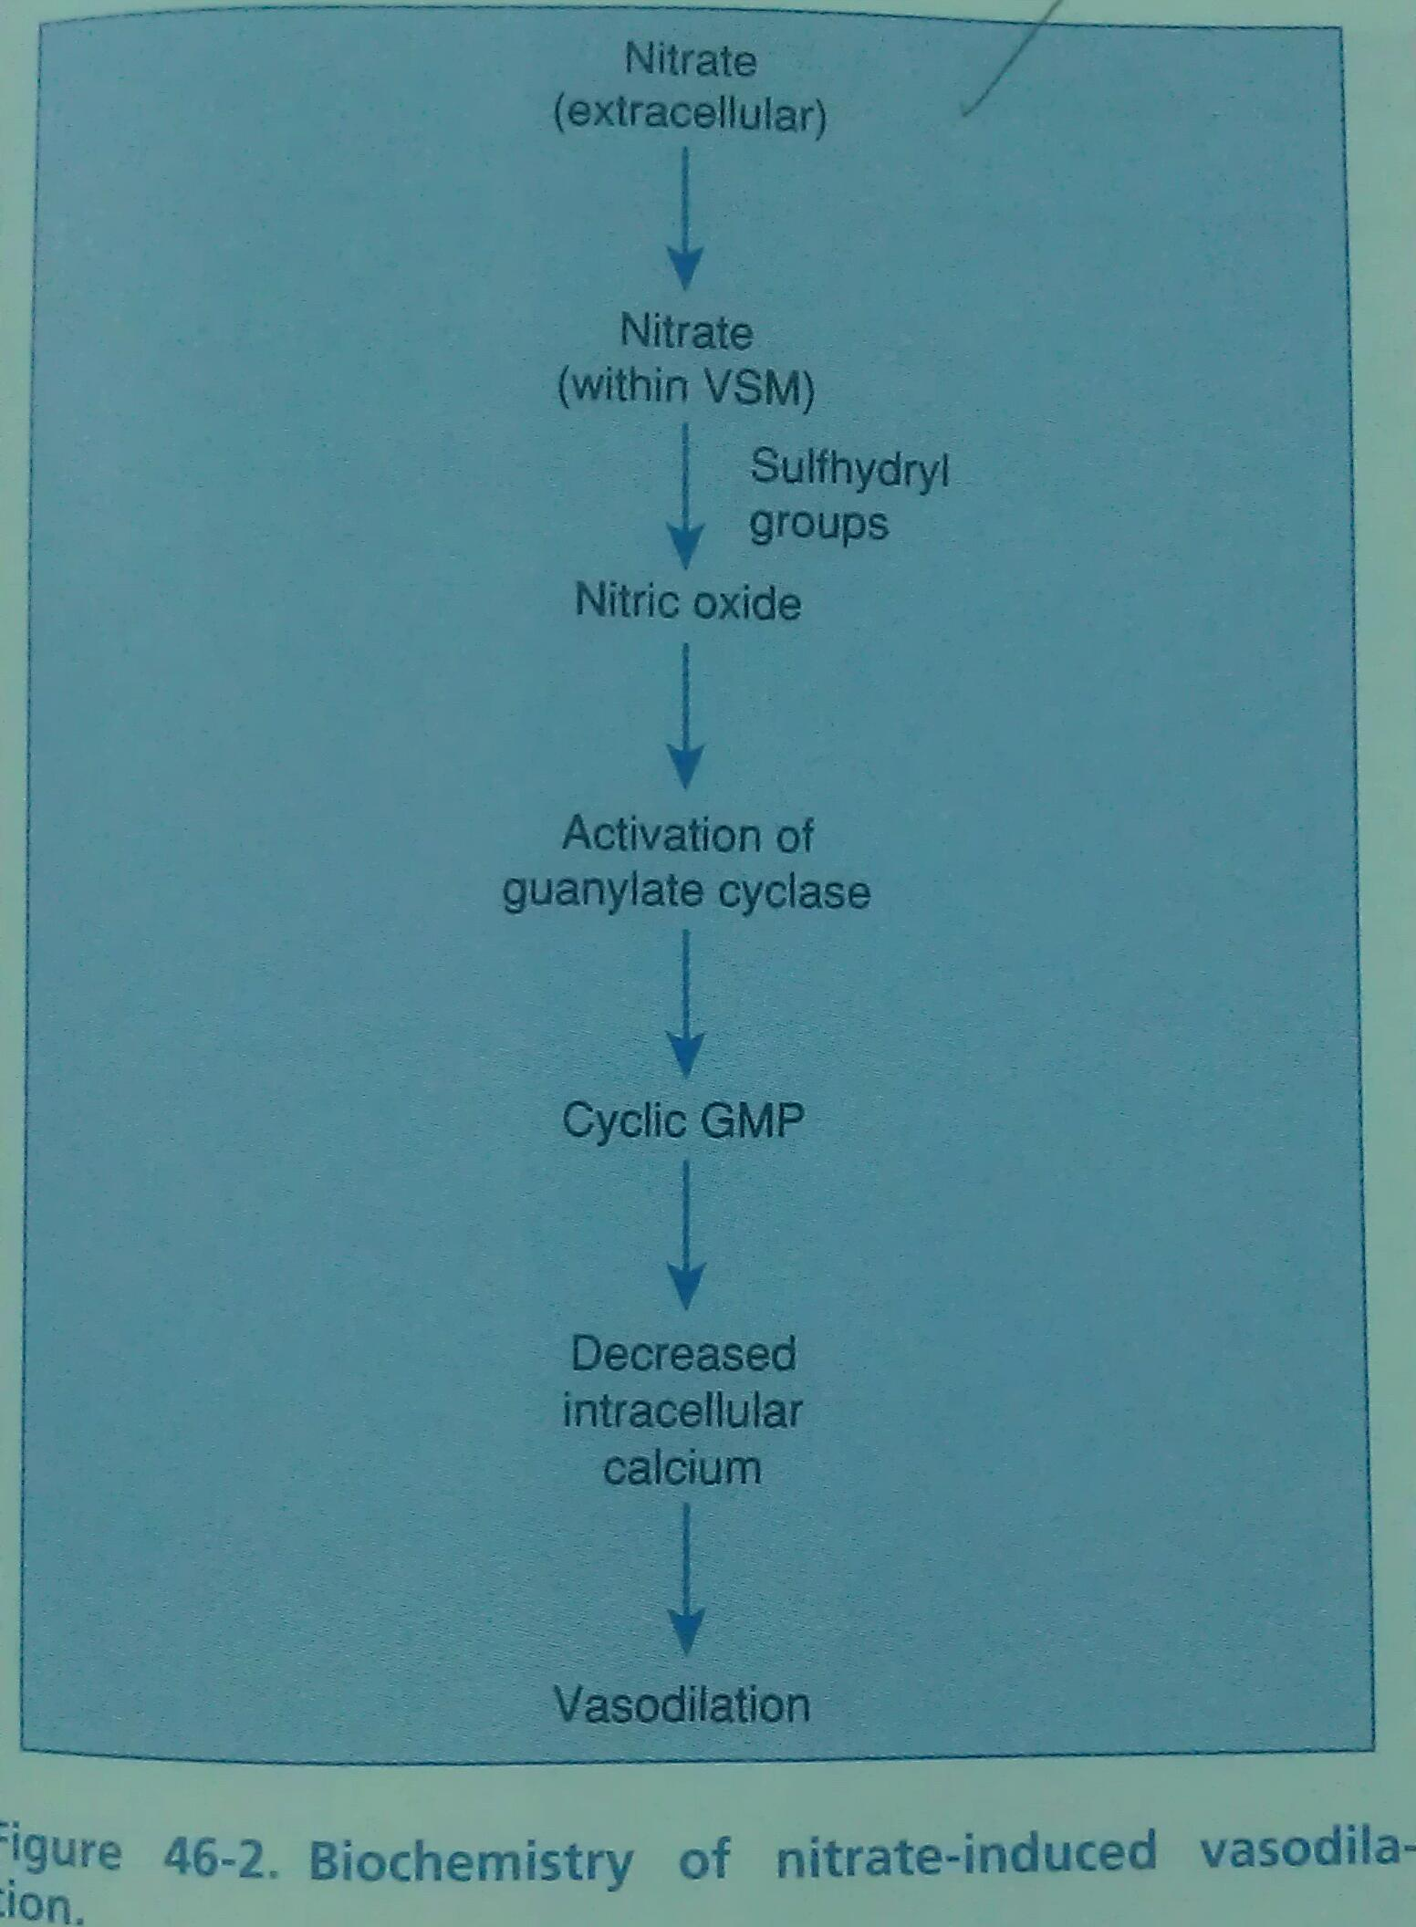

Adverse Effects
Headache
Orthostatic Hypotension
Reflex Tachycardia
Drug Interactions
Hypotensive Drugs
Beta Blockers, Verapamil, and Diltiazem
Sildenafil
Other Organic Nitrates
Isosorbide Dinitrate, Isodorbide Mononitrate, Erythrityl Tetranitrate, Pentaerythritol Tetranitrate
All of these nitrates have pharmacologic actions identical to those of nitroglycerin.
All are used for angina, all are taken orally, and all produce headache, hypertension, and reflex tachycardia.
Differences among them relate only to route of administration and time course of action.

