What is a mutation?
A mutation is any change in the DNA sequence. Mutations can lead to genetic disorders or disease. Most mutations are recognised because the phenotype, that is the characteristics displayed by an organism, have changed. There are many different types of mutation .

Germinal and Somatic Mutations
Eukaryotic organisms have two primary cell types --- germ and somatic. Mutations can occur in either cell type. If a gene is altered in a germ cell, the mutation is termed a germinal mutation. Because germ cells give rise to gametes, some gamete s will carry the mutation and it will be passed on to the next generation when the individual successfully mates. Typically germinal mutations are not expressed in the individual containing the mutation
Somatic cells give rise to all non-germline tissues. Mutations in somatic cells are called somatic mutations. Because they do not occur in cells that give rise to gametes, the mutation is not passed along to the next generation by sexual means.
- According to origine
- 2 types of mutations:
1-Spontaneous Mutations: Some mutations arise as natural errors in DNA replication (or as a result of unknown chemical reactions); these are known as spontaneous mutations
  - occur in the natural environment without the addition of mutagens (agents that cause mutations)
  - Occur randomly and spontaneously
  - (without any known causal factors),
- Most common type of substitution
- Mistake during DNA replication, incorrect base incorporated into
DNA
four types:
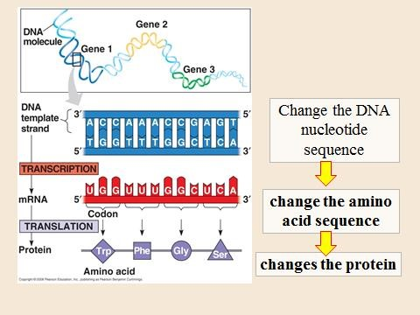

Single base substitutions
A single nucleotide base becomes replaced by another. These single base changes are also called point mutations. If a purine (a, t) replaces a purine or a pyrimidine (c, g) replaces a pyrimidine, it is called a transition. If a purine replaces a pyrimidine or vice-versa, the substitution is called a transversion.
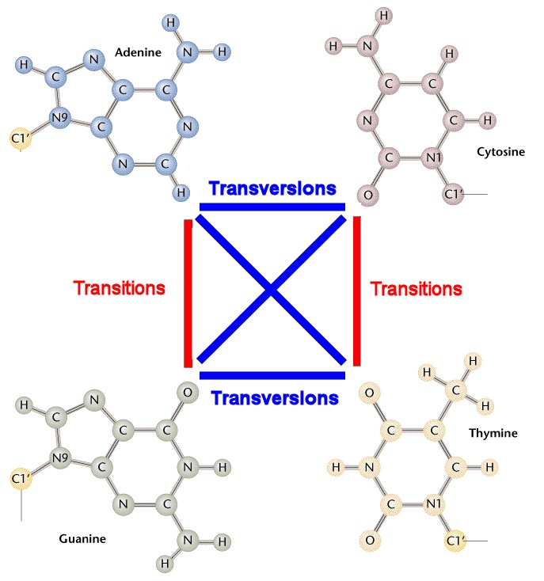
- Missense mutations - In a missense mutation, the new base alters a codon resulting in a different amino acid being incorporated into the protein chain. This is what happens in sickle cell anaemia. The 17th nucleotide of the gene for the beta chain of haemoglobin is changed from an 'a' to a 't'. This changes the codon from 'gag' to 'gtg' resulting in the 6th amino acid of the chain being changed from glutamic acid to valine. This apparently trivial alteration to the beta globin gene alters the quaternary structure of haemoglobin, which has a profound influence on the physiology and wellbeing of the individual.
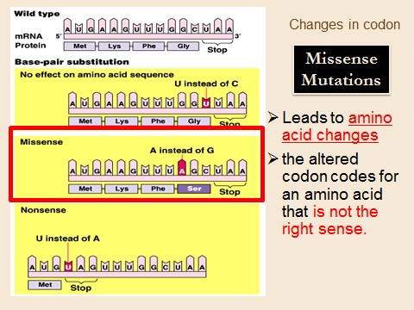

Nonsense mutations - In a nonsense mutation, the new base changes a codon that specified an amino acid into one of the stop codons (taa, tag, tga). This will cause translation of the mRNA to stop prematurely and a truncated protein to be produced. This truncated protein will be unlikely to function correctly. Nonsense mutations occur in between 15% to 30% of all inherited diseases including, haemophilia, and duchenne muscular dystrophy.
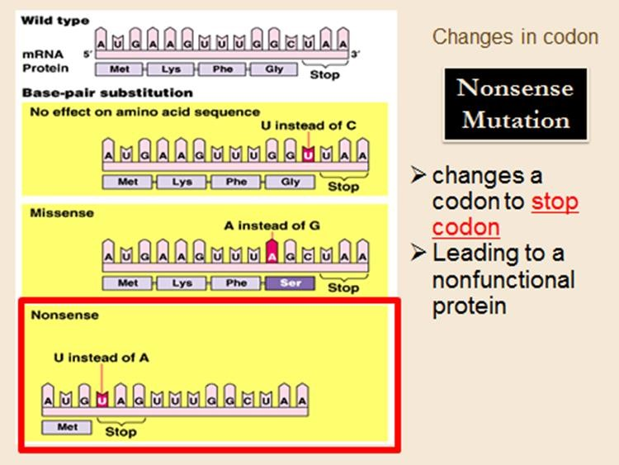
- Silent mutations - Silent mutations are those that cause no change in the final protein product and can only be detected by sequencing the gene. Most amino acids that make up a protein are encoded by several different codons. So, if for example, the third base in the 'cag' codon is changed to an 'a' to give 'caa', a glutamine (Q) would still be incorporated into the protein product, because the mutated codon still codes for the same amino acid. These types of mutations are 'silent' and have no detrimental effect.
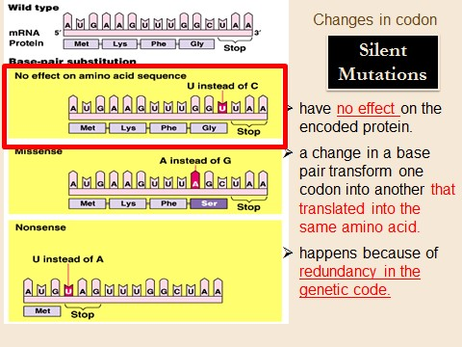

Insertions and deletions

Extra base pairs may be added or deleted from the DNA of a gene. The number of bases can range from a few to thousands. Insertions and deletions of one or two bases or multiples of one or two cause frameshifts (shift the reading frame). These can have devastating effects because the mRNA is translated in new groups of three nucleotides and the protein being produced may be useless.

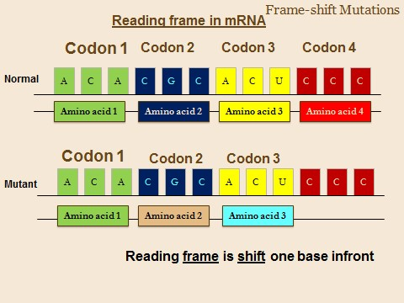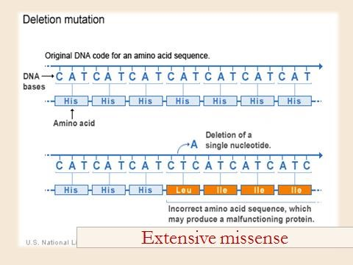

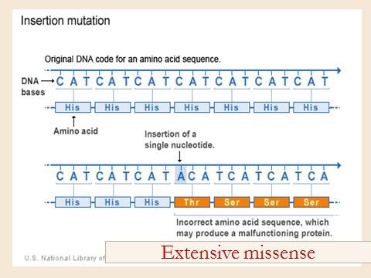

2-Induced mutation
Induced mutations on the molecular level can be caused by:
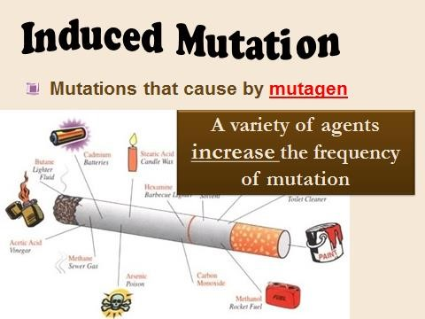

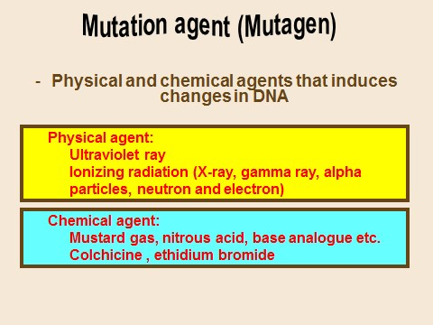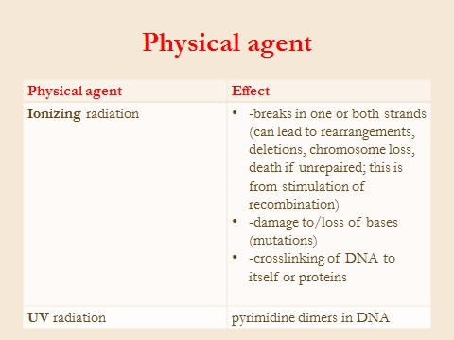

Radiation •
Ultraviolet radiation (nonionizing radiation). Two nucleotide bases in DNA – cytosine and thymine – are most vulnerable to radiation that can change their properties. UV light can induce adjacent pyrimidine bases in a DNA strand to become covalently joined as a pyrimidine dimer
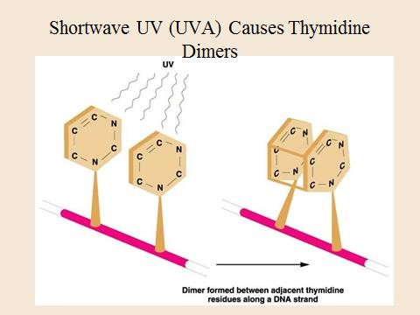
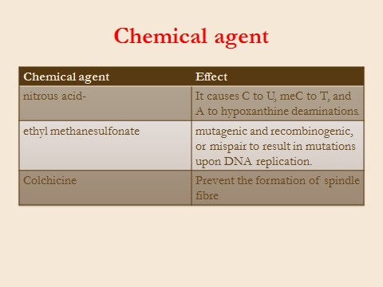
•
•

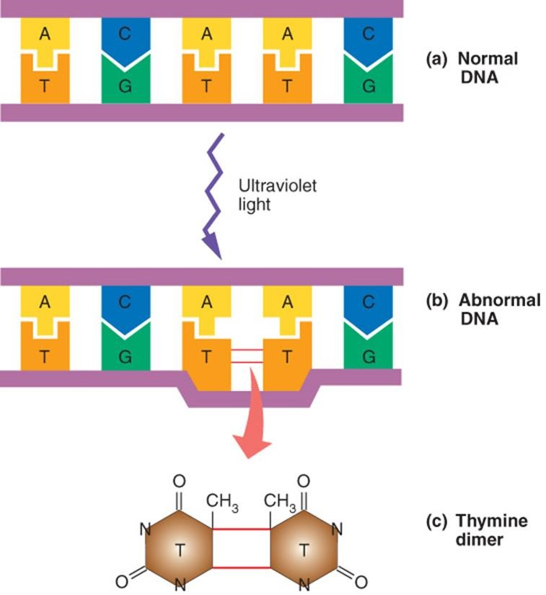

chromosomal aberrations or chromosomal mutations

Definition:
• Abnormalities ~ in chromosomal structure (chromosome aberration) & changes in chromosome number (aneuploidy / euploidy)
.
The changes in the genome involving a chromosome or part of a chromosome are called as chromosomal aberrations or chromosomal mutations. Mutation are observed in all organisms from bacteria to man and arise all of a sudden. They may be dominant or recessive, sex-linked or autosomal, germinal or somatic, lethal or non-lethal possibly because they disturb the genic balance
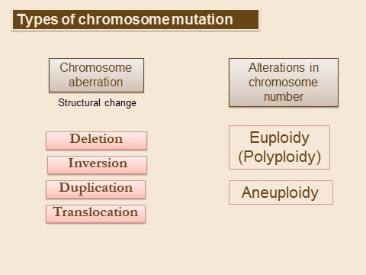

They are heritable changes and are of following types-
- Changes in structure of chromosomes
  - Change in number of genes (Addition or Deletion)
  - Rearrangement of genes (Inversion or Translocation)
- Changes in number of chromosomes
  - Change in number of part of chromosome set (Aneuploidy)
  - Change in number of entire chromosome set (Haploidy or Polyploidy)

STRUCTURAL CHANGES IN CHROMOSOMES
The structural changes in chromosomes which appear phenotypically are known as chromosomal mutations or aberrations.

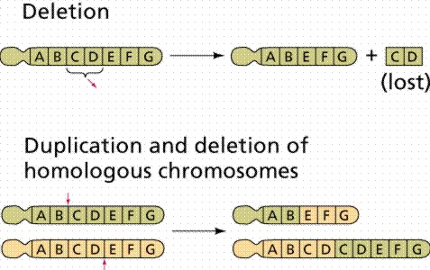
1. Deficiency or Deletion. It involves the loss or absence of a part of chromosome involving one or more genes. Genic balance is usually disturbed and this affects the phenotype. If deletion occurs in the chromosome of gametes, it will be transmitted to the next generation. Deletion can be terminal or intercalary. Terminal deletion involves loss of chromosome segment from its one end. Due to this, one of the paired chromosome appears to be longer than the other. Intercalary deletion involves loss of intermediate chromosome segment. Due to this, the normal chromosome forms a loop near the deleted region of its homologue as only identical regions pair with each other. An interesting example of deletion in humans is Cri du chat syndrome, where the short arm of chromosome 5, i.e. 5p (p means short arm; q is long arm) is deleted. Individuals having this syndrome have a distinctive cat-like cry, are mentally retarded, moon face, low set ears and small head (microcephally).

Fig.7.1. Effect of deletion and duplication on a
chromosome. In the second diagram, CD genes
are
deleted from one chromosome and are
inserted into another, causing its duplication.

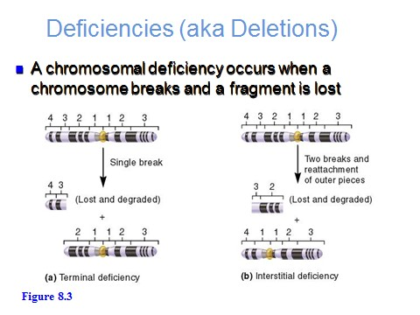

  - Deletion generally produce striking genetic and physiological effects.
  - When homozygous, most deletions are lethal, because most genes are necessary for life and a homozygous deletion would have zero copies of some genes.
  - When heterozygous, the genes on the normal homologue are hemizygous: there is only 1 copy of those genes.
  - Crossing over is absent in deleted region of a chromosome since this region is present in only one copy in deletion heterozygotes.
  - 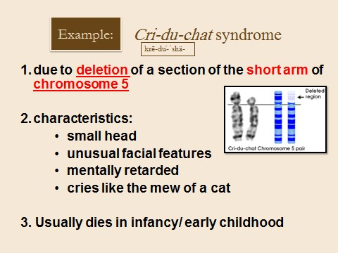
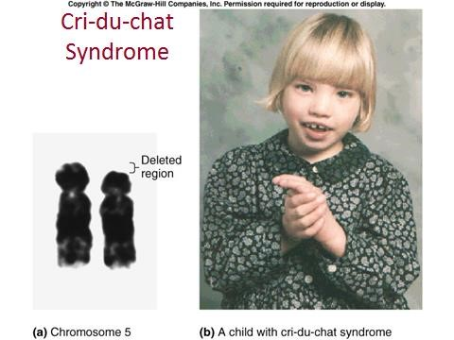

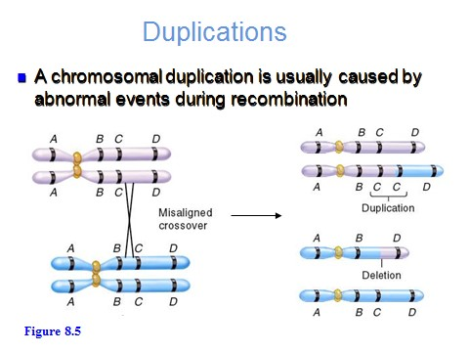

- Duplication. The presence of a part of a chromosome in excess of the normal complement is known as duplication. A broken part of chromosome attaches itself to a normal homologus chromosome or non- homologus chromosome. Thus, due to duplication some genes are present in a cell in more than two doses. The effects of duplications are generally less harmful than those of deletions. Depending upon the mode of joining of the duplicated region to a chromosome, duplication can be of following types:
  - Tandem. Here the duplicated region is situated just side by side of the normal corresponding section of the normal chromosome and the sequence of genes are the same in the normal and duplicated regions. e.g.: if the normal chromosome has gene sequence ABCD•EFGH (the point shows the position of centromere), the gene sequence in tandem duplication will be
ABCDBCD•EFGH.
  - Reverse. In this case, the sequence of genes in the duplicated section of a chromosome is just the reverse of the normal sequence. e.g.: if the normal chromosome has gene sequence ABCD•EFGH, the gene sequence in reverse duplication will be ABCDDCB•EFGH.
  - Displaced. Here, the duplicated section is situated adjacent to the normal, but elsewhere in the chromosome.
  - The additional chromosome segment is located in a non-homologous chromosome is translocation duplication

- Translocation. It involves the transfer of a chromosome section or a set of genes to a non-homologus chromosome. It results in the change in sequence and position of genes (rearrangement) but not in their number (no addition or deletion).
e.g.: if the original chromosomes were ABCD•EFGH and PQRS•TUVW, the new ones may be ABCD•EUVW and PQRS•TFGH. Translocation are of following types:
- Simple. This involves a single break in a chromosome and the broken part gets attached to one end (terminal) of a non-homologus chromosome. e.g.:
ABC•DEF C•DEF
MN•OPQ ABMN•OPQ

- Reciprocal. In this case, there is an exchange of chromosome part between two non-homologus chromosomes, so that two translocation chromosomes are formed
simultaneously. This is the most frequent type of translocation, and is of two typeshomozygotic, in which both the homologus chromosomes are involved and heterozygotic, in which only one chromosome of a pair of homologus chromosomes is involved. In humans, Philadelphia chromosome is an example of translocation, occurring between 22q and 9q (long arm) characterized by chronic myelocytic leukemia, a kind of cancer. e.g.:
ABC•DEF MNC•DEF
MNO•PQR ABO•PQR

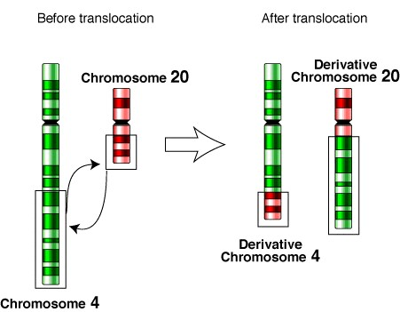

- Robertsonian. It also involves the exchange of chromosome segments between two non-homologus chromosomes, but in this case, whole arm of a chromosome is transferred to the other chromosome. In humans, they are the most common structurally abnormal chromosomes. e.g.:
ABC•DEF MNO•DEF

MNO•PQR ABC•PQR

Another frequently observed anomaly (1:1'000 newborns) is the robertsonian translocation, which occurs between two acrocentric chromosomes of groups G and D. It is also referred to as the centric fusion of two acrocentric chromosomes. It is a special kind of translocation in that on the acrocentric chromosomes (most often chromosomes 14 and 21 or 22) the very short, satellite-bearing arm is lost and a centric fusion t(14q21q or 14q22q) of the two remainder chromosomes, i.e., the long arms of the two pieces, results.

robertsonian translocations are phenotypically
inconspicuous. Also here, though, problems arise when it comes to gamete formation because, normally, the diploid chromosome set is halved thereby. Since, however, in this translocation a chromosome has fused to another one, no ordered segregation can take place. The carrier has a larger probability of having offspring with trisomy/monosomy and this is independent of his age. Often a translocation (e.g., t[14q21q]) is found in families with inherited
trisomy 21

.

- Robertsonian translocation of acrocentric chromosomes
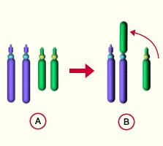
Fig. In a reciprocal translocation two acrocentric chromosomes
lose their short arms. Afterwards, the
remaining

- normales partial pieces
- Chromosomenpaar (q- arms) fuse centric fusion of two to one another.
non-homologous chromosomes

- Ring formation
Ends (telomeres) of

Asst. Prof. Dr. Kazhal M. Sulaiman
chromosomes sometimes break off and are lost. In
this case the formation of chromosome rings can
take place in that the two ends bind to one another

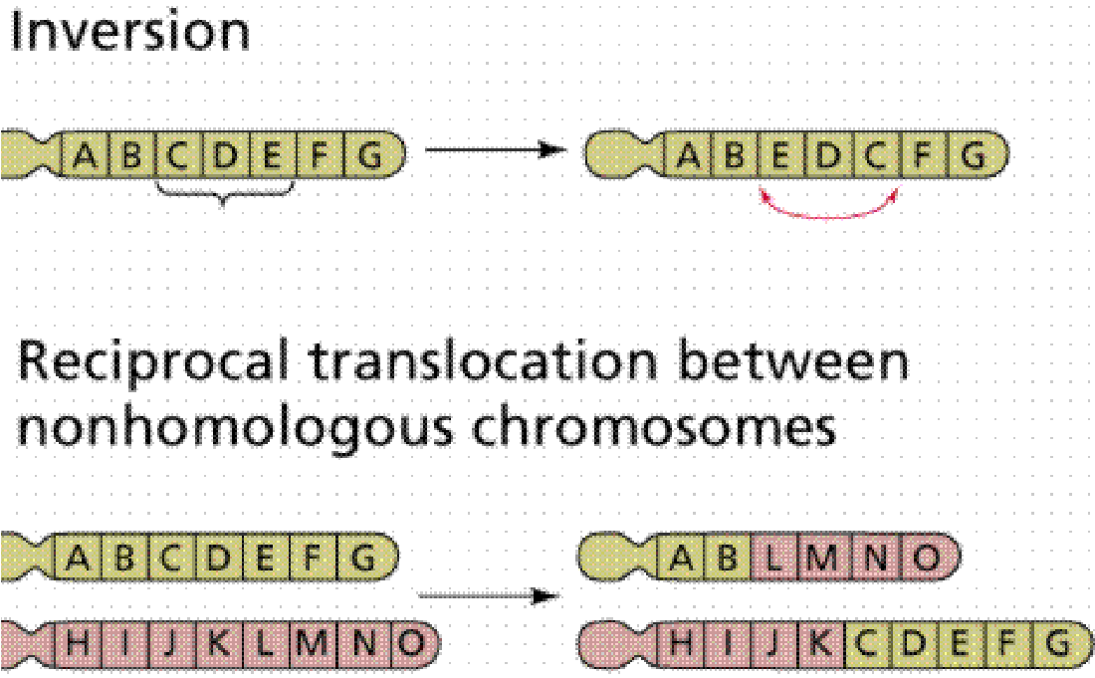
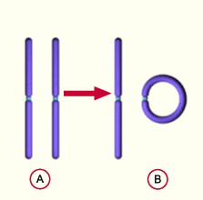
4. Inversion. It involves rotation of a part

Fig.. Effect of inversion and
translocation on a

of
are
a
chromosome or a set of genes by 180˚ on its own axis. Breakage and reunion
essential for inversion. The net effect is neither a gain nor a loss in the genetic material but simply a rearrangement of the gene sequence. e.g.: chromosome having a gene sequence ABCDEF will have a gene sequence of ABEDCF after inversion. Inversions are of two types on the basis of centromere in relation to the inverted segment.
- Paracentric. In this type the inverted segment does not include the centromere, i.e., the centromere is located outside the inversion loop. e.g.: if the normal gene sequence is ABCD•EFGH, the sequence in paracentric inversion will be ABCD•EGFH. Paracentric inversions are very rare because it is less probable for two breaks to be in the same arm. Further they are difficult to detect, since they do not change the length of chromosome.
- Pericentric. Here, centromere is involved or located in the inversion loop. e.g.: if the normal gene sequence is ABCD•EFGH, the sequence in pericentric inversion will be ABFE• DCGH.

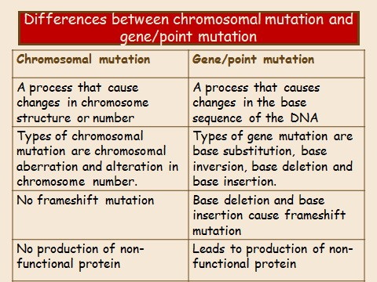

NUMERICAL CHANGES IN CHROMOSOMES

NUMERICAL CHANGES IN CHROMOSOMES are also referred as genomic mutations because they involve variations in chromosome number of a whole genome. The number of chromosome may change in two ways, either the number of sets of chromosomes increases resulting in polyploidy or decreases leading to haploidy (does not occur in man), or the number of individual normal chromosomes changes giving rise to aneuploidy. The only types of polyploidy found in man are triploidy (3n) and tetraploidy (4n) and majority of these cases end up as spontaneous abortions. The only known autosomal monosomy is the extreme rare 21 monosomy, and of the trisomics only 3, those for chromosomes 13, 18, 21.

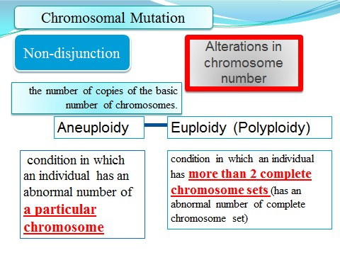

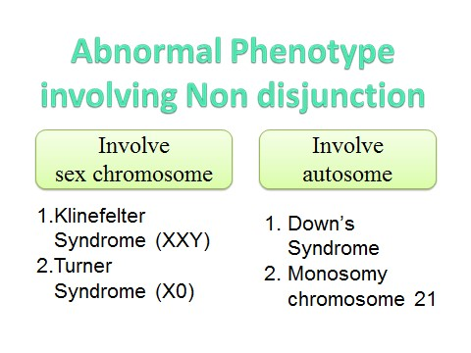

Variation In Chromosome Number
Non-Disjunction
Generally during gametogenesis the homologous chromosomes of each pair separate out (disjunction) and are equally distributed in the daughter cells.
But sometime there is an unequal distribution of chromosomes in the daughter cells.
The failure of separation of homologous chromosome is called nondisjunction.
This can occur either during mitosis or meiosis or embryogenesis.

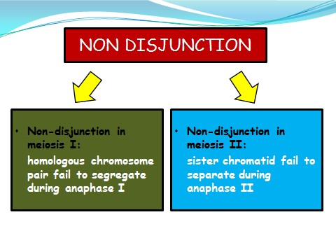

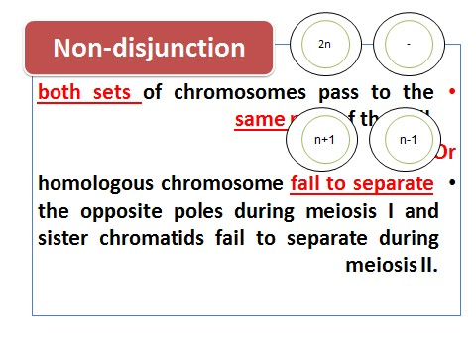
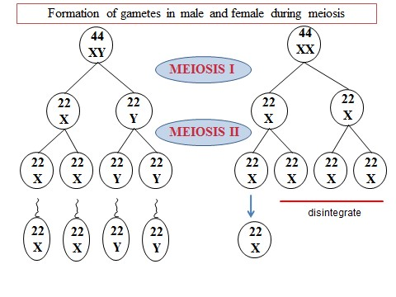

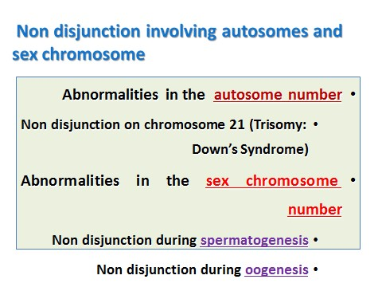

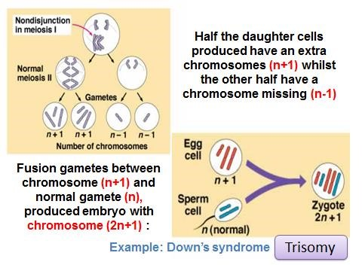

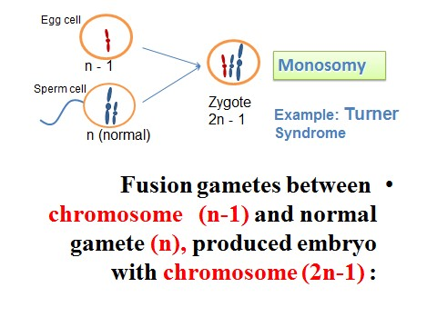

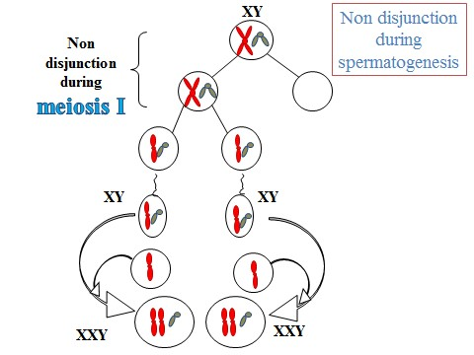

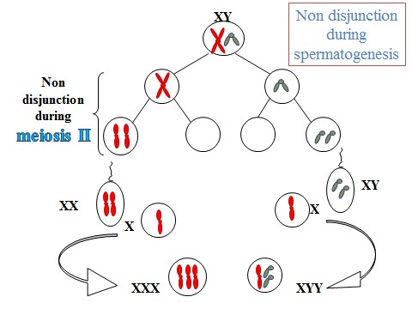

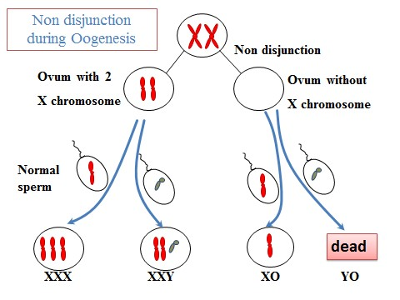

Human aneuploidies

1. Aneuploidy. Aneuploidy is either due to the loss of one or more chromosomes (hypoploidy) or due to addition of one or more chromosomes (hyperploidy). In both the cases, the variation involves one or a few chromosomes but not the entire set. Aneuploids are probably produced by non-disjunction of chromosomes, during mitosis or meiosis. It is of following types:
- Monosomy. It represents the loss of a single chromosome from the diploid set, having the genomic formula 2n-1. Since, there is lack of one complete chromosome, such aberrations create major mortality or reduced fertility.
- Nullisomy. It is due to the loss of a single pair of homologus chromosome and have the chromosome complement 2n-2. It should not be confused with double monosomy (2n-1-1) where the missing chromosomes are also two in number, but they are non-homologus as in wheat.
- Trisomy. Here, the organisms have an extra chromosome (2n+1). It is commonly found in humans and is responsible for following three syndromes:
- 13 Trisomy (Patau’s syndrome). Most of the 13-trisomic zygote end up as spontaneous abortions. Individuals with Patau’s syndrome are severely mentally retarded and are often deaf. Various degrees of forebrain defect are common. Eye anomalies range from anopthalmia (absence of eyes) to micropthalmia (small eyes). Poldactyly is almost always present. Increased maternal age is a factor of trisomy.

- 21 Trisomy (Down’s syndrome, Mongolism). This is a least severe condition of autosomal trisomy, but most frequent. The affected individuals are mentally retarded, large swollen and protruding tongue, short posture, small and underdeveloped ears, enlarged liver and spleen. In 21 trisomics, the probability of developing leukemia is increased 20 fold. Women above 45 years of age are likely to give birth to a child with
Down’s syndrome. Women having hepatitis prior to pregnancy have 3 times more chances to give birth to a Down’s syndrome infant.

•
- 18 Trisomy (Edward’s syndrome). Because of their severe failure to survive, 18 trisomics have many high abnormalities and death usually occurs within hours or days, but most of the cases end up as spontaneous abortions. They are characterized by severe mental retardation, low set ears, cardiac malformation and is more common in females. It is also related to maternal age.

Most of the human aneuploidies that come to term involve the sex chromosomes. These are more viable than autosomal aneuploidies because:
- The Y chromosome has relatively few genes.
- There are dosage compensation mechanisms in place for the X chromosome.
Known aneuploidies
- Turner syndrome (45,X or X0)
- Klinefelter syndrome (47,XXY)
- Jacobs syndrome (47,XYY)
- Down syndrome (47,+21 or Trisomy 21)
- Patau syndrome (47,+13 or Trisomy 13)
- Edwards syndrome (47,+18 or Trisomy 18)
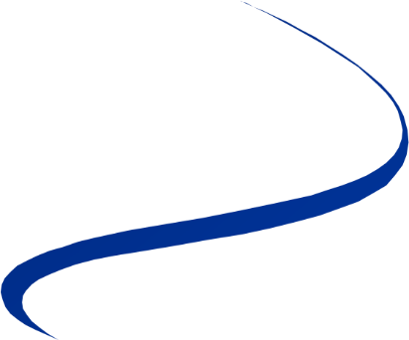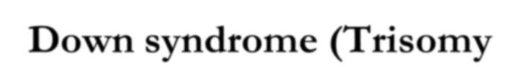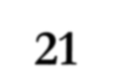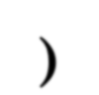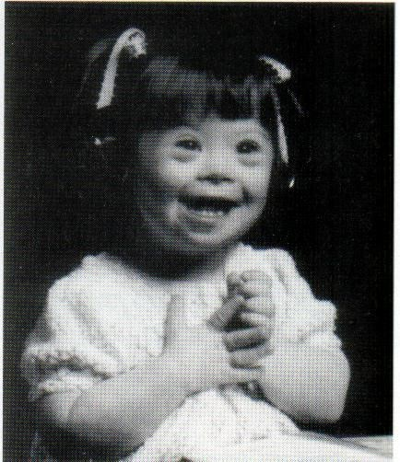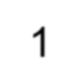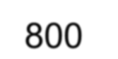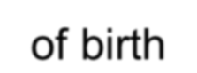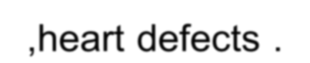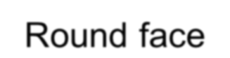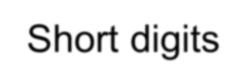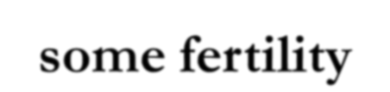
Down syndrome (Trisomy
21
)
➢
1
:
800

of birth
➢
Mental deficiency
,heart defects .
➢
Round face
➢
Short digits
➢
some fertility

Trisomy 18; Edward Syndrome
47; +18
1/8000 live births; maternal age affect low birth weight multiple dysmorphic features
chin, ears, single palmar crease, clenched hands malformations of the brain, heart, kidneys, and other organs rarely survive beyond 1 ye

Trisomy 13; Patau Syndrome
47; + 13
1/20,000 live births; maternal age effect multiple dysmorphic features
micropthalmia, cleft palate, clenched fists, polydactyly, ears and scalp abnormal… heart defects; systemic defects….
50% die in first month; rarely survive beyond 1 year
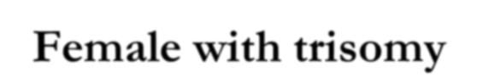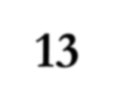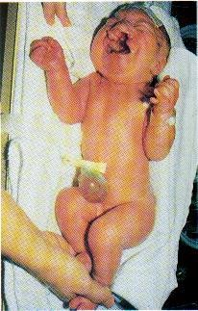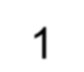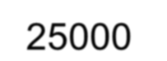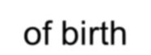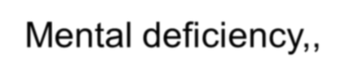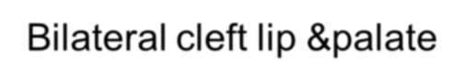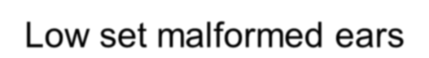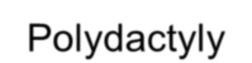
Female with trisomy
13
➢
1
:
25000

of birth
➢
Mental deficiency,,
Bilateral cleft lip &palate
➢
Low set malformed ears
➢
Polydactyly

47, XXY; Klinefelter Syndrome
1/500 live male births (?) often asymptomatic except for sterility, learning disabilities small testes; low testosterone levels poorly developed male 2º sexual charact. some female characteristics:
enlarged breasts, elongated limbs, increased incidence of “female” diseases: breast cancer, osteoporosis hormone therapy improves symptoms

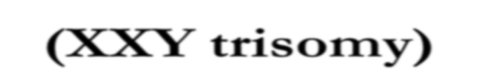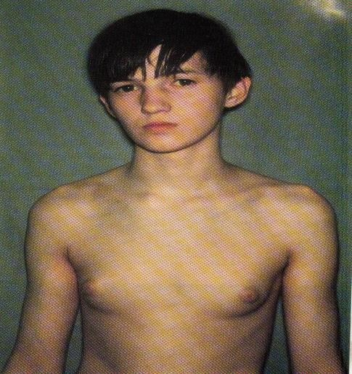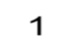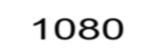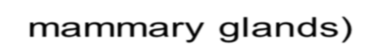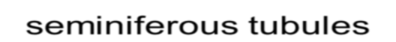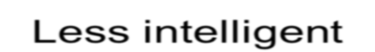
Young male with Klinefelter syndrome
(
XXY trisomy
)
➢
1
:
1080

of birth
➢
Presence of breasts
➢
Gynecomastia (excessive
development of male
mammary glands)
➢
Small testes
,aspermatogenesis due
to hyalinization of
seminiferous tubules
➢
Less intelligent

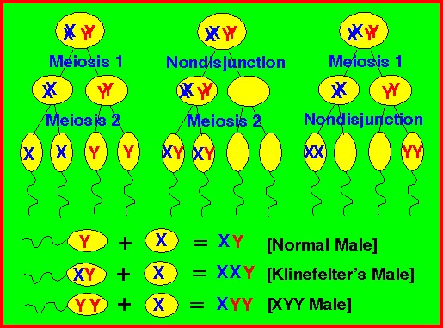

Genome Mutation or Polyploidy
Polyploidy is a change in the quantity of total genomes. This type of mutation affects chromosome content of an organism. Humans are diploid creatures; that is, for every chromosome in our body, there is another one to match it. If an organism possesses multiples of the haploid number of chromosomes, it is called euploid.
Human and other eukaryotes are diploid (2n). The following are the various types of euploids:
_ Haploid creatures have one of each chromosome.
_ Diploid creatures have two of each chromosome.
_ Triploid creatures have three of each chromosome.
_ Polyploid creatures have three or more of each chromosome.
They can be represented by ‘n’ where n equals haploid, 2n equals diploid, and so on. It is possible for a species, particularly a plant species, to produce offspring that contains more chromosomes than its parent. This can be a result of nondisjunction, where normally a diploid parent would produce diploid offspring, but in the case of non-disjunction, one of the parents produces a polyploid. In the case of triploid, although the creation of particular triploids in species is possible, they cannot reproduce themselves because of the inability to pair homologous chromosomes at meiosis, therefore preventing the formation of gametes. Polyploids have important applications in plant breeding and agriculture and are responsible for the creation of thousands of species in today’s planet, and will continue to do so. They are also responsible for increasing genetic diversity and producing species showing an increase in size, vigor, and increased resistance to disease.

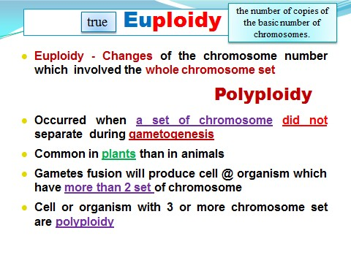

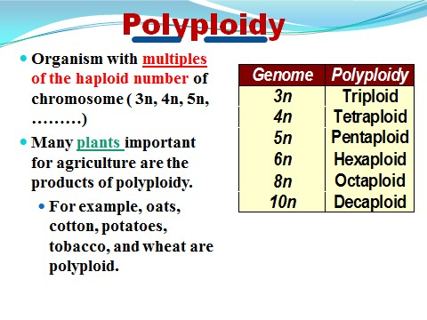

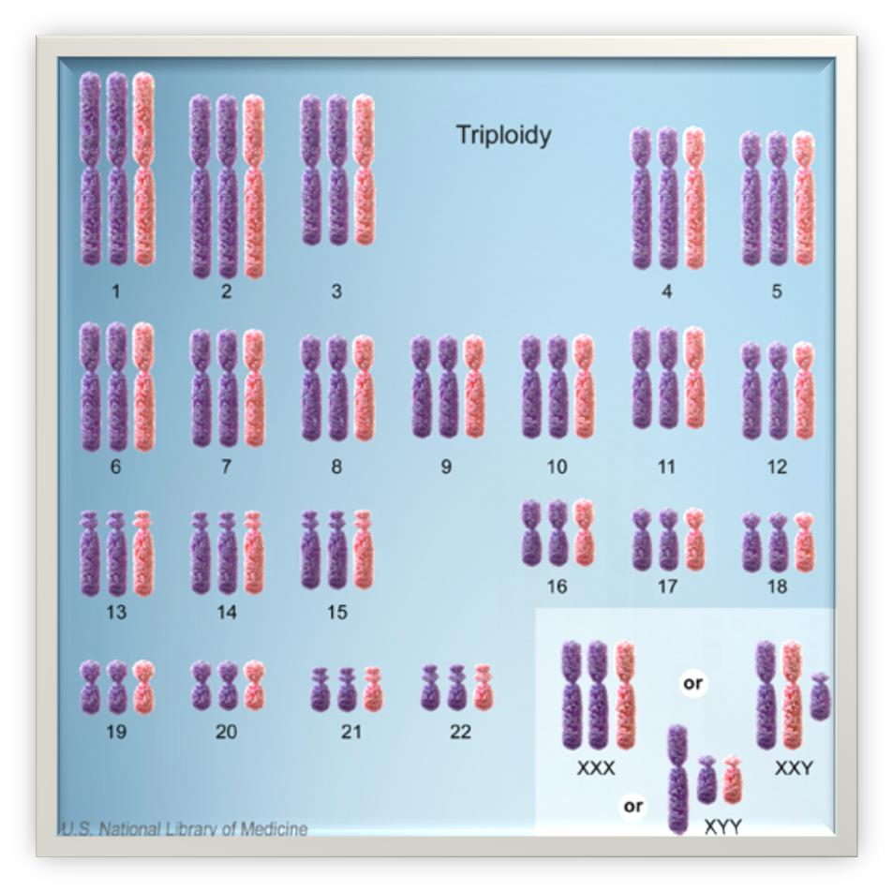

Autopolyploids arise due to doubling of 2n genome (diploids) to a 4n genome (autotetraploids). These are also very important in crop breeding as they increase the size of plant parts such as seeds, fruits, leaves, etc. The haploids can be converted into homozygous diploids with a process called diploidization, which uses chemical mutagenic agents such as colchicine. These homozygous diploids can be used as parents in

