What is a chromosome?

In the nucleus of each cell, the DNA molecule is packaged into thread-like structures called chromosomes. Each chromosome is made up of DNA tightly coiled many times around proteins called histones that support its structure.
Chromosomes are not visible in the cell’s nucleus—not even under a microscope— when the cell is not dividing. However, the DNA that makes up chromosomes becomes more tightly packed during cell division and is then visible under a microscope. Most of what researchers know about chromosomes was learned by observing chromosomes during cell division.
Each chromosome has a constriction point called the centromere, which divides the chromosome into two sections, or “arms.” The short arm of the chromosome is labeled the “p arm.” The long arm of the chromosome is labeled the “q arm.” The location of the centromere on each chromosome gives the chromosome its characteristic shape, and can be used to help describe the location of specific genes
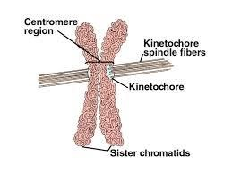
Structure
- For most of the life of the cell, chromosomes are too elongated and tenuous to be seen under a microscope.
- Before a cell gets ready to divide by mitosis, each chromosome is duplicated (during S phase of the cell cycle).
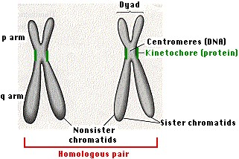
- As mitosis begins, the duplicated chromosomes condense into short (~ 5 µm) structures which can be stained and easily observed under the light microscope. • When first seen, the duplicates are held together at their centromeres. In humans, the centromere contains 1–10 million base pairs of DNA. Most of this is repetitive DNA: short sequences (e.g., 171 bp) repeated over and over in tandem arrays.
- While they are still attached, it is common to call the duplicated chromosomes sister chromatids.
- The kinetochore is a complex of >80 different proteins that forms at each centromere and serves as the attachment point for the spindle fibers that will separate the sister chromatids as mitosis proceeds into anaphase.
- The shorter of the two arms extending from the centromere is called the p arm; the longer is the q arm.
- Staining with the trypsin-giemsa method reveals a series of alternating light and dark bands called G bands.
- G bands are numbered and provide "addresses" for the assignment of gene loci.

Chromosome Numbers
- All animals have a characteristic number of chromosomes in their body cells called the diploid (or 2n) number.
- These occur as homologous pairs, one member of each pair having been acquired from the gamete of one of the two parents of the individual whose cells are being examined.
- The gametes contain the haploid number (n) of chromosomes.

Diploid numbers of some commonly studied organism
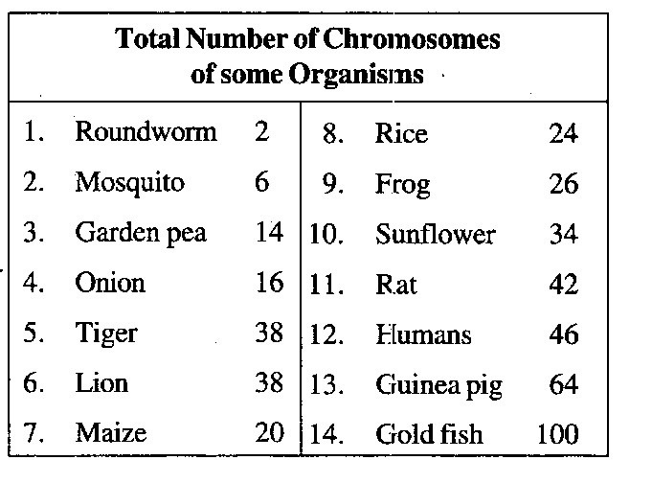
- The chromosomes bear genes which are composed of the DNA. Genes are responsible for the transmission of hereditary characteristics from one generation to another.
- Chromosomes control the synthesis of structural proteins and thus help in cell division, cell repair, cell growth and cell differentiation.
Chromosomes in eukaryotes and prokaryotes are different
PROKARYOTES | EUKARYOTES
single chromosome plus plasmids | many chromosomes
circular chromosome | linear chromosomes
made only of DNA | made of chromatin, a nucleoprotein (DNA coiled around histone proteins)
found in cytoplasm | found in a nucleus
copies its chromosome and divides immediately afterwards | copies chromosomes, then the cell grows, then goes through mitosis to organise chromosomes in two equal  groups

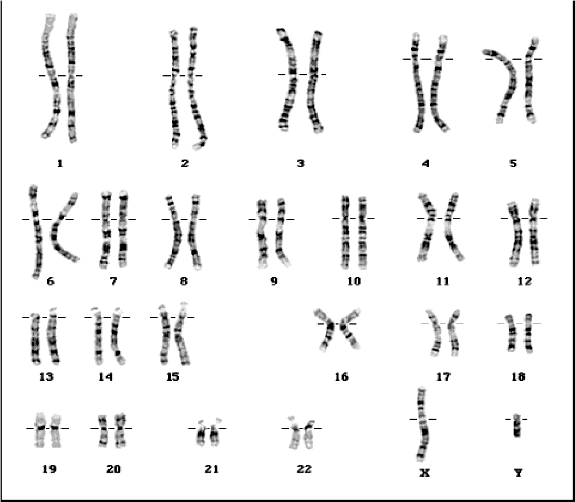
Sex Chromosomes and Autosomes

The human species has 23 pairs of chromosomes.
Out of the 23 pairs, a specific pair, the 23rd pair of chromosomes determines the sex of the individual. These are called the sex chromosomes.
All other chromosomes are called autosomes or autosomal chromosomes.
- The two members of each pair of chromosomes are alike, except one pair. The exception is the pair which determines sex, always referred to as the X chromosomes.
- The somatic cells of females always have a true pair XX (homomorphic).
The somatic cells of males have a pair of sex chromosomes which are not alike, XY (Y being much smaller than X, hence heteromorphic).
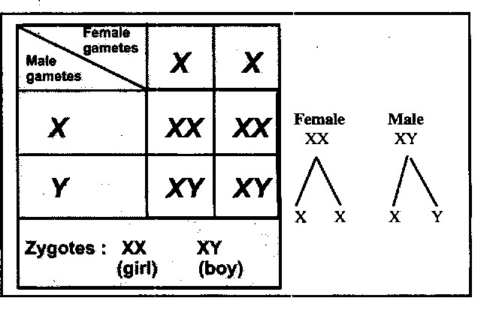
- As a result of meiosis, each reproductive cell gets only one sex chromosome.
- All the ova have the X chromosome.
- Half the sperm cells get X chromosomes while the other half gets Y.
4. During fertilization, there are equal chances that an ovum will be fertilization by an X-bearing sperm or a Y-bearing sperm. The resulting zygote has its sex determined at the moment of fertilization.
- If XX chromosomes are present, the child will be a girl.
- If XY chromosomes are present, the child will be a boy.
Each species has a specific number of chromosomes (Human somatic cells have 46)
Gametes (sperm and egg) contain half the number of chromosomes of somatic cells.
(Human gametes have 23 chromosomes)
The Structure of the Chromosome
The DNA is tightly wound and folded on a protein core. How tightly? Well, the DNA in a typical human cell has to fit inside a nucleus only 0.005 millimeter (.0002 of an inch) in diameter. If you could fully extend it, it would stretch to almost two meters, or around six feet.
This is when chromosomes become readily visible with staining. , different species have different numbers of chromosome pairs
In humans, there are 23 pairs. The first 22 pairs, called the autosomes,
are labeled according to length, longest to shortest, 1 through 22. The 23rd pair are the sex chromosomes—the X and Y chromosomes mentioned earlier.
The centromere, vital to the proper alignment of the chromosome pairs before cell division, divides the chromosome into two arms of varying lengths.
Its location varies from chromosome to chromosome. If it’s near the center, the chromosome will have two arms of almost equal length and is called metacentric. If it’s slightly off-center, one arm will be longer than the other, and the chromosome is submetacentric. If it’s greatly off-center, the size difference between the arms will be even greater, and the chromosome is called acrocentric. In those cases, the shorter arm is called the p arm and the longer arm is called the q arm. Finally, if the centromere is at or very near the end of the chromosome, the chromosome is called telocentric .
Chromosomes may differ in the position of the Centromere, the place on the chromosome where spindle fibers are attached during cell division.
In general, if the centromere is near the middle, the chromosome is metacentric
If the centromere is toward one end, the chromosome is acrocentric or submetacentric
If the centromere is very near the end, the chromosome is telocentric.
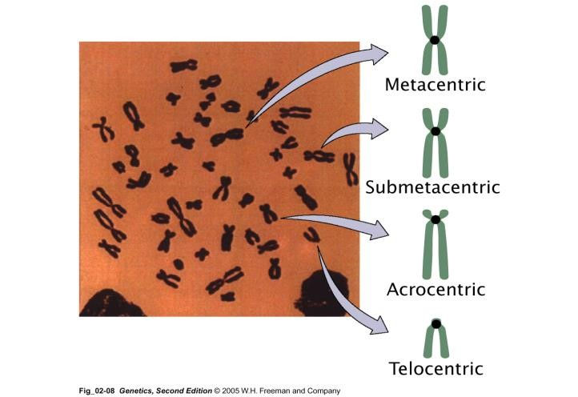

The centromere divides the chromosome into two arms, so that, for example, an acrocentric chromosome has one short and one long arm,
While, a metacentric chromosome has arms of equal length.
All house mouse chromosomes are telocentric, while human chromosomes include both metacentric and acrocentric, but no telocentric

Human chromosomes are divided into 7 groups & sex chromosomes
- A 1-3 Large metacentric 1,2 or submetacentric
- B 4,5 Large submetacentric, all similar
- C 6-12, X Medium sized, submetacentric - difficult
- D 13-15 medium-sized acrocentric plus satellites
- E 16-18 short metacentric 16 or submetacentric 17,18
- F 19-20 Short metacentrics
- G 21,22,Y Short acrocentrics with satellites. Y no satellites.

KARYOTYPE:
Karyotype: is the general morphology of the somatic chromosome. Generally, karyotypes represent by arranging in the descending order of size keeping their centromeres in a straight line.
Idiotype: the karyotype of a species may be represented diagrammatically, showing all the morphological features of the chromosome; such a diagram is known as Idiotype

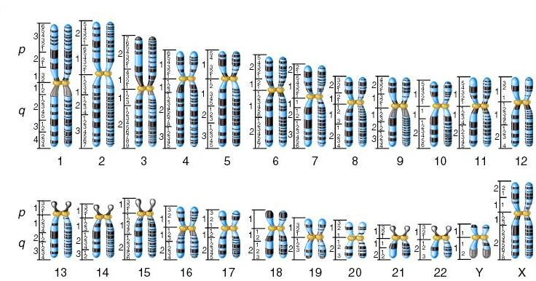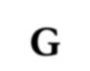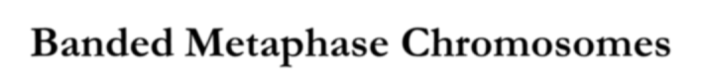
Figure
8
.
1
G
-
Banded Metaphase Chromosomes

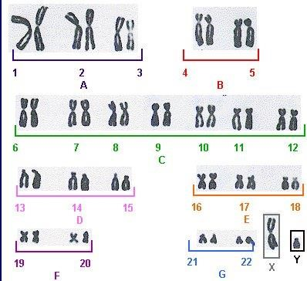
- 23 derived from each parent
- sex is determined by X and y chromosomes
- Males are XY
- Females are XX
- The sex of an offspring is determined by the sex chromosome carried in the sperm
Chromosomes are always arranged with the short arm on top
- Short arm is labeled P (French for petit) • Long arm is labeled Q.
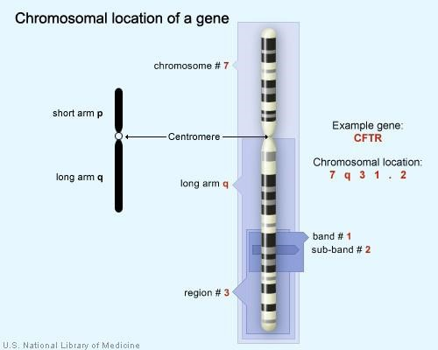

Chromosomes were first described by Strausberger in 1875.
The term “Chromosome”, however was first used by Waldeyer in 1888.
They were given the name chromosome (Chromo = colour; Soma = body) due to their marked affinity for basic dyes.
Their number can be counted easily only during mitotic metaphase.
Chromosomes are composed of thin chromatin threads called Chromatin fibers.
These fibers undergo folding, coiling and supercoiling during prophase so that the chromosomes become progressively thicker and smaller during metaphase.
Normally, all the individuals of a species have the same number of chromosomes.
Closely related species usually have similar chromosome numbers.
Presence of a whole sets of chromosomes is called euploidy.
Gametes normally contain only one set of chromosome – this number is called Haploid
Somatic cells usually contain two sets of chromosome - 2n : Diploid
The size of the chromosomes in mitotic phase of animal and plants sp generally varies between 0.5 µ and 32 µ in length, and between 0.2 µ and 3.0 µ in diameter.
In general, plants have longer chromosomes than animal and species having lower chromosome numbers have long chromosomes than those having higher chromosome numbers
Among plants, dicots in general, have a higher number of chromosome than monocots.
Chromosomes are longer in monocot than dicots.
Euchromatin and Heterochromatin
Chromosomes may be identified by regions that stain in a particular manner when treated with various chemicals.
Several different chemical techniques are used to identify certain chromosomal regions by staining then so that they form chromosomal bands.
For example, darker bands are generally found near the centromeres or on the ends (telomeres) of the chromosome, while other regions do not stain as strongly.
The position of the dark-staining are heterochromatic region or heterochromatin.
Light staining are euchromatic region or euchromatin.
Euchromatin
Chromatin or chromosomal regions that are lightly staining, and relatively uncoiled during the anaphase .
(1) Heterochromatin
- Highly condensed region of chromosome
- Mainly located around centromere and telomere region
- About 10% of interphase chromosome
- Most part of mammalian Y chromosome is heterochromic
- Heterochromatin formation of one X chromosome in female cells
-Permanent inactivation for dosage compensation
- Nongenic regionHeterochromatin is classified into two groups: (i) Constitutive and (ii) Facultative.
Constitutive heterochromatin remains permanently in the heterochromatic stage, i.e., it does not revert to the euchromatic stage.
In contrast, facultative heterochromatin consists of euchromatin that takes on the staining and compactness characteristics of heterochromatin during some phase of development.
Prokaryotic and Eukaryotic Chromosomes
Not only the genomes of eukaryotes are more complex than prokaryotes, but the DNA of eukaryotic cell is also organized differently from that of prokaryotic cells.
The genomes of prokaryotes are contained in single chromosomes, which are usually circular DNA molecules.
In contrast, the genomes of eukaryotes are composed of multiple chromosomes, each containing a linear molecular of DNA.
The DNA of eukaryotic cell is tightly bound to small basic proteins (histones) that package the DNA in an orderly way in the cell nucleus.
For e.g., the total extended length of DNA in a human cell is nearly 2 m.

The structure of the interphase chromosome

- Each interphase chromosome contains one DNA double helix. (Unless it has passed through S-phase and then it has two double helices, joined at the centromere region. At this stage one can say that each chromatid has one DNA double helix.)

- A large proportion of the protein in chromatin consists of the proteins called histones. There are 5 major histone molecules.

- The histone molecules are basic (positively charged) proteins, which is why they associate so well with the negatively charged double helix.

- It is the positively charged R-groups of lysine and arginine that are most responsible for making histone positively charged. Please know the structure of the amino acid lysine:

- In the early 1970s, electron microscopists showed (with isolated and thinly “spread” chromatin) that the primary structure of a eukaryotic chromosome appeared as “beads on a string
- The beads were given the term nucleosomes.

- Chromosomes are composed of essentially equal masses of DNA and protein. This combination of DNA and protein was called chromatin by the early microscopists because it stained the same color (chromo) as the chromosomes with various stainsThe major proteins of chromatin are the histones – small proteins containing a high proportion of basic amino acids (arginine and lysine) that facilitate binding negatively charged DNA molecule proteins in eukaryotic cells.

- Analysis of the nucleosome showed them to be composed of: (a) 2 “turns” of DNA double helix around (b) 8 histone molecules. The 8 histones are said to from an octamer (oct = 8, mer = parts).

- There were 2 molecules each of the following 4 types of histone molecule; 2A, 2B, 3, and 4.

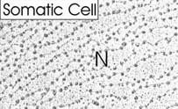
This is an electron micrograph of isolated chromatin from a human body (somatic cell), perhaps a liver cell. The chromatin has been spread extensively and then stained with lead (Pb⁺⁺) acetate. Notice the very obvious “beads on a string”.

Thus, both nuclease digestion and the electron microscopic studies suggest that chromatin is composed of repeating 200 base pair unit, which were called nucleosome.
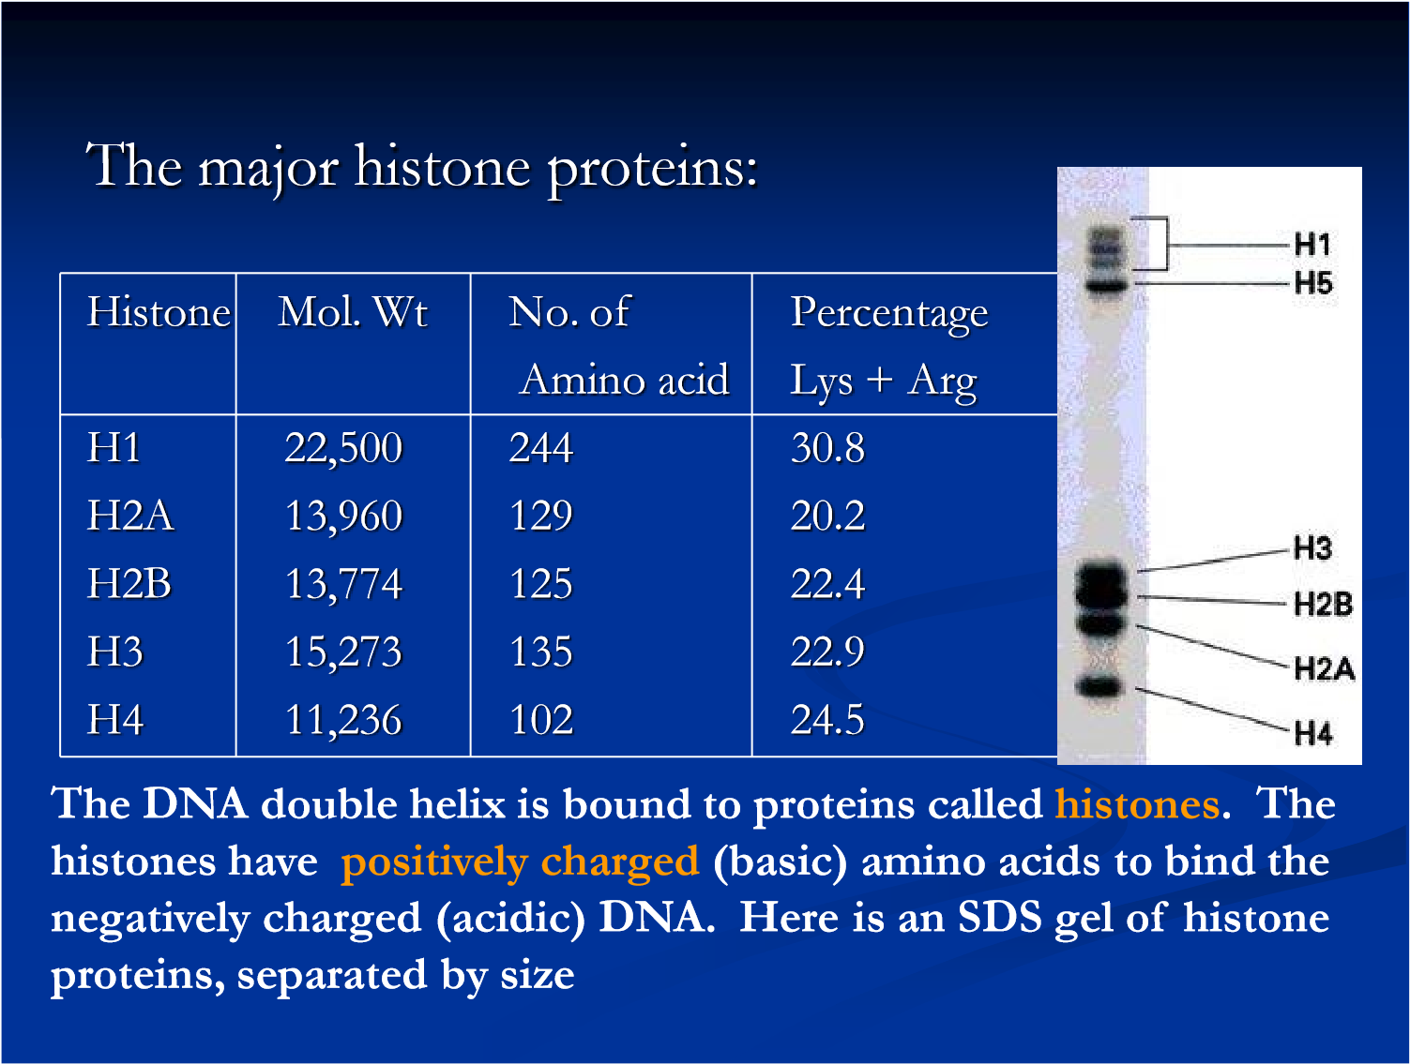
Detailed analysis of these nucleosome core particles has shown that they contain 146 base pairs of DNA wrapped 1.75 times around a histone core consisting of two molecules each of H2A, H2B, H3, and H4 (the core histones).
- The nucleosomes are “pulled together” by the addition of another type of histone molecule (histone 1), to the outer surface of the nucleosome, and various nonhistone proteins to the “linker” region of the DNA. The latter is not shown in the diagram below. The “beads on a string” chromatin “fiber” is about 10 nm in diameter.

HISTONE 1
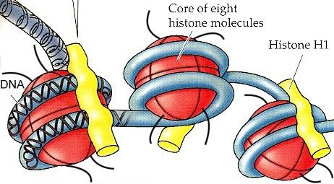

LINKER REGION

- This compacted “beads on a string” structure is now twisted to form a thicker
“fiber” that is
30 nm in diameter. Hence this fiber is about 3X thicker than the plasma membrane (which has a diameter of about 10 nm).

- This 30 nm diameter fiber is then folded (pleated) into loops when it is bound to various non-histone scaffold proteins.

- Depending upon the exact condensation state of the heterochromatin there can be further
“packing” events.

- To form a mitotic chromosome another set of proteins called condensins is required.

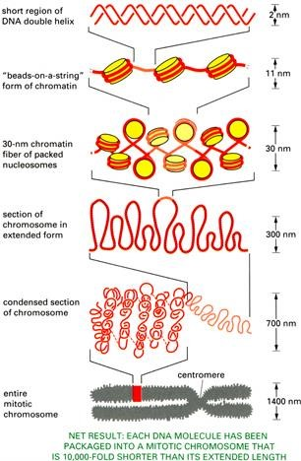

There are 5 major types of histones: H1, H2A, H2B, H3, and H4 – which are very similar among different sp of eukaryotes. The histones are extremely abundant

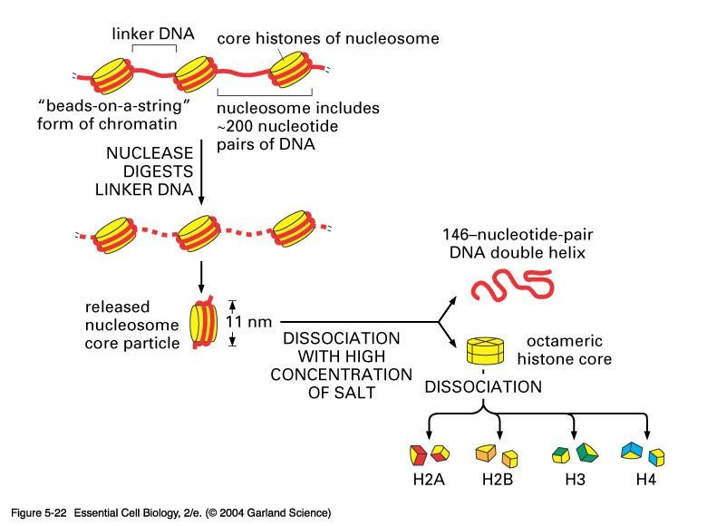

Centromeres and Telomeres

Centromeres and telomeres are two essential features of all eukaryotic chromosomes.
Each provide a unique function i.e., absolutely necessary for the stability of the chromosome.
Centromeres are required for the segregation of the centromere during meiosis and mitosis.
Teleomeres provide terminal stability to the chromosome and ensure its survival
Centromere
The joining point of a metaphase chromosomeis the centromere (primary constriction). The centromere is a constant zone of each chromosome and is present at the same site in all mitotic cycles. In some chromosomes, the centromere is closer to one end and not necessarily in the middle. Specialized proteins bind to the outer faces of the two centromeres of each duplicated chromosome to form laminar structures called kinetochores
The region where two sister chromatids of a chromosome appear to be joined or “held together” during mitotic metaphase is called Centromere When chromosomes are stained, they typically show a dark-stained region that is the centromere. Also termed as Primary constriction During mitosis, the centromere that is shared by the sister chromatids must divide so that the chromatids can migrate to opposite poles of the cell.
On the other hand, during the first meiotic division the centromere of sister chromatids must remain intact whereas during meiosis II they must act as they do during mitosis. Therefore, the centromere is an important component of chromosome structure and segregation.
Kinetochore
Within the centromere region, most species have several locations where spindle fibers attach, and these sites consist of DNA as well as protein.The actual location where the attachment occurs is called the kinetochore and is composed of both DNA and protein. The DNA sequence within these regions is called CEN DNA.

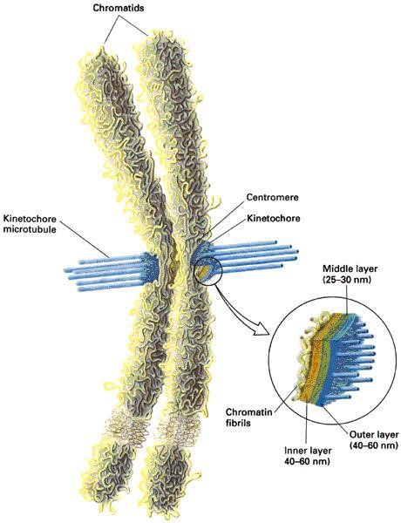
Telomere
The two ends of a chromosome are known as telomeres.
It required for the replication and stability of the chromosome.
When telomeres are damaged or removed due to chromosome breakage, the damaged chromosome ends can readily fuse or unite with broken ends of another chromosome.
Thus, it is generally accepted that structural integrity and individuality of chromosomes is maintained due to telomeres.

McClintock noticed that if two chromosomes were broken in a cell, the end of one could attach to the other and vice versa.
Thus, the ends of broken chromosomes are sticky, whereas the normal end is not sticky, suggesting the ends of chromosomes have unique features.

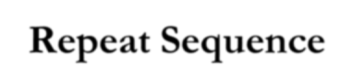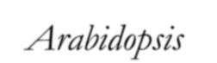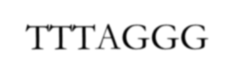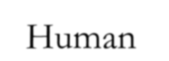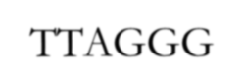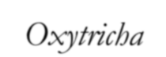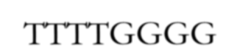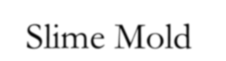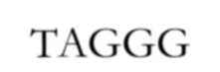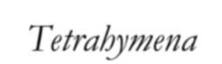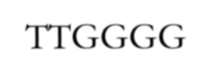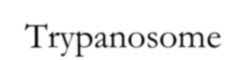
Telomere Repeat Sequences
until recently, little was known about molecular structure of
telomeres. However, during the last few years, telomeres have
been isolated and characterized from several sp.
Species
Repeat Sequence
Arabidopsis
TTTAGGG
Human
TTAGGG
Oxytricha
TTTTGGGG
Slime Mold
TAGGG
Tetrahymena
TTGGGG
Trypanosome
TAGGG

