HAWLER MEDICAL UNIVERSITY
COLLEGE OF NURSING
LABORATORY AND CLINICAL EDUCATION

Procedure Evaluation Document (PED)
PROCEDURE: Foetal Heart Rate Assessment |  |  |  |  |  |  |  |  |  |  |  |  | Code | M-05
No. | Skill steps |  |  |  |  |  |  |  |  |  |  |  | Not  achieved | Achieved
1 | Prepared procedure equipment.  - Client’s medical record  - Hand rub gel  - Non sterile gloves  - Sonic aid device or Doppler machine if available  - Gel  - Antiseptic solution  - 2 Gauze pieces  - Stethoscope or fetoscope
2 | Identified client using two identifiers.
3 | Performed greeting, introduction and permission procedure (G.I.P).
4 | Provided privacy.
5 | Explained the procedure to the client and answered any questions.
6 | Instructed the client to empty her bladder.
7 | Cleaned the device with an antiseptic gel and gauze.
8 | Performed hand hygiene using correct technique.
9 | Put on gloves.
10 | Adjusted the height of the bed.
11 | Exposed the abdomen protecting the privacy.
12 | Put gel on the device.
13 | Placed the device over the convex portion of the foetus closest to the anterior uterine wall.
14 | Confirmed the presence of foetal heart tones (verbal report).
15 | Noted the area of maximum intensity (verbal report).
16 | Counted FHR (baseline FHR 120 - 160 bpm).
17 | Compared the FHR to the normal range verbally.
18 | Dried the abdominal area with gauze.
19 | Restored client to a comfortable position.
20 | Removed gloves.
21 | Cleaned the device with an antiseptic gel and gauze.
22 | Performed hand hygiene using correct technique.
23 | Documented the result in the medical record.
24 | Informed the client or relative if appropriate of the result.
25 | Returned equipment to the dedicated area.
26 | Reported abnormal findings to the appropriate health care provider (student reported this action verbally).
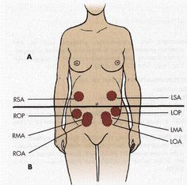
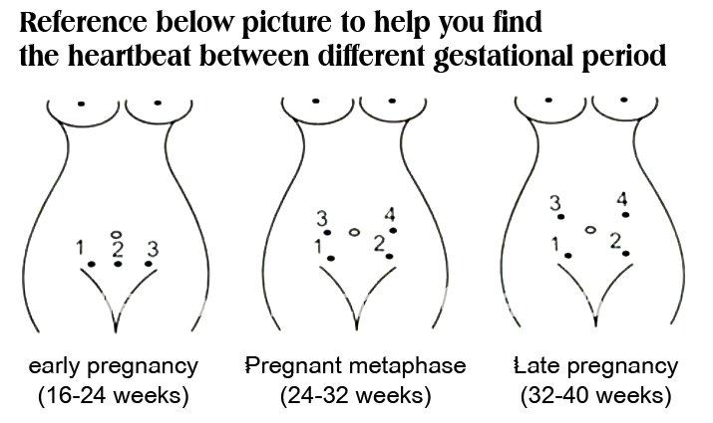

- SKILL EVALUATION 60%
Steps | 0 | 1-2 | 3-5 | 6-8 | 9-11 | 12-13 | 14-16 | 17-19 | 20-22 | 23-24 | 25-26 | Skill steps achieved
Points | 0 | 6 | 12 | 18 | 24 | 30 | 36 | 42 | 48 | 54 | 60 | Skill points achieved
Level | F |  |  |  |  |  | U | N | S | C | I | Skill level achieved
- PROCEDURE ASPECTS EVALUATION 40%
Rationale 10% |  |  |  | Client Focus 10% |  |  |  | Professional Manner 10% |  |  |  | Time 10%
Failed |  |  | 5 | Failed |  |  | 5 | Failed |  |  | 5 | Failed +10 |  | 5
Unsatisfactory |  |  | 6 | Unsatisfactory |  |  | 6 | Unsatisfactory |  |  | 6 | Unsatisfactory+8 |  | 6
Novice |  |  | 7 | Novice |  |  | 7 | Novice |  |  | 7 | Novice +6 |  | 7
Supervised |  |  | 8 | Supervised |  |  | 8 | Supervised |  |  | 8 | Supervised +4 |  | 8
Competent |  |  | 9 | Competent |  |  | 9 | Competent |  |  | 9 | Competent +2 |  | 9
Independent |  |  | 10 | Independent |  |  | 10 | Independent |  |  | 10 | Independent TA |  | 10
Notes: |  |  |  |  |  |  |  |  |  |  |  | Time allowed (TA) |  | 15
 |  |  |  |  |  |  |  |  |  |  |  | Time achieved
 |  |  |  |  |  |  |  |  |  |  |  | Aspects points achieved
- COMPLETE PROCEDURE EVALUATION 100%
≤50 |  | 51-60 |  | 61-70 |  | 71-80 |  | 81-90 |  | 91-100 |  | Total points achieved
Failed |  | Unsatisfactory |  | Novice |  | Supervised |  | Competent |  | Independent |  | Total level achieved
Student |  |  |  |  |  | Signature |  |  |  |  |  | Actual Mark/Out of
Teacher |  |  |  |  |  | Signature
Clinical Area |  |  |  |  |  | Date

