HAWLER MEDICAL UNIVERSITY
COLLEGE OF NURSING
LABORATORY AND CLINICAL EDUCATION

Procedure Evaluation Document (PED)
PROCEDURE: Performing an episiotomy |  |  |  |  |  |  |  |  |  |  |  |  | Code | M -08
No. | Skill steps |  |  |  |  |  |  |  |  |  |  |  | Not  achieved | Achieved
1 | Prepared procedure equipment:  - Client medical record  - Sterile gloves  - Sterile syringe with needle (10 ml)  - Scissors  - Lidocaine %5(10 ml) or %1 (5 ml)  - Gauze pieces  - Hand rub gel  - Antiseptic solution
2 | Identified the client using two identifiers.
3 | Performed greeting, introduction and permission procedure (G.I.P).
4 | Provided privacy.
5 | Explained the procedure to the client and answered any questions.
6 | Performed hand hygiene using correct technique.
7 | Put on gloves.
8 | Placed the client in lithotomy position when the fetal head is distending the perineum. |  |  |  |  |  |  |  |  |  |  |  | “
9 | Clean the skin (perineum) with antiseptic using aseptic technique.
10 | Reported the best and ideal time for episiotomy is a bulging thin perineum at the peak of a contraction just prior to crowning.
11 | Inserted the first and second fingers into the vagina to protect the foetal skull from injury and anaesthetic.
12 | Inserted the needle via the forchette and direct it at a %45 angle from the midline for 4-5 cm, to ensure a medio-lateral incision.
13 | Injected lidocaine slowly as the needle is withdrawn.
14 | Waited for 3 to 5 minutes for anaesthetic action (verbal report).
15 | Placed the index and middle fingers in the vagina and separated them slightly with pressure downward on the perineal body.
16 | Performed an episiotomy with a scissor by one of the following ways:  -A media-lateral episiotomy - cut the perineum at a slant starting at the midline of the forchette with the points of the scissors directed toward the ischial tuberosity on the same side of the position.  -A midline episiotomy - cut in the middle of the central tendentious points of the perineum from the posterior fourchette down to the external anal sphincter.
17 | If a midline episiotomy was cut, palpate for the external anal sphincter.
18 | Inserted the scissors from above the backside of the hand to slide down the fingers to make the cut (to protect the foetal presenting part).
19 | Applied pressure with some pieces of gauze for control of bleeding.
20 | Removed gloves.
21 | Performed hand hygiene using correct technique.
22 | Returned equipment to the dedicated area.
23 | Recorded the result (the time of episiotomy was performed, type of episiotomy, and any abnormality if present) in the labour chart.
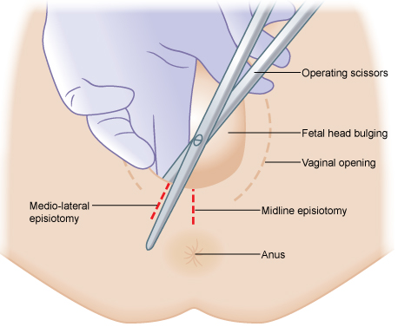
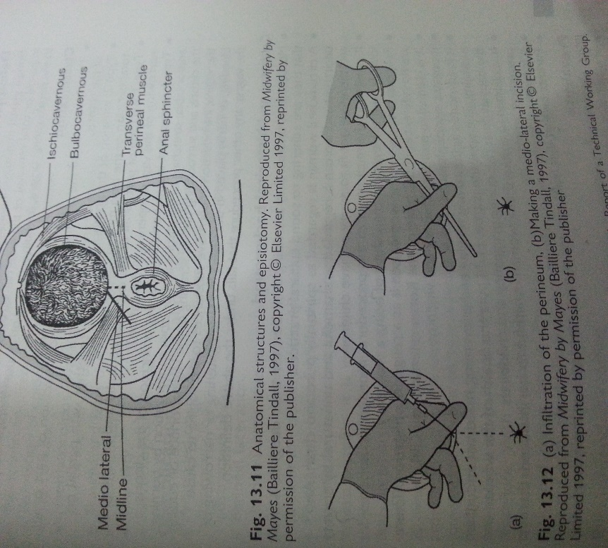
- SKILL EVALUATION 60%
Steps | 0 | 1-2 | 3-4 | 5-6 | 7-9 | 10-11 | 12-14 | 15-17 | 18-19 | 20-21 | 22-23 | Skill steps achieved
Points | 0 | 6 | 12 | 18 | 24 | 30 | 36 | 42 | 48 | 54 | 60 | Skill points achieved
Level | F |  |  |  |  |  | U | N | S | C | I | Skill level achieved
- PROCEDURE ASPECTS EVALUATION 40%
Rationale 10% |  |  |  | Client Focus 10% |  |  |  | Professional Manner 10% |  |  |  | Time 10%
Failed |  |  | 5 | Failed |  |  | 5 | Failed |  |  | 5 | Failed +10 |  | 5
Unsatisfactory |  |  | 6 | Unsatisfactory |  |  | 6 | Unsatisfactory |  |  | 6 | Unsatisfactory+8 |  | 6
Novice |  |  | 7 | Novice |  |  | 7 | Novice |  |  | 7 | Novice +6 |  | 7
Supervised |  |  | 8 | Supervised |  |  | 8 | Supervised |  |  | 8 | Supervised +4 |  | 8
Competent |  |  | 9 | Competent |  |  | 9 | Competent |  |  | 9 | Competent +2 |  | 9
Independent |  |  | 10 | Independent |  |  | 10 | Independent |  |  | 10 | Independent TA |  | 10
Notes: |  |  |  |  |  |  |  |  |  |  |  | Time allowed (TA) |  | 10
 |  |  |  |  |  |  |  |  |  |  |  | Time achieved
 |  |  |  |  |  |  |  |  |  |  |  | Aspects points achieved
- COMPLETE PROCEDURE EVALUATION 100%
≤50 |  | 51-60 |  | 61-70 |  | 71-80 |  | 81-90 |  | 91-100 |  | Total points achieved
Failed |  | Unsatisfactory |  | Novice |  | Supervised |  | Competent |  | Independent |  | Total level achieved
Student |  |  |  |  |  | Signature |  |  |  |  |  | Actual Mark/Out of
Teacher |  |  |  |  |  | Signature
Clinical Area |  |  |  |  |  | Date

