Part A- **Answer The Following Questions (20 points)**

**1-**Metabolism is carried out by a large class of proteins that decrease the activation energy required for chemical reactions inside a cell. Therefore, they only facilitate reactions that would naturally occur at a much slower rate. What is the name of these proteins that speed up biochemical reactions?

**Answer: Enzyme**

**2-** Name the four macromolecular components found inside a cell.

1. Carbohydrate b- lipid c- Protein d- Nucleic acid

3- What makes up 65-70% of the intracellular space? Water

**Answer:water**

4-RNA is composed of strands of nucleotides that are read as a 3 nucleotide codon. These are distinguished by tRNAs that match the codons on one end and carry individual building blocks of a protein chain. What are these building blocks of protein that tRNAs bind?

**Answer: amino acid**

5- a- What is this(following) image?

**Answer:Cell Membrane**

b) Name the components of following image

**Answer:Lipid, carbogydrate and protein**

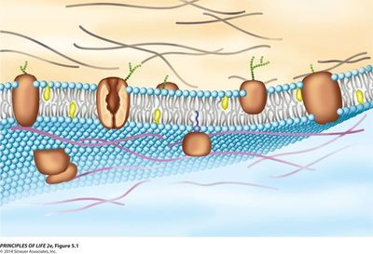

**Part B- Choose The Correct Alternative**

***Read These Instructions First:*** *Read each question carefully, for each question, there is ONE answer, circle the appropriate answer for each question, work as quickly and carefully as possible. Each correct answer will score 2 marks.*

**1. In a cell membrane, oxygen and carbon dioxide molecules can pass directly through the cell membrane without requiring any energy along the concentration gradient. This is a form of simple ………..**

1. Diffusion
2. Endocytosis
3. Phagocytosis
4. Active transport
5. Osmosis

**2. The real-life examples of ……. are:**

1. Feeling thirsty after having salty food.
2. Dialysis of kidney in the excretory system.
3. Swelling of resins and other seeds when they are soaked in water.
4. Movement of salt-water in the animal cell across our cell membrane.

Which of the following events best describes the above examples?

A) Diffusion

B) Endocytosis

C) Phagocytosis

D) Active transport

E) Osmosis

**3.** **What is the definition of endocytosis?**

A) The process of breaking down nutrients into simple, basic components

B) The process of actively transporting molecules out of the cell by fusing vesicles with its membrane.

C) A system of the cell that causes an equal amount of molecules to move in and out

D) The process of actively transporting molecules into the cell by engulfing it with its membrane.

E) All

**4. Which of the following is not function of plasma membrane proteins?**

A) Transport

B) Receptor

C) Cell Recognition

D) Intercellular Junction

E) ATP is synthesized

**5.****Osmotic pressure changes the shape of red blood cells in hypertonic, isotonic, and hypotonic solutions.**

.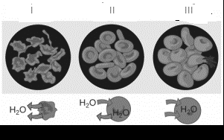

**Give the uses of** **osmotic pressure changes the shape of red blood cells in hypertonic, isotonic, and hypotonic solutions** **in the right order:**

**I II III**

A) Hypertonic Isotonic Hypotonic solutions

B) Hypertonic Hypotonic Isotonic solutions

C) Hypotonic Isotonic Hypertonic solutions

D) Isotonic Hypotonic Hypertonic solutions

E) Isotonic Hypertonic Hypotonic solutions

1. **This is considered to be the opposite of diffusion because it moves molecules from an area of low concentration to high concentration. the cell must use energy to make this happen.**

A) Diffusion B) Osmosis C) Active transport D) Isotonic E) Hypotonic

**7. All of the following are true about the structure of DNA except**

A) Short strands of DNA are contained in chromosomes inside the nucleus of a cell.

B) Every DNA nucleotide contains a sugar, a phosphate group, and a nitrogen base.

C)  DNA consists of one strand of nucleotides joined by hydrogen bonds.

D)  The long strands of nucleotides are twisted into a double helix.

E) Nitrogen bases of DNA are Adenine, Guanine, Cytosine, and Thymine

**8. Which of the following is TRUE about mutation?**

A) Acceptable variations in the ‘normal’ DNA and protein sequences

B) The exchange of DNA between chromosomes during meiosis.

C) The movement of a ribosome from one reading frame to another at an internal position within a gene

D) DNA repair process that corrects various types of DNA damage by excising and resynthesizing a region of polynucleotide

E) Permanent, heritable alterations in the base sequence of the DNA.

9.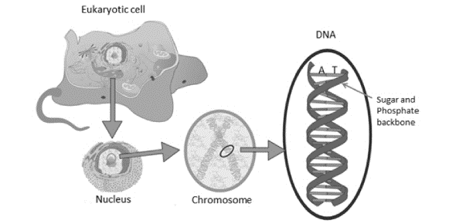

**DNA consists of two antiparallel strands of nucleotide chains held together by**

1. Peptide bonds.
2. Polar covalent bonds.
3. Ionic bonds.
4. Hydrogen bonds.

E) Complementary base pairing bonds

.

**10. This is a partial sequence of one strand of DNA. Choose the correct complimentary strand of DNA.​ AATTCGCGAT**

A) UUAAGCGCUA

B) TTAACCGCGTA

C) TTAAGCGCTA

D) CCGGATATCG

E) GCGGATATCG

**11. What are the 3 parts of the nucleotide (smallest unit of DNA)?**

1. Sugar (ribose), Phosphate group, Nitrogenous bases: A, T, C, G
2. Sugar (deoxyribose), Phosphate group, Nitrogenous bases: A, U, C, G
3. Sugar (deoxyribose), Sulfate group, Nitrogenous bases: A, T, C, G
4. Sugar (deoxyribose), Phosphate group, Nitrogenous bases: A, T, C, G
5. Sugar (ribose), Sulfate group, Nitrogenous bases: A, T, C, G

**12. What is the genetic material for all living organisms?**

1. RNA
2. MRNA

1. DNA

1. Proteins
2. All

**13. Which of the following one is not a property of RNA?**

A) It is single stranded.

B) Its special sugar is Ribose.

C) It cannot replicate itself.

D) Its special base is Thymine.

E) Its special base is Uracil

**14. Which molecule brings the amino acid to the ribosome?**

A) DNA B) mRNA C) tRNA D) rRNA E) All

**15. Which of the following structure and their contents are incorrectly paired?**

* 1. Protein – amino acids
  2. Lipid – fatty acid
  3. Starch – glucose
  4. Glycogen – glucose
  5. Cellulose- Glycerol

**16. Which one of the following is not a property of carbohydrates?**

A) They are a source of energy.

B) Excess amounts are converted into lipid.

C) They are stored in the body.

D) They are found in the structure of DNA, RNA and ATP.

E) They are regulatory molecules.

**17. Huseyin Bolt is World’s Fastest Man who is the best athletes in the world line up and run the 100 meters at the Olympic Games. Which organic molecule(food) is very active during the Huseyin Bolt** **Run?**

A) Glucose B) Fatty Acid C) Amino acid D) Glycerol E) Cellulose

**18. Complex molecules (macromolecules) are made by joining smaller molecules together using dehydration synthesis.**

A) True B) False

**19. Nucleic acids are polymers composed of nucleotides; RNA is deoxyribonucleic acid, DNA is ribonucleic acid.**

A) True B) False

**20. Which term most precisely describes the cellular process of breaking down large molecules into smaller ones?**

A) Catalysis B) Metabolism C) Anabolism D) Dehydration E) Catabolism

**21. Which of the following is false for enzymes?**

A) Can use again and again

B) It can work out of the cell

C) One type of enzyme can use in all reaction

D) They contain protein

E) Reduce activation energy

**22. Which of the following does not affect the enzyme activity ?**

A) pH B) Temperature C) Enzyme concentration D) Substrate concentration E) Light

**23. In the diagram, what is letter E?**

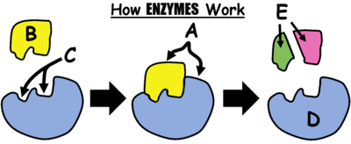

* 1. Product B) Substrate C) Enzyme-substrate complex D) Active site E) None

**24.** This man uses these foods -meats, poultry and fish: Sirloin steak, ground beef, pork tenderloin, venison, chicken breast, salmon, tilapia and cod- for bodybuilding.

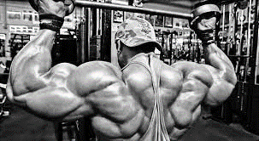

**Which of the following is true?**

1. Firstly uses protein
2. Firstly uses Carbohydrate
3. Firstly uses nucleic acid
4. Firstly uses lipid
5. All

**25. The four main categories of large biological molecules present in living systems are …..**

A) Proteins, nucleic acids, Carbohydrates, and lipids

B) Monosaccharaides, lipids, polysaccharides, and proteins

D) Proteins, DNA , RNA, and steroids

E) Proteins, polysaccharides, Carbohydrates, and lipids

**26. Starch is a carbohydrate made out of thousands of units of glucose and would therefore be considered a**

A) Triglyceride B) Monomer C) Monosaccharide D) Disaccharide E) Polysaccharide

**27.** **The graph shows how enzymes affect reactions in cells. Which statement best summarizes the information shown in the graph?**

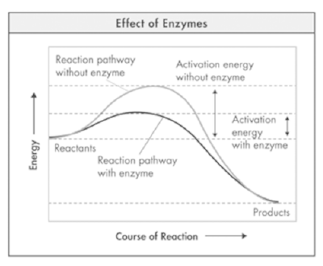

1. Enzymes increase the energy of the reactants.
2. Enzymes decrease the energy level of the products.
3. Enzyme decreases the activation energy of the reaction.
4. Enzymes reverse the direction of the reaction.
5. None

**28.Which kingdom is made up of unicellular organisms that do not have a nucleus and can be found in common places like on the keyboard of the computer you are on now?**

A) Monera B) Protista C) Animalia D) Fungi E) Plantae

**29. What is taxonomy?**

A) The scientific study of how living things are classified

B) The name of Aristotle's classification system

C) The process used by geologists to classify rocks

D) The process of observing an organism's behavior

E) None

**30. Why do scientists organize living things into groups?**

A) so they can find them in the wild more easily

B) so that the organisms are easier to study

C) so they can make sense of the variety of rocks on Earth.

D) so products from living things can be easily found in groceries

**31.** **Which kingdom is made up of multicellular organisms that have cells with nuclei, can move, and cannot make their own food?**

A) Monera B) Protista C) Animalia D) Fungi E) Plantae

**32.Which kingdom is made up of organisms that cannot move, have many cells with cell walls, and cannot make their own food (decomposers)?**

A) Monera B) Protista C) Animalia D) Fungi E) Plantae

**33.** The equation shows a chemical reaction that occurs in living organisms.

**glucose + oxygen → carbon dioxide + water**

Which of these characteristics of living organisms is this equation associated with?



**B**

**34.** **According to the binomial system, how should a human be named?**

A) Homo Sapiens

B) Homo sapiens

C) homo Sapiens

D) homo sapiens

E) All

**35. All matter can be considered living or non-living.**

A) True B) False

**36.** **Which of the following levels of organization is NOT matched with the appropriate structure?**

A) Tissue : epithelium

B) Organ : liver

C) Tissue : nerve

D) Organ : skin

E) Tissue : stomach

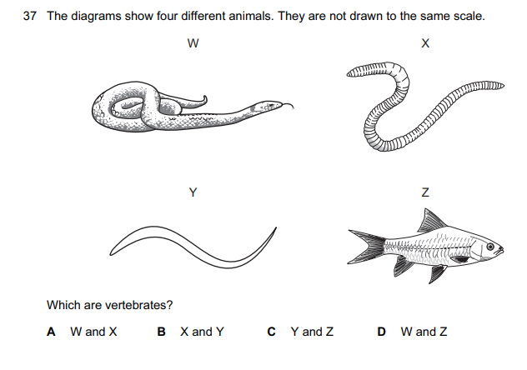

**E** All

**D**

**38. In the list below, which characteristic is NOT necessary in order to be classified as a living organism?**

A) able to reproduce

B) more organized than its environment

C) requires oxygen

D) requires energy from its environment

E) responsive to external stimuli

**39. Which statement is false?**

A) Zoology deals with plants and plants life, including the study of the structure, physiology.

B) Cell biology is the study of cells.

C) Genetics is the study of how features is passed to offspring from their parents.

D) Anatomy is the study of the inner organs of the body (kidney, hert, liver etc.)

E) Physiology is the study of the function of living organisms and their parts

**40.**

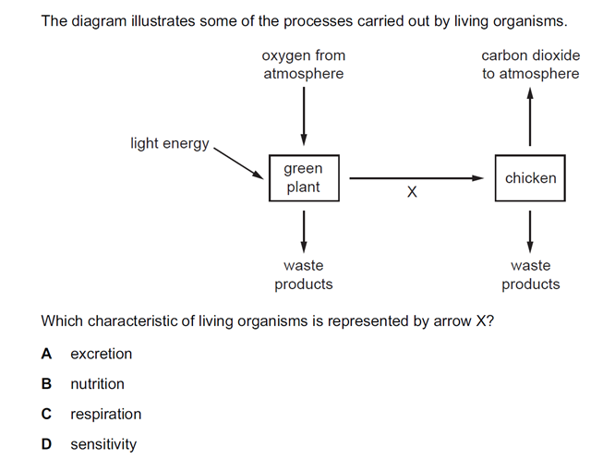

**E** Photosynthesis

**B**

**Dr. Mehmet Ozdemir**