THISK INTERNATIONAL UNIVERSITY
FACULTY OF APPLIED SCIENCES
MEDICAL ANALYSIS DEPARTMENT
Biology Quiz Exam (A)
Duration:30 minutes
Full Name:
Choose The Correct Alternative
Read These Instructions First: Read each question carefully, for each question, there is ONE answer, circle the appropriate answer on answer sheet for each question, work as quickly and carefully as possible. Each correct answer will score 5 marks.

1-. Enzymes are special proteins that speed up biochemical reactions increasing activation energy.

A. True B. False

2- Nucleic acids control all life activities in the cell.
A. True B. False

3- A major difference between prokaryotic and eukaryotic cells is that in prokaryotic cells genetic material (DNA) is not enclosed in a nucleus so it is free in the cytoplasm.

A. True B. False

4- Meat, fish, chicken, and egg is very rich protein source food.
A. True B. False

5- What is this(following) image?
A) Cell Membrane B) Cytoplasm C) Nucleus D) All
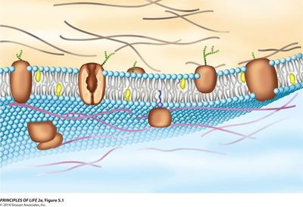

6- What are the three main components of cell membranes?

- Lipid, starch and protein
- Lipid, protein and carbohydrate.
- Protein, Glucose, and DNA
- Carbohydrate, protein, and nucleotide

7- In a cell membrane, oxygen and carbon dioxide molecules can pass directly through the cell membrane without requiring any energy along the concentration gradient. This is a form of simple ………..
- Diffusion
- Endocytosis
- Phagocytosis
- Active transport

8- The real-life examples of ……. are:
- Feeling thirsty after having salty food.
- Dialysis of kidney in the excretory system.
- Swelling of resins and other seeds when they are soaked in water.
- Movement of salt-water in the animal cell across our cell membrane.
Which of the following events best describes the above examples?
- Endocytosis
- Phagocytosis
- Active transport
- Osmosis

9- What is the definition of endocytosis?

A) The process of breaking down nutrients into simple, basic components
B) The process of actively transporting molecules out of the cell by fusing vesicles with its membrane.
C) A system of the cell that causes an equal amount of molecules to move in and out
D) The process of actively transporting molecules into the cell by engulfing it with its membrane.

10- Which of the following is not function of plasma membrane proteins?
A) Transport
B) ATP is synthesized
C) Cell Recognition
D) Receptor

11- This is considered to be the opposite of diffusion because it moves molecules from an area of low concentration to high concentration. the cell must use energy to make this happen.

A) Diffusion B) Osmosis C) Active transport D) Isotonic

12- All of the following are true about the structure of DNA except
- Every DNA nucleotide contains a sugar, a phosphate group, and a nitrogen base.
- DNA consists of one strand of nucleotides joined by hydrogen bonds.
- The long strands of nucleotides are twisted into a double helix.
- Nitrogen bases of DNA are Adenine, Guanine, Cytosine, and Thymine

13- Osmotic pressure changes the shape of red blood cells in hypertonic, isotonic, and hypotonic solutions.

.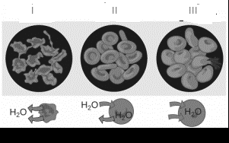

Give the uses of osmotic pressure changes the shape of red blood cells in hypertonic, isotonic, and hypotonic solutions in the right order:
I II III
A) Hypertonic Isotonic Hypotonic solutions
B) Hypertonic Hypotonic Isotonic solutions
C) Hypotonic Isotonic Hypertonic solutions
D) Isotonic Hypotonic Hypertonic solutions

14- 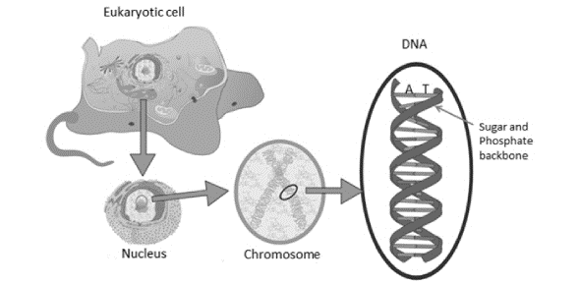

DNA consists of two antiparallel strands of nucleotide chains held together by
- Peptide bonds.

- Polar covalent bonds.

- Ionic bonds.

- Hydrogen bonds.

.

15- Which molecule brings the amino acid to the ribosome?

A) DNA B) mRNA C) tRNA D) rRNA

16- Which of the following structure and their contents are incorrectly paired?
  - Protein – amino acids
  - Enzyme – fatty acid
  - DNA – Dioxyribose sugar
  - RNA–Ribose sugar

17- The graph shows how enzymes affect reactions in cells. Which statement best summarizes the information shown in the graph?
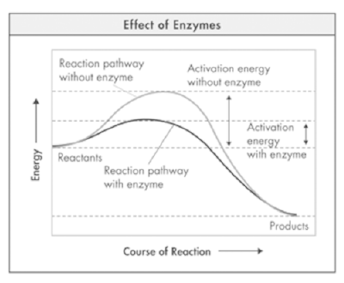

- Enzymes increase the energy of the reactants.
- Enzymes decrease the energy level of the products.
- Enzyme decreases the activation energy of the reaction.
- Enzymes reverse the direction of the reaction.

18- A selectively permeable membrane allows all molecules to cross.

A. True B. False

19- Passive transport requires…
A) No energy B) Energy from the molecules C) Half of the cell's energy D) None

20- Exocytosis is the removing of big complex molecules from the cytoplasm.

A. True B. False

Dr. Mehmet Ozdemir

