Question Bank

Introduction
Dear Students,
First and foremost, I would like to express my gratitude for your dedication and hard work throughout the semester. The final exam is crucial in determining your final grade for this course, so please give it your utmost attention.
Study diligently and strive for understanding, not just memorization. All lecture notes covering the topics are provided. Please study and understand them thoroughly. Feel free to email me anytime if you have questions.
This paper will guide you through the types of questions in the exam. The only major changes since last time are the addition of multiple-choice questions and an essay writing section.

Instructions:

Q1) Answer two of the following questions (20 Marks total, each question 10 marks).
Ensure to provide a comprehensive explanation. Aim for conciseness and avoid overly brief responses. Pay special attention to questions with multiple parts.
Questions are listed below.

- What Are the Differences Between Academic and Non-Academic Writing?

- For What Purposes Do Sociologists, Artists, Economists, and Anthropologists, Among Others, Employ Academic Research and Writing?
- What Are the Forms of Academic Writing?
- What Does “Reading with Attention” Mean, and What Are Its Three Core Key Tasks?
- What Are the Three Important Parts of an Essay? Explain Each One and Discuss the Concept of a Christmas Cracker.
- What Are the Different Types of Essay Writing?
- What Is the Purpose of Essay Writing?
- What Do Signposting and Cohesion Mean? Provide Examples for Each.
- Define the Meaning of a Literature Review and Identify Its Purpose.
- Identify the Steps of a Literature Review and Explain Two of These Steps.
- Explain the Difference Between Primary and Secondary Data with Examples.
- Explain the Meaning and Differences Between Quantitative and Qualitative Data.
- What Is Qualitative Data Analysis? List and Explain the Three Most Common Methods.
- What Is Quantitative Data Analysis? List and Explain the Three Most Common Methods.
- What Are the Criteria to Evaluate a Source? List All of Them and Explain Four.
- What Are the Characteristics of Research? (Refer to the Research Process PPT)
- The Research Process Consists of Eight Steps. Mention Five of Them and Explain Three.
- According to Andrew and Hilderbrand, What Characteristics Must a Problem Statement Have to Be Effective? Identify Them.
- What Are Strategies for Critical Reading?
- List the Key Components of Critical Reading and Explain Two.
- Explain the Research Conducted by Brown and Keely in 2013 on the Importance of Critical Thinking Skills.
- List the Reasons for Referencing Sources in Academic Writing.
- Explain the Meaning of Plagiarism and Provide Three Examples.
- List Down the Strategies for Using Referencing.

Fill in the Blank Instructions:

Q2) Fill in the Blank (20 Marks, 5 blanks, each 4 marks)
You will be given a list of words, including two or three extras, so choose wisely. If unsure about an answer, move to another and return to it later.

True/False Instructions:

Q3) True or False (10 Marks, 5 statements, each 2 marks)
You will be given several statements. Think carefully before answering, as no corrections are required. Simply determine if the statement is correct or not.

Multiple Choice Instructions:

Q5) Multiple Choice Questions (20 Marks, 5 questions, each 4 marks)
Read each question thoroughly and recall relevant topics. Apply your knowledge to select the correct answer.

Essay Writing Instructions:
Essay Writing (30 Marks)
You will be given a topic to develop an essay using an academic approach. Pay attention to essay and paragraph structure, and ensure proper citation as mentioned in the question (you will be provided with several ones). Avoid non-academic writing styles and stay on topic. Make sure to follow “the Christmas Cracker” structure.
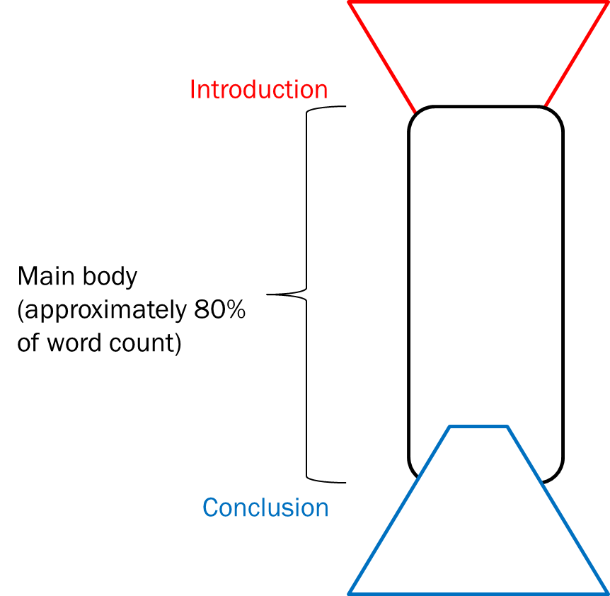
Include thesis statement for the introduction and Topic sentence.
for each paragraph.

I wish you the best in your finals

