**Lecture 1**

**Immunohistochemistry IHC**

* **Refers to the process of localizing proteins in cells of a tissue section by using of antigen - antibody reaction.**
* **It is used as an additional method for the diagnosis of diseases.**
* **This technique requires paraffin tissue section.**
* **The slides used are special called charge slides.**
* **Many reagents are required for this techniques example: antibodies, enzymes, chromogen….etc.**
* **Clinical application: Diagnosis and classification of different tumors.**

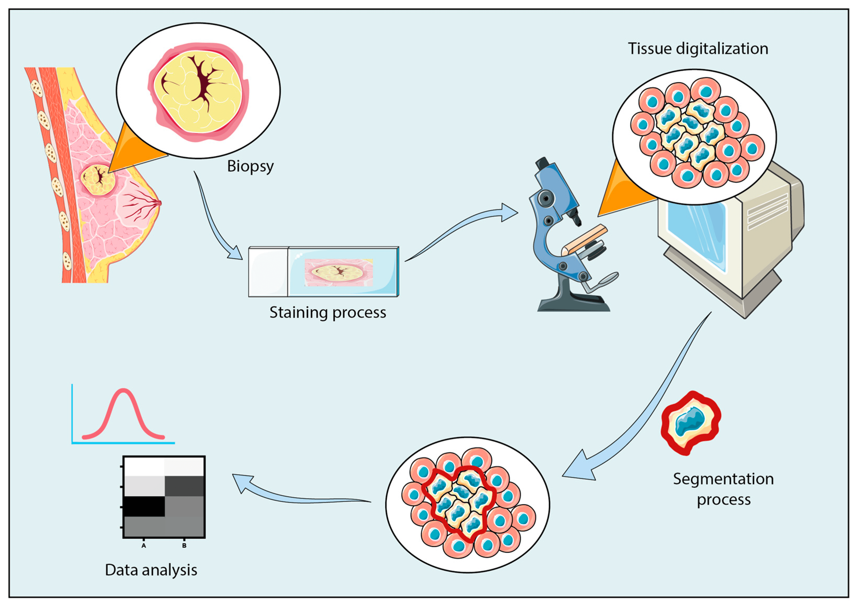

**Immunofluorescence IF**

* **A useful method in Microtechnique, used to detect different molecules on the cells using antibodies that are chemically conjugated to fluorescent dyes. This reaction is visualized using fluorescence microscopy.**
* **IF techniques can be used on both fresh and fixed samples.**
* **Clinical application: diagnosis of renal and dermatology immunological diseases.**

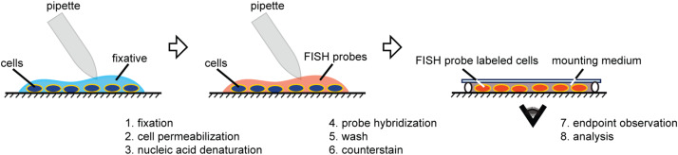

**FISH (**[**fluorescence**](http://en.wikipedia.org/wiki/Fluorescence)[**in situ**](http://en.wikipedia.org/wiki/In_situ)[**hybridization**](http://en.wikipedia.org/wiki/Hybridisation_(molecular_biology))**)**

* **It is a** [**cytogenetic**](http://en.wikipedia.org/wiki/Cytogenetics) **technique.**
* **Used to detect and localize the presence or absence of specific** [**DNA**](http://en.wikipedia.org/wiki/DNA)[**sequences**](http://en.wikipedia.org/wiki/DNA_sequence) **on** [**chromosomes**](http://en.wikipedia.org/wiki/Chromosome)**.**
* **Uses** [**fluorescent probes**](http://en.wikipedia.org/wiki/Hybridization_probe) **that bind to only those parts of the chromosome. Now a day chromogen can also be used which called CISH.**
* **detection is by fluorescence microscopy or light microscope in CISH**
* **Clinical application: HER2/Neu for breast carcinoma and so many others.**

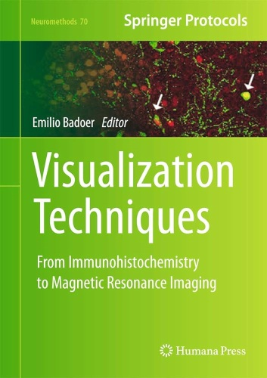 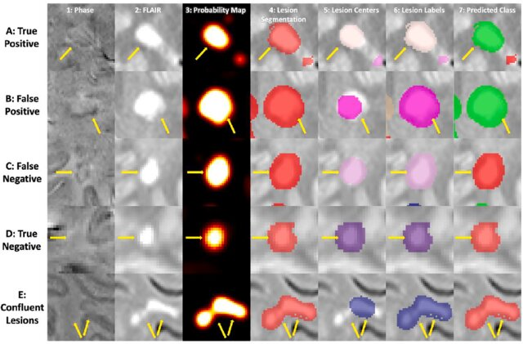

**----------------------------------------------------------------------**

**Lecture 2**

**Cytology**

***Cytology:* - is the study of cells, their origin, structure, function, and pathology**

***The Cell*: is the fundamental, structural and functional unit of living organism.**

***Cytopathology:* is a branch of** [**pathology**](http://en.wikipedia.org/wiki/Pathology) **that studies and diagnoses disease on the cellular level.**

***Methods of specimen collection for cytological examination:***

1. **Exfoliative cytology**
2. **Aspiration cytology**
3. **Body fluids**

**Exfoliative cytology**

**It is the study of cells that have been shed or removed from the epithelial surface of various organs. These can be obtained by wash, smear, scraping, or brushing.**

**Aspiration cytology (Fine Needle Aspiration Cytology "FNAC"):**

**This is a technique used to obtain material from organs or lesions by needle aspiration. It is valuable in diagnosis of lesions of the breast, thyroid, lymph nodes, liver, lungs, skin, soft tissues …etc.**

**Body fluids:**

**Body fluids like Urine, Pleural fluid, Pericardial fluid, Cerebrospinal fluid, Synovial fluid and Ascitic fluid can be studied by cytology.**

***There are two methods of processing smears, which depend on the requirements of the stain to be used.***

1. **Air-drying smear followed by hematological stains like Giemsa, Diff Quik stain. In this method, smears are air dried, but if smears are not correctly made and dried quickly, artifacts will result.**
2. **Alcohol fixation (95% ethanol) for 15 min, followed by Papanicolaou (pap) or hematoxylin and eosin (H&E) staining: Rapid fixation in alcohol (wet fixation) is essential. Carnoy’s fixative is used to lyses RBCs in haemorrhagic fluids.**

***The advantages of diagnostic cytology are that it is:***

1. **a non-invasive procedure,**
2. **helps in faster reporting,**
3. **is relatively inexpensive**
4. **Has high population acceptance**
5. **Facilitates cancer screening.**

***How to prepare slides for cytological examination:***

1. **Smear 2) Cytocentrifuge**

**Smears:**

* + **The smears are usually made directly from the aspirated fluid, as rapid as possible to prevent dry artifacts on the cells. If delay is anticipated, the fluids kept at refrigerator for 24-48 hours.**
  + **If too much fluid is obtained, it is centrifuged first for 5 minutes, and then the sediment is used to make a smear because it is more cellular.**
  + **If little amount of fluid is aspirated (few drops), or if the fluid is thick, the centrifuge doesn’t required.**

**Cytocentrifuge: It is a special machine that performs a centrifuge and collection of sediment on the center of the slides.**

***Gross examination***

**The fluid specimen obtained should be examined grossly which gives a lot of information for the diagnosis e.g.: Appearance: clear, turbid or hemorrhagic; Color: white yellow, and Volume (ml).**

***Staining***

**Pap stain is recommended for routine diagnosis.**

**Papanicolaou Staining Method**

1. **Fixation 95% ethyl alcohol ------ 15 minutes.**
2. **Hydration. Alcohol to water.**
3. **Nuclear staining done by using haematoxylin stain.**
4. **Cytoplasmic staining done by OG-6 and EA-50.**
5. **Dehydration absolute alcohol**
6. **Clearing: Xylene.**
7. **Mounting of slide**

***Diff Quik stain:***

**This is a rapid staining method in diagnostic cytology; it is usually used to stain the slide from the aspirate during FNAC to evaluate the adequacy and cellularity of aspirate.**

***Imprint Cytology Smears***

* **It is a method for preparation of cytological smears from the fresh tissue.**
* **It is used for rapid diagnosis like the frozen section, during surgery for intraoperative consultation.**
* **Soon after an excisional biopsy, the specimen is cut using a sharp scalpel blade. Then take imprint smears by touching the cut surface with a clean microslide and fix immediately and rapidly stained.**

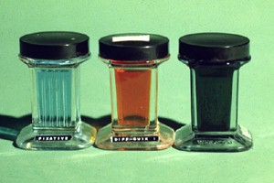

***Diff Quik stain***

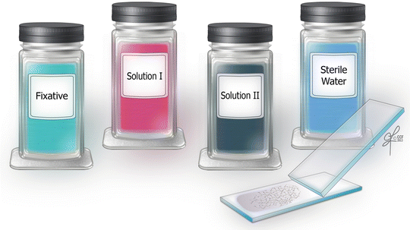

**Updates in cytology:**

**Liquid based cytology LBC**

* **Liquid based cytology (LBC) is a method of processing cytology material for preparation of slide smears by using a special machine.**
* **The samples obtained are placed in special preservative fluids inside the containers.**
* **Many different fluids are made for different purposes.**
* **The basic principles are the vacuum and special filtering with collection of diagnostic material at the center of the slides.**
* **Advantages:**
  + **Preservation of aspiration material with easy slide preparation.**
  + **Cleaning the smear background from unnecessary debris like mucous or inflammatory cells.**
  + **Collecting the diagnostic materials in the center of the slides.**
  + **Many special tests can be done on the same sample with no need for taking second sample from the patient**

**C:\Users\dell\Desktop\Cytojournal-19-41-g019.png**

**Liquid-based cytology: Technical aspects -**

**Collection**

**A gentle vacuum is applied to the cylinder, which aspirates the cell suspension through the filter [Figure 18b]. Most of the broken red blood cells and debris are allowed to pass through while the diagnostic cells attach to the external surface of the filter. The instrument monitors cell density across the filter and the flow rate decreases when cells are evenly distributed on the filter with minimal overlap.**

**Transfer**

**The cylinder moves out of the specimen, is inverted 180°, gently pressed against a positively charged slide, and with slight positive pressure transfers the cells to the glass slide [Figure 18c]. The result is a 20 mm circular smear with even distribution of cells and minimal overlap.**

**Staining**

**Papanicolaou staining is either performed manually or in an automatic stainer. The staining process takes 30 min. Papanicolaou stain of fixed samples offers the best option of judging the fine details of cell structure.**

**Residual LBP specimen**

**The shelf life of the residual specimen for SurePath and ThinPrep is 3 weeks and 3 months, respectively, at room temperature. A residual specimen can be used for immunochemistry, molecular tests, or processed as a cell block.**

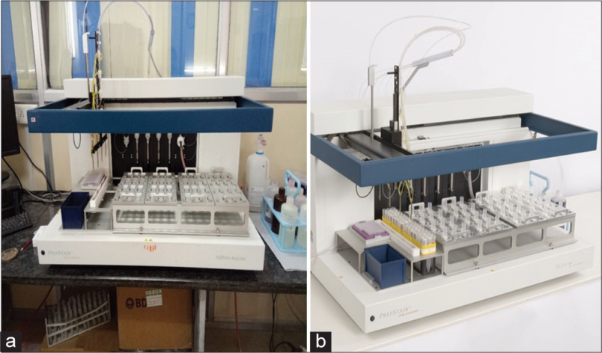

**(a and b) PrepStain device.**

**Lecture 3**

Paraffin method

Updates in immunohistotechniques

**Telepathology**:

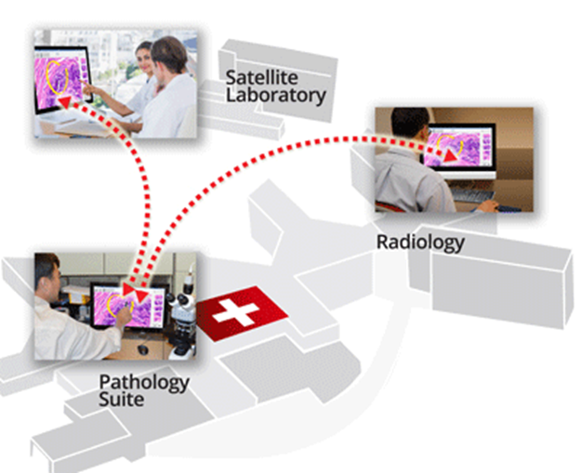

* It is the practice of [pathology](http://en.wikipedia.org/wiki/Pathology) at a distance.
* It uses [telecommunications](http://en.wikipedia.org/wiki/Telecommunications) technology to facilitate the transfer of image-rich pathology data between distant locations for the purposes of [diagnosis](http://en.wikipedia.org/wiki/Medical_diagnosis), [education](http://en.wikipedia.org/wiki/Medical_education), and [research](http://en.wikipedia.org/wiki/Medical_research).
* ***Types of telepathology systems***
  1. static image-based systems,
  2. [real-time systems](http://en.wikipedia.org/wiki/Real-time_systems),
  3. [virtual slide](http://en.wikipedia.org/wiki/Virtual_slide) systems

**Microwave Tissue Processing**:

* To provide rapid tissue processing that will decrease turn-around-time.
* Principle:
  + Microwave exposure is used to dehydrate, clear and impregnate tissue samples.
  + Dehydration is accomplished using Ethyl Alcohol.
  + Isopropanol is substituted for xylene as a clearing agent.
* Quality: Microwave processing considerably shortens the preparation time for histologic sections without a demonstrable decrease in section quality.

**Automated machines**

1. laser cassette printer
2. Slide printer
3. Computerized tissue processor
4. Electronic automated microtome
5. Automated slide stainer
6. Automated special stain stainer
7. Automated cover slip.

----------------------------------------------------------------------------------

**Lecture 3**

Problems and solving

**Problem** (1): Some time the staining is not optimal.

**Causes:**

1. Fixation and tissue processing are not performed correctly.
2. Problem in the staining steps
   1. Wrong concentrations of ethanol.
   2. The solutions are expired
   3. The times are not enough to complete each process.

**Solution**: Two choices:

1. Cut another slide and stain again after checking the staining solutions.
2. Destaining and Restaining:
3. Destaining is to remove the previous stain on the slide:
   1. Remove the cover slip and mounting media (DPX) by xylene.
   2. Hydration.
   3. Put the slide in acid alcohol (1% hydrochloric acid in 70% alcohol) until is fairly colorless.
   4. Wash with tap water.
4. Restain: is to stain the tissue after destaing, starting from hematoxyline.

*Note:*

If the staining quality is not corrected, it could be due to improper tissue processing which can also be corrected by tissue Reprocessing.

**Problem** (2): When tissue is not completely dehydrated during tissue processing, the paraffin cannot infiltrate properly and the paraffin block is impossible to cut, or crumbling of sections occurs and the staining will not be optimal.

**Solution**: Tissue Reprocessing:

* + - 1. Take the paraffin block and trim all the paraffin from around the tissue.
      2. Melt the remaining paraffin by placing the tissue inside the oven.
      3. Put the tissue inside a cassette and label it
      4. Place the tissue in a several changes of xylene to clear.
      5. Pass the tissue slowly through several changes of absolute alcohol for complete dehydration.
      6. clear in xylene
      7. re-infiltrate tissue with paraffin.
      8. continue the embedding and cut with microtome.

**Problem (3)**: cloudy, opaque areas on the slide:

It is noted after staining & covering which is usually indicates insufficient dehydration or clearing during staining.

How to remove them from the slides:

1. Remove the cover slip (by xylene).
2. Put the slide in absolute alcohol for complete dehydration.
3. Clearing in xylene
4. Apply cover slip.

**Problem** (4): formalin pigments:

Formalin pigment: is a brown, granular, refractile deposit seen in tissue.

Usually formed when the formalin become acidic by time by the formation of formic acid.

How to solve the problem:

* 1. Stopped by using 10% neutral buffered formalin (NBF) as the fixative.
  2. If still formed, add this solution (Alcohol-ammonia solution for one hour) to the steps of staining before hematoxyline.

**Problem** (5): Some time the specimen come to the laboratory and contains unknown fluid instead of formalin.

**Solution**: use Schiff reagent method.

1. Take a little amount of the unknown fluid.
2. Add few drops of Schiff reagent to the unknown fluid.
3. The result:

* If the color changed to bright dark pink **instantly**, then the fluid contain aldehyde (formalin)
* If the color changed to pink **slowly** within 1-2 minute then it is not an aldehyde, either alcohol or water or any other fluid.

**Lecture 3**

**Frozen Method**

**Definition:**

It is a pathological laboratory procedure to perform rapid microscopic analysis of a tissue specimen.

The result given by frozen method should be rapid in minute and require fast communication with the surgeon.

**Intraoperative consultation:**

It means that the surgeon during operation needs to take the opinion of other specialty like pathologist and include:

1. Frozen method (tissue).
2. Touches imprint (cytology).

**Indications:**

The principal use of the frozen method procedure is the examination of tissue during surgery for the

following purposes:

1. To establish the presence and the nature of a lesion.
2. to determine the adequacy of surgical margins
3. Unexpected intraoperative finding.
4. to establish whether the tissue obtained contains diagnosable material

**It can also be used in special conditions like:**

1. oil red staining for fat
2. immunofluorescence for renal biopsy

**Preparation of frozen sections**

1- **Receiving the specimen**: Usually the tissue received in a fresh state (No fixative). Care should be taken to minimize the risk of infection.

2- **Transfer the tissue to frozen cryostat with the following steps**:

* The surgical specimen is placed on a metal chuck and frozen rapidly to about -20°C using isopentane (methylbutane) cooled with liquid nitrogen or with an electronic device.
* Sections taken by a cryostat microtome (which is a microtome inside a freezer). The thickness of section is 8-10 µm

3- **fixation**: Slides are placed directly in a fixative acetic alcohol- fix for 1 minute (Absolute alcohol 95 ml + acetic acid 5 ml). This is kept at the room temperature.

4- **staining**: RAPID H&E STAIN

1. Hydrate in 95%, 70% and distilled water, **5 to 10 seconds** each.
2. Stain in modified Harris Hematoxylin for **1 minute**
3. Wash in running tap water **5 to 10 seconds**
4. Blue in warm tap water **5 to 10 seconds**
5. Counterstain in alcoholic eosin: **3 dip**
6. Wash in tap water
7. Dehydrate in 95% and absolute alcohol **5 to 10** seconds each
8. Clear in Xylene
9. Mount and cover slip.

**Updates on special procedures**

**-----------------------------------------------------------------------------------------------------------------**

**Lecture 4**

**Immunohistochemistry**

**Microtechniques**

**Paraffin method**

***Fixation***

**Definitions:**

**Fixation**: It is a process of treating pieces of tissue with certain fluids in order to preserve cells & tissue constituents in a condition identical to that existing during life.

**Fixatives:** They are substances used in the process of fixation.

**Aims and effects of fixation:**

1. Preserve tissue by preventing autolysis by cellular enzymes, to get similar appearance to the origin as much as possible.
2. Preventing decomposition by the actions of bacteria and molds.
3. Devitalize or deactivate infectious agents.
4. Harden tissue to allow thin sectioning.
5. Enhance avidity for dyes.
6. Fortify tissue against harmful effects of tissue processing (e.g. dehydration, Clearing, infiltration…etc.).

**Autolysis (*self digestion*):**

It is the process of destruction of cells or tissues of the body by autologous enzymes, as occur after death or some pathological conditions.

Autolysis is affected by many factors:

1. Inhibited by fixation, heating to 50 0C.
2. Retarded by 🡪 cold 4° C
3. Accelerated by 🡪 keeping at 37
4. Autolysis is more severe in tissue rich in enzymes like: liver, brain.

How it occurs: Autolysis is initiated by the cells [lysosomes](http://en.wikipedia.org/wiki/Lysosome) releasing the [digestive enzymes](http://en.wikipedia.org/wiki/Digestive_enzyme) out into the [cytoplasm](http://en.wikipedia.org/wiki/Cytoplasm). The cell then starts to digest itself.

Features: The cytoplasm becomes swollen & granular

**Bacterial decomposition**

It is the digestion and destruction of the cellular composition by bacterial enzymes to get nutrients to maintain their growth.

it is similar to the process of autolysis and is best inhibited by fixation and in keeping specimen in cold place (4 ° C)

**Classification of fixation:**

Two main methods:

1. Physical method
   1. Heat fixation:
      * Boiling of tissue in normal salin
      * Heating of fixatives solution
   2. Microwave fixation
      * It reduce the time needed for fixation
      * Glyoxal-based fixatives heated at 55 0C.
   3. Freeze drying: liquid nitrogen or acetone at - 40 0C
2. Chemical method
   1. Coagulant fixatives
      1. Coagulate protein making proteins inactive
      2. Types:
         1. Dehydrant:
            1. Common
            2. like: ethanol or acetone
         2. Acidic:
            1. Coagulate nucleic acid. Not precipitate protein
            2. Like: picric acid
   2. Cross linking fixatives
      1. Forming cross linking of protein to nucleic acid
      2. Formaldehyde, mercuric chloride, glutaraldehyde
   3. Compound fixatives.

**Factors affect tissue fixation:**

1. Temperature:
   * Usually fixation is performed routinely at room temperature.
   * Sometime large specimens can be fixed better at 4° C
   * Avoid freezing because ice crystal distortion will result.
   * Hot formalin will fix tissue faster
2. PH:
   * Should be neutral between (PH=6-8).
   * Acidic formalin will cause formalin pigments.
3. Penetration:
   * 10% buffered formalin penetrate the tissue at 1 mm/hr.
   * The time needed for fixation of specimens depend on the size of tissue or organ.
4. Concentration:
   * 10% formalin concentration is the best
   * Concentration in a range between 8% and 12% is accepted and no noticeable differences will be noted.
5. Volume: it should be at least 10 times the size of biopsy.
6. Time: rapid fixation is better than delay fixation.
7. Osmolarity and ionic composition:
   * Osmolarity best with slight hypertonic
   * Ionic composition should be isotonic
8. Additive:
   * Addition of electrolyte and nonelectrolyte improve morphology
   * Like: Calcium chloride, ammonium sulfate

-----------------------------------------------------------------------------------------------------

**Lecture 5**

***Histopathological methods***

**Types of Specimens**

**Histopathological:**

1. **Biopsy**: It is a piece of tissue or organ taken from the body for histological examination during life.
2. **Autopsy**: It is piece of tissue or organ taken from the body for histological examination after death.

***Types of biopsy:***

* + - 1. Incisional biopsy: a portion of the lesion is sampled for diagnostic purposes.

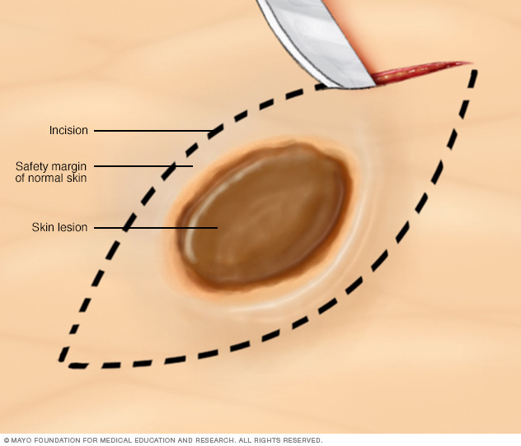

* + - 1. Excisional biopsy: the entire lesion is removed, usually with a rim of normal tissue. This procedure used for diagnosis and therapy.

Endoscopic biopsy: when a piece of tissue taken by endoscopy.

* + - 1. Resection biopsy: the whole organ is removed
      2. Punch biopsy: commonly used for skin biopsy.
      3. Core needle biopsy: taken by wide bore needle.
      4. Curetting: in case of endometrial curettage.

Cytological:

1. Body fluids
2. Exfoliative cytology
3. Fine needle aspiration cytology.

**Methods of preparation of microscopical sections from tissues:**

1. Paraffin method
2. Frozen method

**Paraffin method:**

It is a method used in preparing a selected portion of tissue for microscopic examination. The tissue is fixed, dehydrated, and infiltrated by and embedded in paraffin, forming a block that is cut with a microtome into slices 3-5 μm thick which will be ready for different staining methods.

**Frozen method:**

It is a pathological laboratory procedure to perform rapid microscopic analysis of a tissue specimen using the freezing material.

**Paraffin method**

**Steps of paraffin method**

**------------------------------------**

1. Transfer and reception of biopsy specimens
2. Fixation
3. Gross examination and cutting
4. Processing
5. Embedding
6. Microtome and mounting on glass slide
7. Staining
8. coverslip
9. **Transfer and reception of biopsy specimens**. These include three initial steps:
10. Proper handling and transfer of biopsy specimens to the laboratory.
11. Identification and reception of specimens.
12. Initial laboratory work.

***A- Proper handling and transfer of specimens to the laboratory:***

1. **Handling**: the tissue should be handled gently to prevent crushing.
2. **Fixation of biopsy:**
   * Any tissue taken for paraffin method should be fixed with appropriate fixatives in order to prevent autolysis.
   * Rapid fixation is very essential
3. **Labelling:**
   * Label the specimen container for identification and avoid mistakes.
   * Request paper contains clinical data for proper diagnosis.
4. **Transfer of specimen:**
   * The specimen with the request paper should be transferred to the histopathology laboratory for examination.

***B. Identification & reception of specimens:***

1. The specimens should be received in the lab in a proper container and adequate good quality fixatives.
2. The specimen should accompanied by a request form paper with basic essential informations.
3. The initial data of the patient is recorded and better if entered to a computer system which differs from laboratory to another.

***C. Initial laboratory work:***

1. The specimens transferred to the gross (cutting) laboratory room and placed in a proper area.
2. Check the containers, amount of fixative, and if the specimen is large it should be sliced to smaller pieces for better fixation.
3. Keep the specimen overnight for fixation.

**Q1. What is the reason of that every cell aliment to growth**

***Common fixative, practical points***

***10% Buffered formalin***

It is a common fixative used in histopathology laboratories

Formaldehyde is produced industrially by the catalytic oxidation of methanol.

**Main uses of formalin:**

1. Fixation of tissue in paraffin method
2. Storage of postmortem specimens.

**Advantages of formalin over other fixatives:**

1. it is cheap
2. Cause little shrinkage of tissue
3. Fixation is done without precipitation of protein.
4. Tissue can be stored for long duration without adverse effect.
5. Fixation with it can be followed by most staining techniques

**How to prepare 10% formalin for fixation of tissue**

* "Pure" formalin is a concentrated (40%) solution of the gas formaldehyde in water.
* When it is used for fixation it should be diluted according to this ratio:
  + 1 volume of 40% formalin + 9 volume of tap water.
* Thus a 10% formalin solution represents a 4% solution of the gas.

**-----------------------------------------------------------------------------------------------**

**Lecture 6**

**Paraffin method (Fixations and decalcification)**

**How the fixative used in general**

* Used singly or in combination.
* No single substance or known combination has the ability to preserve every tissue component.
* Some fixatives have only special & limited applications.

**Special fixatives:**

Used for special purposes or particular tissue or method e.g.:

* Alcohol: Fixation of cytological smears.
* Glutaraldehyde (Clear): fixation of tissue for electron microscopy

**Compound fixatives:**

They are fixative solution contains more than one type of fixative agents used for specific conditions in order to give best fixation result.

**Bouins Solution; (Yellow):**

**Composition:** Picric acid, formaldehyde and acetic acid.

**Used for:** Fixation of testis and bone marrow biopsy.

**Advantages:** RBCs are lysed, and iron and small calcium deposits are dissolved.

**Note**: The biopsy needs washing with 70% alcohol for 3-8 hours to remove unbound picric acid.

**Carnoy's fixative (Clear)**

**Composition:** Glacial Acetic Acid, ethanol, and chloroform.

**Used for:** dissolving the fat tissue and lyses of RBC.

**Disadvantages:** Chloroform is hazardous to handle.

**How to deal with bone tissue**

* Bone tissue should be soften before cutting and further processing by a method called "Decalcification"
* **Definition:**

**Decalcification:** is the removal of calcium ions from the bone making the bone flexible and easy for pathological investigation.

* **How it done?**

It can be done by many agents; the most common is the **acids**: example:

* 1. strong acid (nitric and hydrochloric acid)
  2. Weak (picric, acetic and formic acid).
* **How long it takes?**

The bone is placed in the decalcification solutions for hours to weeks depend on the size, type and strength of the bone. The solution should be changed every day.

* **Factors affecting the decalcification:**
  1. Concentration: high conc. decalcifies rapidly but harms the tissue.
  2. Temperature: better at room temp. Because high temp will decalcifies more rapidly but unfortunately the damage effect also increase.
  3. Physical movement: some said it reduce the time required.
* **Decalcification end points:**
  1. Radiography by X-ray
  2. Chemically: by calcium oxalate test
* **After decalcification**: The biopsy should be washed by water to remove the excess acid on the surface for at least 30 min.

**-----------------------------------------------------**

**Lecture 7**

**Paraffin method**

Paraffin method - Processing

**Definition:**

**Processing**: It is a process of treating tissue sections with several solutions in to paraffin wax to facilitate tissue sectioning and further staining process.

The main steps are: Dehydration, Clearing and infiltration.

**Processing has three steps:**

**1) Dehydration**

**Principle**: The tissue is placed in solution in which the water content of the tissue is removed to outside and replaced by the solution. The dehydrating agent or solution is a substance freely miscible with water and capable of replacing it, the best example is ethanol.

**Points on dehydration:**

* Dehydration by alcohol is started by low concentration and increased to high concentration to end with absolute alcohol.
* The starting concentration is depend on the type of tissue:
* Most tissue specimens started with 70% alcohol.
* Delicate tissue needs to be dehydrated slowly (e.g. brain, spinal cord or embryo's) starting with 50% alcohol.
* Tissues **cannot** be transferred directly to high alcohol concentration, because water will come out of the tissue rapidly causing shrinkage of tissue.

**2) Clearing**

**Principle**: The dehydrated tissue that contain the dehydrant, like alcohol, is now placed in a solution or reagent called clearing agent, like Xylene. The clearing agent will remove and replace the dehydrant. This process is called clearing.

**The clearing agents should be:**

* 1. Freely miscible with dehydrating agent (alcohol)
  2. Cause a minimum shrinkage of the tissue.
  3. Freely miscible with embedding medium (paraffin)

**3) Infiltration or impregnation**

**Principle**: The tissue after the step of clearing, which contains the clearing agent, like Xylene, is placed in melted paraffin which has the ability to infiltrate the tissue replacing the clearing agent.

**Paraffin wax:**

* The paraffin used for processing of infiltration should be in liquid form.
* The melting point of paraffin is between 50 °C and 60 °C
* The melted paraffin is kept in paraffin oven, which keep the temperature above the melting point.

**Processing can be done:**

* 1. manually
  2. Automated machine.
  3. Computerized machine.

**Problems of storage:**

* Formalin becomes acidic on storage through the production of formic acid, so it must be changed every 3 months and always use a fresh solution.
* We can neutralize the acidic formalin by adding buffer salts.
* The concentrated solution of formalin sometimes becomes turbid on keeping through the production of Para formaldehyde. This decreases the strength of the solution for fixation, but doesn't prevent its use if removed by filtration.

**Precautions about the use of formalin:**

* Always work with formalin inside the hood or air vacuum.
* Avoid direct contact with skin because it will cause dermatitis, if accidentally touch your skin, wash the area soon.
* Avoid inhalation because it is irritant to the respiratory tract
* If a drop of formalin entered the eye, immediately wash the eye thoroughly by normal saline or if not available by tap water for several minutes

------------------------------------------------------------------------------------

Lecture 8

Paraffin method - **Embedding (Blocking out)**

**Principle:**

The processed tissue section is placed inside special molds to make solid paraffin block which fix and hold the tissue in well oriented position in order to get thin sections by microtome.

Paraffin method - **Microtome**

**Introduction:**Microtome is a precision instrument designed to cut uniformly thin sections of a variety of materials for detailed microscopic examination.

**The thickness of sections:**

1. For light microscopy: between 1 and 10 microns **(thin sections)**.
2. For electron microscopy, usually 10 nanometers **(ultra-thin sections).**

**Principle of microtome:**

A section is cut by advancing the material holder towards the knife whilst the knife is held rigidly in place. The vertical cutting action is coupled with the advance mechanism so that the material holder is moved forward after each cut.

**Principle of cutting sections by microtome:**

1. Before cutting put the blocks on to a cold surface to harden the surface to be cut.
2. Avoid prolonged cooling and very cold surfaces as both can cracks the surface of the paraffin wax block.
3. Triming should be done before cutting thin sections.

**Triming:** means removal of excess was from the edges of the paraffin block and from the cutting surface till reaching the tissue surface. This is done by cutting with microtome on **15-20 µm**.

1. The thickness of cutting sections is from **3 to 5 µm**.

**Mounting Sections on glass slides:**

1. The sections taken by microtome should be transfer and spread on the water surface and then put the sections on a glass slide.
2. The temperature of the water bath should be approximately 10°C below the melting point of the paraffin wax used in the block and is usually 45 ­0C.
3. After that the slides placed in vertical position inside the slide baskets, to allow draining of excess water.

**How to remove folds from paraffin sections during mounting?**

**Problem**: Formation of folds on paraffin section during mounting

**Solution: Use the 50% alcohol.**

1. Put 50% alcohol over an extra glass slide.
2. Place the cut section directly on alcohol moistened slide.
3. Transfer tissue ribbon on the slide to the hot water bath.

The tissue will spin & spread out.

Pick up the proper tissue section and put on properly identified slide.

-----------------------------------------------------------

**Lecture 9.**

**STAINING OF PARAFFIN SECTIONS**

**What are dyes?**They are colored, ionizing, aromatic organic compounds. Used for different staining purposes. They may be toxic, carcinogenic, or harmful to the health that is why we should handle dyes with care.

**Terminology:**

**Mordant**: They are substances which combine the tissues and the stain, linking the two and causing a staining reaction between them.

**Indirect staining**: It is the staining process that needs a mordant. E.g. Hematoxylin

**Direct staining**: It is the staining process that does not need a mordant.

**Specific (special) Stains**: some stains have the ability to stain only particular constituents of

cells and tissues, but have no effect upon the remaining elements.

**Progressive stains**: stains that color the tissue elements in a definite order.

**Regressive stains**: those color all the tissue elements at the same degree, and necessitate

washing out (differentiating) before the individual tissue elements can be examined.

**Counterstains:**  Means the use of one or more additional stains to show the other components

of the tissue. They must be of different color, pale to avoid masking the specific stain and shouldn't remove any of the specific stain.

**Classification of Stains:**

1. *According to the source:*
   1. Synthetic
   2. Natural
2. *According to usage:*
   1. General (Routine).
   2. Special stains
3. *According to the chemical activity:*
   1. Acidic stains
   2. Basic stains
   3. Neutral stains
4. *According to the type of staining (quality):*
   1. **Histological stains**: They used to demonstrate the general features of tissues. But they do not emphasize on the detailed structure of the cells.
   2. **Cytological stains**: They demonstrate the detailed structure of individual cells.

**Principle of staining:**

* Many of the dyes in common use appear to become attached to tissue because they are acidic or basic.
* The base dyes stain acidic tissue and vice versa.
* Common acidic components of the tissue are: nuclei, mucus, and cartilage.
* Common basic component of tissue are: cytoplasmic components.

**The most common histological staining method:**

***HEMATOXYLIN AND EOSIN STAIN***

**HEMATOXYLIN**

* It is a natural dyes and one of the most valuable dyes in Microtechniques.
* Hematoxylin is the oxidized product of the logwood tree known as hematein. Since this tree is very rare nowadays, most hematein is of the synthetic variety. In order to use it as a stain it must be "ripened" or oxidized.
* It is an indirect stain, it need mordant e.g: iron, aluminum, or tungsten.
* It is a basic dye and has an affinity for the acidic component of the tissue like: cell nucleus, cartilage and mucin.
* Hematoxylin stains are: either "regressive" like in daily use of large number of slides or "progressive" for obtaining a desirable intensity of stain like frozen section.

**Eosin**

* Eosin is an acid synthetic dye which stains the basic component of tissue like the cytoplasmic components of the cell.
* The only problem of eosin is over staining, especially with decalcified tissues.
* It is a direct stain (no need to use the mordant).

|  |  |  |
| --- | --- | --- |
| **Feature** | **HEMATOXYLIN** | **EOSIN** |
| 1. **Nature** | Natural and synthetic | synthetic |
| 1. **Reaction** | Basic | acidic |
| 1. **Staining tissue component** | Nucleus, cartilage, mucin | Cytoplasmic component |
| 1. **Type of staining** | Indirect stain | Direct stain |
| 1. **Mordant** | need mordant | no need mordant |

**Lecture 10.**

**Paraffin method (Staining … *cont*.)**

**Steps for staining paraffin sections using H&E stain**

1. *Deparaffinization.*
2. *Hydration*
3. *Staining.*
4. *Dehydration*
5. *Clearing.*

**Before starting**

After cutting paraffin blocks with microtome, the slides need to be placed in the oven for dryness, adherence of tissue to the slide and removing the excess paraffin (deparaffinization).

If you will stain the slides after cutting immediately: the slides should put in warm oven to 60 0C for 15 min then start staining. But if you will stain your slides latter, keep the slides either in 45 0C for several hours, or 37 0C for next days.

1. **Deparaffinization.**

* Is to remove the paraffin wax from the tissue and surrounding area on the slides.
* It is partially done in oven at 60 0C for 15 min and completely by several changes in xylene.
* The slides at the end should be clear and no paraffin should remain.

1. **Hydration**

* Is to remove xylene by ethanol and then to water which will enter the tissue.
* it is done by gradual decrease in alcohol concentration from absolute ethanol to low ethanol concentration and then to water.

1. **Staining.**
   1. Hematoxylin (which need mordant and also differentiation)
   2. Eosin.
2. **Dehydration:**

* Is to remove water from tissue sections, using ethanol
* It is done by gradual increase of the alcohol concentration: from low to absolute eothanol.

1. **Clearing:**

* Is to remove alcohol from tissue section.
* It is done by several changes in Xylene.

**Results of H&E stain:**

Cytoplasm, collagen, erythrocytes and muscle.............. Pink to red

Nuclei, cartilage and mucin..............................................Blue

---------------------

Staining of Slides

Staining is a technique used in microscopy to enhance contrast in the microscopic image in

biology and medicine to highlight structures in cell populations or organelles within individual

cells.

The term stain and dye are not the same.

A dye is a coloring agent that is used for general purposes.

A stain is one that is used for biological purposes.

Dyes and Stains Structure

Dyes are colored organic compounds that can selectively bind to tissues. Most modern dyes are

synthesized from simpler organic molecules, usually benzene or one of its derivatives.

Most simple organic compounds such as alkanes, benzene and alcohols are colorless to the

human eye but will absorb light outside the visible spectrum. Benzene, for example, absorbs

strongly in the UV region of the spectrum but appears water-white to the human eye. Any group

that makes an organic compound colored is called a chromophore. Benzene can be made to absorb visible light by adding a suitable chromophore.

The Staining Process

The actual staining process may involve immersing the sample (before or after fixation and

mounting) in dye solution, followed by rinsing and observation. Many dyes, however, require the   
 use of a mordant (a chemical compound that reacts with the stain to form an insoluble, colored

precipitate). When excess dye solution is washed away, the mordant stain remains. Stains are

generally prepared largely as aqueous solutions. However in some cases stock solutions are

prepared in alcohol, and are diluted with water as needed. Since alcohol removes the stains,

pure alcoholic solutions should not be used. Staining solutions are prepared to contain low

concentrations of stains rarely exceeding 1%. A very dilute staining solution activity for a long

period of time will produce much better results than more concentrated solution acting for a

shorter interval.

Classification of Days (Stains) Based on their chemical behavior, the dyes are classified as acidic, basic and neutral.

An acid (or anionic) dye has a negative charge. eg., Eosin, Rose Bengal and

Acid fuchsine. Since they are negatively charged, bind to positively charged

cell structures. The anionic dyes stain better under acidic conditions, where the proteins and many other molecules carry a positive charge.

• A basic dye (or cationic) carries a positive charge. eg., Methylene Blue, basic fuchsine,

crystal violet, malachite green, safranin. Basic dyes bind to negatively charged molecules like

nucleic acid and many proteins. Since the bacterial cells surfaces are negatively charged, basic

dyes are most often used in Bacteriology. Basic dyes are normally available as chloride salts.

• A neutral dye is a complex salt of a dye acid with a dye base.

The dyes used in bacteriology have two features in common

1- They have chromophore groups, groups with double bonds that give the dye its color

2- They can bind with cells by ionic, covalent or hydrophobic bonding.

Most of the dyes commonly used in microscopy are available as certified stains.

Names of common dyes

Dye manufacturers usually give the dyes they produce common names such as eosin or Congo

red rather than their full chemical name.

Example:

The full chemical name of Congo red is:

3,3′-((biphenyl)-4,4′-diylbis(azo))-bis(4-amino-1-naphthalenesulphonicacid)

disodium salt, whilst its common name is Congo red.

More of a problem is the fact that different dyes can be produce by different manufacturers under

the same name. For example, a dye called light green is usually considered an acid dye in

histology and used for staining connective tissue, but the term light green is also used by some

manufacturers for some basic dyes that will stain the nucleus and not the connective tissues.

Buying the wrong dye can totally alter the results of a staining method.

In vivo staining and In vitro staining

In vivo staining ( Intra Vital Staining ) is the process of dyeing living tissues in vivo means "in life" .By causing certain cells or structures to take on contrasting color(s), their form (morphology) or

position within a cell or tissue can be readily seen and studied.

In vitro staining involves coloring cells or structures that have been removed from their biological

context. Certain stains are often combined to reveal more details and features than a single stain

alone. Those stains excluded by the living cells but taken up by the already dead cells are called

vital stains (e.g. trypan blue or propidium iodide for eukaryotic cells). Those that enter and stain

living cells are called supravital stains (e.g. New Methylene Blue and Brilliant Cresyl Blue for

reticulocyte staining). However, these stains are eventually toxic to the organism, some more so

than others. Partly due to their toxic interaction inside a living cell, when supravital stains enter a

living cell, they might produce a characteristic pattern of staining different from the staining of an

already fixed cell .To achieve desired effects, the stains are used in very dilute solutions ranging

from 1:5000 to 1:500000. Note that many stains may be used in both living and fixed cells.

Common biological stain

There are many types of staining techniques, all of these dyes may be used with fixed cells and

tissues

1- Gram staining

Gram staining is used to determine gram status to classify bacteria broadly. It is based on the

composition of their cell wall. Gram staining uses crystal violet to stain cell walls, iodine as a

mordant, and a fuchsine or safranin counter stain

to mark all bacteria. Gram status is important in medicine; the presence or absence of a cell wall changes the bacterium's susceptibility to some antibiotics.

Gram-positive bacteria stain dark blue or violet. Their cell wall is typically rich with peptidoglycan

and lacks the secondary membrane and lipopolysaccharide layer found in Gram-negative

bacteria.

On most Gram-stained preparations, Gram-negative organisms appear red or pink

because they are counterstained.

Because of presence of higher lipid content, after alcohol-treatment, the porosity of the cell wall

increases, hence the CVI complex (crystal violet – iodine) can pass through.

Thus, the primary stain is not retained. Also, in contrast to most Gram-positive bacteria, Gram-

negative bacteria have only a few layers of peptidoglycan and a secondary membrane

(lipopolysaccharide layer).

2- Negative staining

A simple staining method for bacteria that is usually successful, even when the "positive

staining" methods detailed below fail, is to use a negative stain. This can be achieved by

smearing the sample onto the slide and then applying nigrosin (a black synthetic dye) or Indian

ink (an aqueous suspension of carbon

particles). After drying, the microorganisms may be viewed in bright field microscopy as lighter

inclusions well-contrasted against the dark environment surrounding them. Note: negative

staining is a mild technique that may not destroy the microorganisms, and is therefore unsuitable

for studying pathogens.

3- Ziehl-Neelsen stain

Ziehl-Neelsen staining is used to stain species of Mycobacterium tuberculosis that do not stain with the standard laboratory staining procedures like Gram staining. The stains used are the red colored Carbol fuchsine that stains the bacteria and a counter stain like Methylene blue.

4- Haematoxylin and Eosin (H&E) staining

Haematoxylin and eosin staining protocol is used frequently in histology to examine thin sections of tissue (procedures in histology). Haematoxylin stains cell nuclei, while Eosin stains cytoplasm, connective tissue and other extracellular substances. Hematoxylin stains the cell nucleus and other acidic structures (such as RNA-rich portions of the cytoplasm and the matrix of hyaline cartilage). In contrast, Eosin stains the cytoplasm and collagen.

Eosin is most often used as a counter stain to haematoxylin, imparting a pink or red color to

cytoplasmic material, cell membranes, and some extracellular structures. It also imparts a strong

red color to red blood cells. Eosin may also be used as a counter stain in some variants of Gram staining, and in many other protocols.

Haematoxylin (hematoxylin in North America) is a nuclear stain. Used with a mordant,

haematoxylin stains nuclei blue-violet or brown.

Microscopic view of a histological specimen of human lung tissue stained with hematoxylin and

eosin.

5- Acridine orange

Acridine orange (AO) is a nucleic acid selective fluorescent cationic dye useful for cell cycle determination. It is cell-permeable, and interacts with DNA and RNA by intercalation or electrostatic attractions.

6- Crystal violet

Crystal violet, when combined with a suitable mordant, stains cell walls purple. It is is an important

component in Gram staining.

7- Ethidium bromide

Ethidium bromide intercalates and stains DNA, providing a fluorescent red-orange stain. Although

it will not stain healthy cells, it can be used to identify cells that are in the final stages of apoptosis –

such cells have much more permeable membranes. Consequently, ethidium bromide is often used as a marker for apoptosis in cells populations and to locate bands of DNA in gel electrophoresis. The

stain may also be used in conjunction with acridine orange (AO) in viable cell counting. This EB/AO

combined stain causes live cells to fluoresce green whilst apoptotic cells retain the distinctive red-orange fluorescence.

8- Acid fuchsine

Acid fuchsine may be used to stain collagen, smooth muscle, or mitochondria. Acid fuchsine is used as the nuclear and cytoplasmic stain in Mallory's trichrome method. Acid fuchsine stains cytoplasm in

some variants of Masson's trichrome. Acid fuchsine imparts its red color to collagen fibers. Acid

fuchsine is also a traditional stain for mitochondria by Altmann's technique.

9- Iodine

Iodine is used in chemistry as an indicator for starch. When starch is mixed with iodine in solution, an intensely dark blue color develops, representing a starch/iodine complex. Starch is a substance common to most plant cells and so a weak iodine solution will stain starch present in the cells. Lugol's solution or Lugol's iodine (IKI) is

a brown solution that turns black in the presence of starches and can be used as a cell stain, making the cell nuclei more visible. Iodine is also used as a mordant in Gram's staining (is one component in the staining technique, used in microbiology) it enhances dye to enter through the pore present in the cell wall/membrane.

10- Malachite green

Malachite green (also known as diamond green B or victoria green B) can be used as a blue-green counter stain to safranin in the Gimenez staining technique for bacteria. It also can be used to directly stain spores.

11- Methylene blue

Methylene blue is used to stain animal cells, such as human cheek cells, to make their nuclei more observable. Also used to stain the blood film and used in cytology.

12- Neutral red

Neutral red (or toluylene red) stains Nissl substance red. It is usually used as a counter stain in combination with other dyes.

13- Safranin

Safranin (or Safranin O) is a nuclear stain. It produces red nuclei, and is used primarily as a counter stain. Safranin may also be used to give a yellow color to collagen.

Electron microscopy Stains

As in light microscopy, stains can be used to enhance contrast in electron microscopy. Electron-dense compounds of heavy metals are typically used:

1-Phosphotungstic acid: Phosphotungstic acid is a common negative stain for viruses, nerves, polysaccharides, and other biological tissue materials.

2-Osmium tetroxide: Osmium tetroxide is used in optical microscopy to stain lipids. It dissolves in fats, and is reduced by organic materials to elemental osmium, an easily visible black substance. Because it is a heavy metal that absorbs electrons, it is perhaps the most common stain used for morphology in biological electron microscopy. It is also used for the staining of various polymers for the study of their morphology by TEM.

Other chemicals used in electron microscopy staining include: ammonium molybdate, cadmium iodide, carbohydrazide, ferric chloride, hexamine, indium trichloride, lanthanum nitrate, lead acetate, lead citrate, lead(II) nitrate, periodic acid, phosphomolybdic acid, potassium ferricyanide, potassium ferrocyanide, ruthenium red, silver nitrate, silver proteinate, sodium chloroaurate, thallium nitrate, thiosemicarbazide, uranyl acetate, uranyl nitrate, and vanadyl sulfate.

**Cover slipping**

Purpose: is to preserve the stained tissue and to make it clearly visible under microscope for examination.

The mounting media for cover slipping is called DPX which is a mixture of distyrene, a

plasticizer, and xylene.

**Special stain (specific stain):**

Definition: These are specific type of stains that will stain only particular constituents of cells and tissues, but have no effect upon the remaining elements.

**Classification:**

1) Specific stains of connective tissue:

* Masson's trichrome stain: Collagen fiber
* Reticulin (Silver) stain: Reticulin fiber

2) Specific stains for particular tissue substances

* Periodic acid Schiff (PAS) stain: glycogen, fungi, mucin
* Periodic acid Schiff-diastase (PAS-D) stain: Mucin
* Congo-red: Amyloid
* Perl's Prussian: iron
* Schmorl's stain: melanin

3) Specific stains for micro-organisms e.g. bacteria & fungi.

* Gram stain: bacteria
* Zeihl Neelsen stain: Mycobacterium (TB)
* Grocott's: fungi

**References**

1. Accurso, C., Graeter, L., Hertenstein, E., & Labiner, G. (2014). Elsevier's medical laboratory science examination review. Elsevier Health Sciences.
2. Bancroft, J., Spencer, L., & Gamble, M. (2012). Tissue processing. Bancroft's Theory and Practice of Histological Techniques. 7nd ed. Netherlands, Amsterdam: Elsevier Health Sciences, pp.105-123.
3. Bancroft, J.D. and Layton, C. (2012). Connective and mesenchymal tissues with their stains. Bancroft’s theory and practice of histological techniques, pp.187-214.
4. Bayani, J., & Squire, J.A. (2004). Fluorescence in situ Hybridization (FISH). Current protocols in cell biology, 23(1), pp.22-24.
5. Carson, F.L., & Cappellano, C.H. (2015). Histotechnology. A Self-Instructional Text, pp. American-Society.
6. Castillo, P., Ussene, E., Ismail, M.R., Jordao, D., Lovane, L., Carrilho, C., Lorenzoni, C., Lacerda, M.V., Palhares, A., Rodríguez-Carunchio, L., & Martínez, M.J. (2015). Pathological methods applied to the investigation of causes of death in developing countries: minimally invasive autopsy approach. PloS one, 10(6), p.e0132057.
7. Farahani, N., & Pantanowitz, L. (2015). Overview of telepathology. Surgical pathology clinics, 8(2), pp.223-231.
8. Fiester, S.E. (2011). Characterization of Optically Active Biopolymers (Doctoral dissertation, Kent State University).
9. Geller, S.A., & Petrovic, L.M. (2004). Biopsy interpretation of the liver. Lippincott Williams & Wilkins.
10. Gisselsson, D. (2015). Cytogenetic methods. Cancer Cytogenetics: Chromosomal and Molecular Genetic Aberrations of Tumor Cells, pp.11-18.
11. Graeter, L., Hertenstein, E., Accurso, C., & Labiner, G. (2014). Elsevier's medical laboratory science examination review. Elsevier Health Sciences.
12. Haferlach, C., & Bacher, U. (2011). Cytogenetic methods in chronic lymphocytic leukemia. Cancer Cytogenetics: Methods and Protocols, pp.119-130.
13. Hofman, F.M., & Taylor, C.R. (2013). Immunohistochemistry. Current protocols in immunology, 103(1), pp.21-24.
14. Hussein, T., Desai, M., Tomlinson, A., & Kitchener, H.C. (2005). The comparative diagnostic accuracy of conventional and liquid‐based cytology in a colposcopic setting. BJOG: An International Journal of Obstetrics & Gynaecology, 112(11), pp.1542-1546.
15. Kamyshny, A.M., Yeryomina, A.K., Sukhomlinova, I.E., & Kirsanova, E.V. (2016). Collection of methodical recommendations for practical classes on microbiology, virology and immunology. Part I. Module I.
16. Kiernan, J.A. (2006). Dyes and other colorants in microtechnique and biomedical research. Coloration technology, 122(1), pp.1-21.
17. Liehr, T. (2017). Fluorescence in situ hybridization (FISH). Springer Berlin Heidelberg.
18. Libard, S., Cerjan, D., & Alafuzoff, I. (2019). Characteristics of the tissue section that influence the staining outcome in immunohistochemistry. Histochemistry and Cell Biology, 151, pp.91-96.
19. Magaki, S., Hojat, S.A., Wei, B., So, A., & Yong, W.H. (2019). An introduction to the performance of immunohistochemistry. Biobanking: methods and protocols, pp.289-298.
20. Makwana, R., & Dhale, D. (2023). PHARMACEUTICAL MICROBIOLOGY. Book Saga Publications.
21. Mahajan, S., Rajwanshi, A., Srinivasan, R., Radotra, B.D., & Panda, N. (2021). Should liquid based cytology (LBC) be applied to thyroid fine needle aspiration cytology samples?: comparative analysis of conventional and LBC smears. Journal of Cytology, 38(4), pp.198-202.
22. Mondal, S.K. (2017). Manual of histological techniques. JP Medical Ltd.
23. Mohan, S.K. (2009). Gram stain: Looking beyond bacteria to find fungi in Gram stained smear: A laboratory guide for medical microbiology. AuthorHouse.
24. Moseley, R.P., & Paget, S. (2002). Liquid‐based cytology: is this the way forward for cervical screening?. Cytopathology, 13(2), pp.71-82.
25. Nagoba, B.S. (2008). Microbiology for Physiotherapy Students. BI Publications Pvt Ltd.
26. Pecio, A., & Piprek, R.P. (2019). Introduction to histological techniques. In The Histology of Fishes (pp. 1-12). CRC Press.
27. Pathak, A., & Mangal, H.M. (2010). Histo-Pathology Examination in Medico-legal Autopsy Pros & Cons. Journal of Indian Academy of Forensic Medicine, 32(2), pp.128-131.
28. Ramos-Vara, J.A. (2005). Technical aspects of immunohistochemistry. Veterinary pathology, 42(4), pp.405-426.
29. Rao, M., Pai, S.M., Khanagar, S.B., Siddeeqh, S., Devang, D.D., & Naik, S. (2020). Microwave-assisted tissue processing, fixation and staining in tissues of different thicknesses: A comparative study. Journal of Oral and Maxillofacial Pathology, 24(1), p.186.
30. Schacht, V., & Kern, J.S. (2015). Basics of immunohistochemistry. Journal of investigative dermatology, 135(3), pp.1-4.
31. Shyamasundari, K., & Rao, K.H. (2019). Medical Parasitology. MJP Publisher.
32. Spencer, L., Bancroft, J., Bancroft, J., & Gamble, M. (2012). Tissue processing. Bancroft's Theory and Practice of Histological Techniques. 7nd ed. Netherlands, Amsterdam: Elsevier Health Sciences, pp.105-123.
33. Sathyakumar, M., Premkumar, J., Magesh, T., Martin, Y., & Thirumlaisamy, E. (2013). Tissue processing of oral biopsy specimens: An adjunct to diagnosis. Journal of Cranio-Maxillary Dises pp.
34. Underwood, J.C. (2012). Introduction to biopsy interpretation and surgical pathology. Springer Science & Business Media.
35. Uzaru, A., Yairu, S.G., Ugye, T.J., & Anhwange, B.A. (2010). Formaldehyde as a contrast enhancer in gram’s staining analysis. Appl. Sci. Res, 6, pp.269-271.
36. Wulff, S., Hafer, L., Cheles, M., HTL, D.A., & Stanforth, D.A. (2004). Guide to special stains. Fort Collins, Colorado, USA, pp.41-42.