ACS
Chapter one
Introduction
Atmospheric flight mechanics is a broad heading that encompasses three major disciplines; namely, performance, flight dynamics, and aero elasticity.
Airplane performance deals with the determination of performance characteristics such as range, endurance, rate of climb, and takeoff and landing distance as well as flight path optimization. To evaluate these performance characteristics, one normally treats the airplane as a point mass acted on by gravity, lift, drag, and thrust. The accuracy of the performance calculations depends on how accurately the lift, drag, and thrust can be determined.
Flight dynamics is concerned with the motion of an airplane due to internally or externally generated disturbances. We particularly are interested in the vehicle's stability and control capabilities. To describe adequately the rigid-body motion of an airplane one needs to consider the complete equations of motion with six degrees of freedom. Again, this will require accurate estimates of the aerodynamic forces and moments acting on the airplane.
Aeroelasticity deals with both static and dynamic aeroelastic phenomena. Basically, Aeroelasticity is concerned with phenomena associated with interactions between inertial, elastic, and aerodynamic forces.
  - Fluid
A fluid can be thought of as any substance that flows. To have such a property, the fluid must deform continuously when acted on by a shearing force. A shear force is a force tangent to the surface of the fluid element. No shear stresses are present in the fluid when it is at rest. A fluid can transmit forces normal to any chosen direction. The normal force and the normal stress are the pressure force and pressure, respectively.
Both liquids and gases can be considered fluids. Liquids under most conditions do not change their weight per unit of volume appreciably and can be considered incompressible for most engineering applications. Gases, on the other hand, change their weight or mass per unit of volume appreciably under the influences of pressure or temperature and therefore must be considered compressible.
  - Pressure
Pressure is the normal force per unit area acting on the fluid. The average pressure is calculated by dividing the normal force to the surface by the surface area:
P = F/A (1)
The static pressure in the atmosphere is nothing more than the weight per unit of area of the air above the elevation being considered. The ratio of the pressure P at altitude to sea-level standard pressure Po is given the symbol δ:
δ = P/P_{o} (2)

The relationship between pressure P, density ρ, and temperature Tis given by the equation of state
P = ρRT (3)
where R is a constant, the magnitude depending on the gas being considered. For air, R has a value 287 J/(kg•‹K) or 1718 ft2/(s2"R)
  - Temperature
In aeronautics the temperature of air is an extremely important parameter in that it affects the properties of air such as density and viscosity.
The temperature of the atmosphere varies significantly with altitude. The ratio of the ambient temperature at altitude, T, to a sea-level standard value, To, is denoted by the symbol θ:
Θ = T/To (4)
where the temperatures are measured using the absolute Kelvin or Rankine scales.

  - Density
The density of a substance is defined as the mass per unit of volume:
Ρ = Mass/ unit of volume
The ratio of ambient air density p to standard sea-level air density p, occurs in many aeronautical formulas and is given the designation σ:
σ = ρ/ρ_{o}

  - The Mach Number and the Speed of Sound
The ratio of an airplane's speed V to the local speed of sound a is an extremely important parameter, called the Mach number after the Austrian physicist Ernst Mach. The mathematical definition of Mach number is;
M= V/a (5)

  - AEROSTATICS
Aerostatics deals with the state of a gas at rest. It follows from the definition given for a fluid that all forces acting on the fluid must be normal to any cross-section within the fluid
Variation of Pressure in a Static Fluid:
Consider the small vertical column of fluid shown in Figure 1.3. Because the fluid is at rest, the forces in both the vertical and horizontal directions must sum to 0. The forces in the vertical direction are due to the pressure forces and the weight of the fluid column. The force balance in the vertical direction is given by
PA = (P + dP)A + ρgA dh
or dP = -ρg dh
One of the simplest means of measuring pressure is by a fluid manometer. Hence, the atmospheric pressure therefore can be found to be;
P_{atm} = ρgh ……….(6)
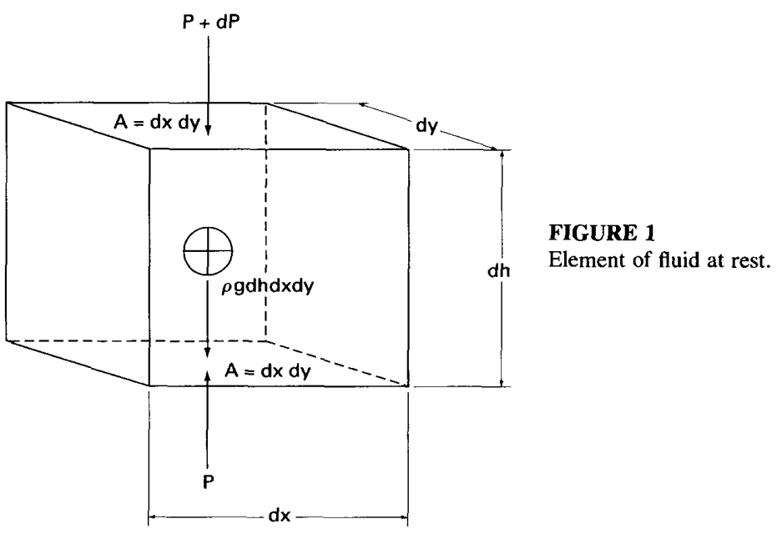

Incompressible Bernoulli Equation
Bernoulli's equation establishes the relationship between pressure, elevation, and velocity of the flow along a stream tube. For this analysis, the fluid is assumed to be a perfect fluid; that is, we will ignore viscous effects.
Consider the element of fluid in the stream tube shown in Figure 1.5. The forces acting on the differential element of fluid are due to pressure and gravitational forces. The pressure force acting in the direction of the motion is given by
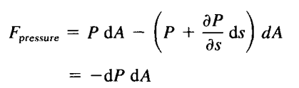 (7)
The gravitational force can be expressed as
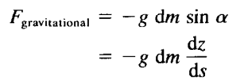 (8)
Applying Newton's second law yields
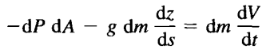
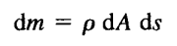
Inserting the expression for the differential mass, rearranging and then take the integration ,we get the Bernoulli's equation establishes the relationship between pressure, elevation, and V :
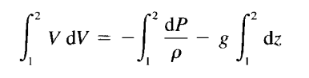 (9)

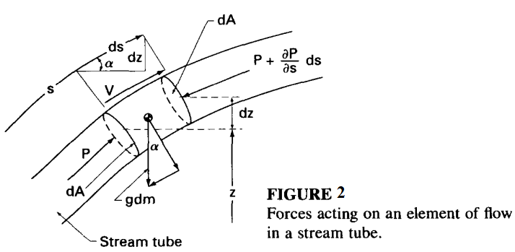

Incompressible Bernoulli Equation
An important application of Bernoulli's equation is the determination of the so-called stagnation pressure of a moving body or a bod a flow. The stagnation point is defined as that point on the body at which the flow comes to rest. At that point the pressure is
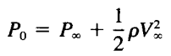 (10)
where P, and V, are the static pressure and velocity far away from the body; that is, the pressures and velocities that would exist if the body were not present. In the case of a moving body, V, is equal to the velocity of the body itself and P, is the static pressure of the medium through which the body is moving.

  - AERODYNAMIC NOMENCLATURE
To describe the motion of an airplane it is necessary to define a suitable coordinate system for the formulation of the equations of motion. For most problems dealing with aircraft motion, two coordinate systems are used. One coordinate system is fixed to the Earth and may be considered for the purpose of aircraft motion analysis to be an inertial coordinate system. The other coordinate system is fixed to the airplane and is referred to as a body coordinate system. Figure 3 shows the two right-handed coordinate systems.
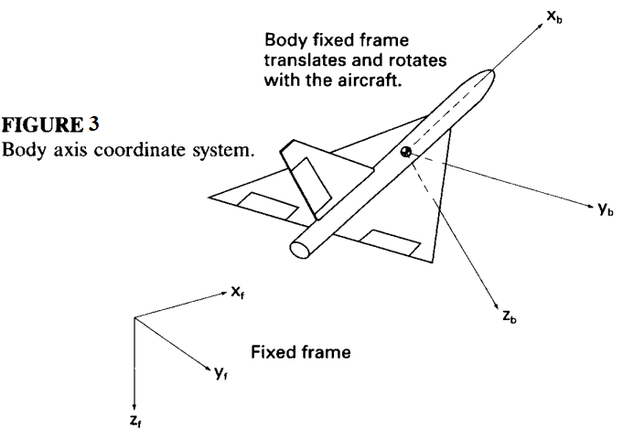
The forces acting on an airplane in flight consist of aerodynamic, thrust, and gravitational forces. These forces can be resolved along an axis system fixed to the airplane's center of gravity, as illustrated in Figure 4. The force components are denoted X, Y, and 2; T,, T,, and T,; and W,, W,, and W, for the aerodynamic, thrust, and gravitational force components along the x, y, and z axes, respectively.
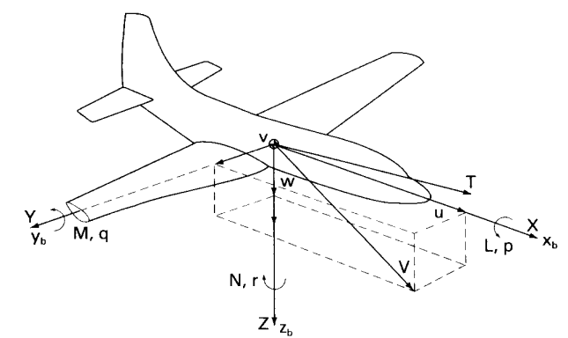
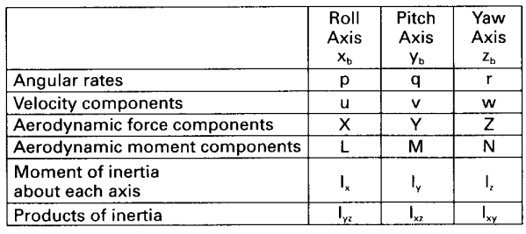
FIGURE 4 Definition of forces, moments, and velocity components in a body fixed coordinate

The aerodynamic forces are defined in terms of dimensionless coefficients, the flight dynamic pressure Q, and a reference area S as follows:
X = C_{x} QS Axial force (11)
Y = C_{y} QS Side force ( 12)
Z = C_{z} QS Normal force ( 13)
In a similar manner, the moments on the airplane can be divided into moments created by the aerodynamic load distribution and the thrust force not acting through the center of gravity. The components of the aerodynamic moment also are expressed in terms of dimensionless coefficients, flight dynamic pressure, reference area, and a characteristic length as follows:
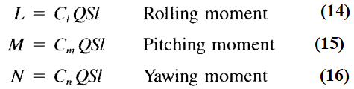
For airplanes, the reference area S is taken as the wing platform area and the characteristic length 1 is taken as the wing span for the rolling and yawing moment and the mean chord for the pitching moment. For rockets and missiles, the reference area is usually taken as the maximum cross-sectional area, and the characteristic length is taken as the maximum diameter.
The aerodynamic coefficients C_{x}, C_{y}, C_{z}, C_{l}, C_{m}, and C_{n}, primarily are a function of the Mach number, Reynolds number, angle of attack, and sideslip angle. The resultant force and moment, as well as the airplane's velocity, can be resolved along these axes.
The angle of attack and sideslip can be defined in terms of the velocity components as illustrated in Figure 5. The equations for α and β follow:
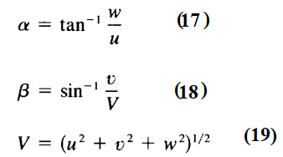
If the angle of attack and sideslip are small, that is, < 15", then Equations (17) and ( 18) can be approximated by;
α = w/u
β = v/V
where α and β are in radians.

  - LIFT: It is a well-known fact from common experience that all material objects are attracted to the earth by a force which is in proportion to the mass of the object; such a force is called gravity. In order for an object to rise from the earth's surface, and to maintain itself at a constant height above the surface, the attraction which gravity has for the object must be opposed by the development of a force called lift. The way to do that is to apply this force (Lift) to the wings of an aircraft.
Wings are designed and chosen on the basis of size, weight and performance requirements of the particσular aircraft .
In order to generate the required lifting force there must be relative movement between the wing and the surrounding air. Theoretically, it makes no difference whether air flows over a stationary wing or whether the wing is moved through the air; in practice, however, the latter movement takes place as a result of the propulsive thrust from a propeller or turbine engine exhaust gases.
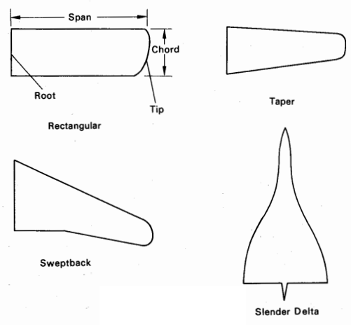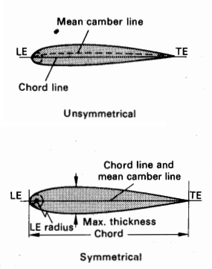
Fig. 1.1 Wing plan forms and aerofoil terminology.

Referring to fig. 1.2 it will be noted that when the air strikes the leading edge of the wing, it divides into a flow over the upper and lower cambered surfaces of its aerofoil section. As a result of differences between the amount of upper and lower surface camber, and also because the wing is at an angle of attack, the velocity of the airflow over the upper surface will be greater than that of the air flowing along the lower surface. Since the pressure of fluid (liquid or gas) decreases at points where the velocity of the fluid increases.
The measurement of the pressures acting on the surfaces are in absolute values, and they are represented by vectors drawn perpendicular to the surfaces. The length of a vector is proportional to the difference between absolute pressure at a point and free stream static pressure. It is usual to convert this to a non-directional quantity called the pressure coefficient
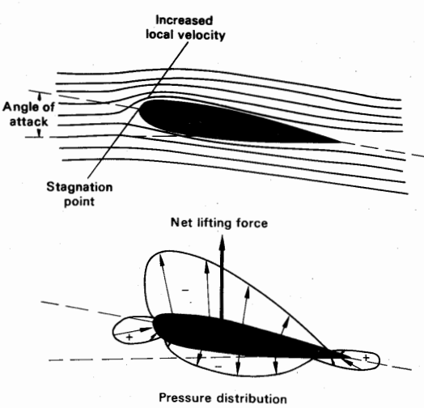
Fig. 1.2 Generation of lift

Flight dynamics characterizes the motion of a flight vehicle in the atmosphere. As such, it can be considered a branch of systems dynamics in which the system studies is a flight vehicle.
The response of the vehicle to aerodynamic, propulsive, and gravitational forces, and to control inputs from the pilot determine the attitude of the vehicle and its resulting flight path. The field of flight dynamics can be further subdivided into aspects concerned with

• Performance: in which the short time scales of response are ignored, and the forces are
assumed to be in quasi-static equilibrium. Here the issues are maximum and minimum flight
speeds, rate of climb, maximum range, and time aloft (endurance).
• Stability and Control: in which the short- and intermediate-time response of the attitude
and velocity of the vehicle is considered. Stability considers the response of the vehicle to
perturbations in flight conditions from some dynamic equilibrium, while control considers the response of the vehicle to control inputs.
• Navigation and Guidance: in which the control inputs required to achieve a particular
trajectory are considered.

In these notes we will focus on the issues of stability and control ( Flight dynamics)
The aspects of stability can be further subdivided into:
(a) static stability (b) dynamic stability.
Static stability: Refers to whether the initial tendency of the vehicle response to a perturbation is toward a restoration of equilibrium.
various types of static stability is illustrated in Figure 2.3:
- Statically stable :If the ball were to be displaced from the bottom of the curved surface (Figure 2.3(a)), the ball would roll back to the bottom (i.e., the force and moment would tend to restore the ball to its equilibrium point). Such a situation would be referred to as a stable equilibrium point
- Statically unstable: , the any displacement from the equilibrium point (fig 2.3b)would cause the ball to roll off the surface. In this case, the equilibrium point would be classified as unstable.
- Neutral stability: If the ball is to be displaced from its initial equilibrium point to another position (fig 2.3c), the ball would remain at the new position. This would be classified as a neutrally stable equilibrium point and represents the limiting (or boundary) between static stability and static instability.
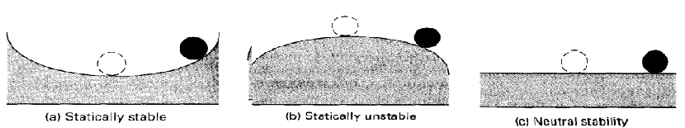
FIGURE 2.3 Sketches illustrating various conditions of static stability.

Dynamic stability:
In the study of dynamic stability we are concerned with the time history of the motion of the vehicle after it is disturbed from its equilibrium point. Figure 2.4 shows several airplane motions that could occur if the airplane were disturbed from
- Consideration of dynamic stability makes sense only for vehicles that are statically stable
- But a vehicle can be statically stable and dynamically unstable. 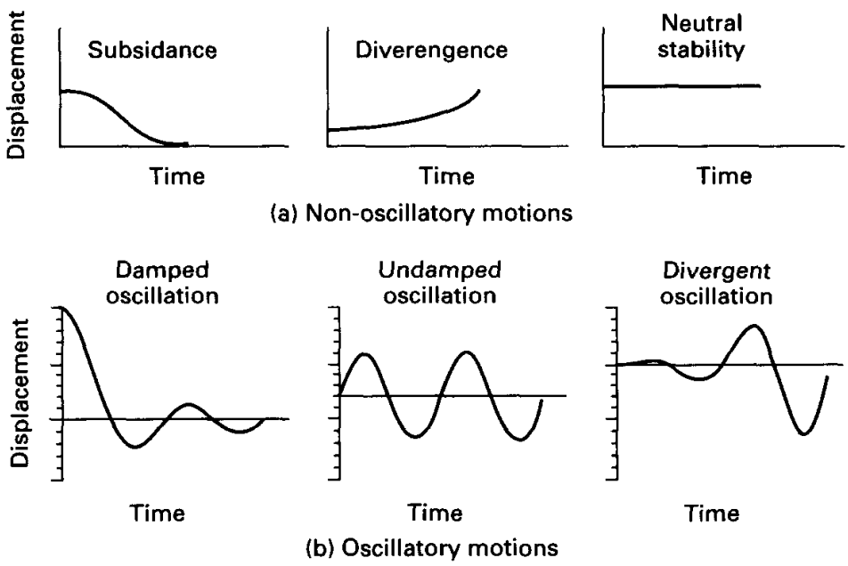
FIGURE 2.4 Examples of stable and unstable dynamic motions.
Note that the vehicle can be statically stable but dynamically unstable. Static stability, therefore, does not guarantee dynamic stability. However, for the vehicle to be dynamically stable it must be statically stable .
Of particular interest to the pilot and designer is the degree of dynamic stability. Dynamic stability usually is specified by the time it takes a disturbance to be damped to half of its initial amplitude or, in the case of an unstable motion, the time it takes for the initial amplitude of the disturbance to double. In the case of an oscillatory motion, the frequency and period of the motion are extremely important.

Control: deals with the issue of whether the aerodynamic and propulsive controls are adequate to trim the vehicle (i.e., produce an equilibrium state) for all required states in the flight envelope.

- The issue of “flying qualities” is intimately connected to control issues; i.e., the controls must be such that the maintenance of desired equilibrium states does not overly tire the pilot or require excessive attention to control inputs.
Nomenclature:
The standard notation for describing the motion of, and the aerodynamic forces and moments acting upon, a flight vehicle are indicated in Fig. 1.2.
- The variables x, y, z represent coordinates, with origin at the center of mass of the vehicle.
The x-axis lies in the symmetry plane of the vehicle1 and points toward the nose of the vehicle.
The z-axis also is taken to lie in the plane of symmetry, perpendicular to the x-axis, and pointing approximately down.
The y axis completes a right-handed orthogonal system, pointing approximately out the right wing.

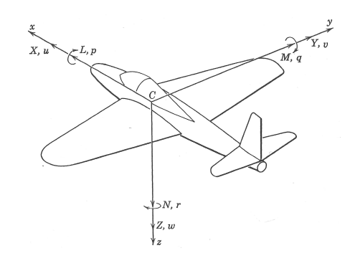
Figure 1.2: Standard notation for aerodynamic forces and moments, and linear and rotational velocities in body-axis system; origin of coordinates is at center of mass of the vehicle.

- The variables u, v, w represent the instantaneous components of linear velocity in the directions of the x, y, and z axes, respectively.
- The variables X, Y , Z represent the components of aerodynamic force in the directions of the x, y, and z axes, respectively.
- The variables p, q, r represent the instantaneous components of rotational velocity about the x, y, and z axes, respectively.
- The variables L, M, N represent the components of aerodynamic moments about the x, y, and z axes, respectively.
- Although not indicated in the figure, the variables φ, θ, ψ represent the angular rotations, relative to the equilibrium state, about the x, y, and z axes, respectively. Thus, p = φ˙ , q = ˙θ, and r = ψ˙ , where the dots represent time derivatives.

The velocity components of the vehicle often are represented as angles, as indicated in Fig. 1.3. The velocity component w can be interpreted as the angle of attack
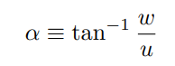
while the velocity component v can be interpreted as the sideslip angle
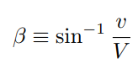
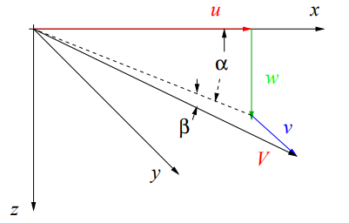
Figure 1.3: Standard notation for aerodynamic forces and
moments. origin of coordinates is at center of mass of the vehicle.

