Urinary Catheter Insertion

PERFORMANCE BEHAVIORS | COMMENTS
Assessment
- Avoid distractions
- Check physician’s order
3. **Check medical record for allergies, noting latex, betadine and povidone-iodine.
Planning
4. Identify expected outcomes.
- Gather equipment  - Indwelling catheter kit, using the smallest catheter if not specified. Determine what equipment is included in the kit (drainage bag etc.).  - Check expiration date.  - State average adult catheter size. (i.e. Female: 14-16Fr, Male: 16-18Fr)  - Extra catheter, clean wash cloth, basin with warm water and towel, blue pad, flashlight, etc | 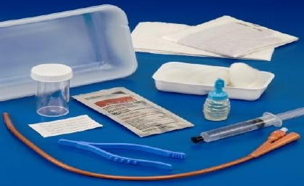
6. Provide for privacy.
Implementation
- Upon entering the room:
  - **Perform hand hygiene
  - Be aware of your spatial safety, have call light within reach
  - Identify self
  - **Identify patient using 2 forms of identification
  - **Ask patient if he/she has allergies and check for identifying armbands.
  - Explain what is about to occur.
  - Allow for patient questions
  - Ask the patient when last voided.
  - Raise bed to comfortable height.
  - Don clean gloves
  - Adjust room for proper lighting
8. Place a waterproof pad between legs and under hips. Place patient in lithotomy position. Use cleansing wipes to clean perineal area. Discard gloves. Wash hands.
- Open catheter kit.
  - Remove kit, reserving plastic bag for garbage.
  - Place kit between patient’s legs.
  - Open outer wrap, maintaining sterile technique.
  - Remove sterile gloves from kit and don gloves.
10. Organize equipment. Attach syringe containing sterile water attached to the balloon port. Do not inflate balloon.

PERFORMANCE BEHAVIORS | COMMENTS
- Male indwelling catheterization  - Lubricate catheter tip with water-soluble gel 2 inches.  - Open swab sticks.  - Cleanse urinary meatus from center out in circular fashion, repeat with clean swab. Keep non-sterile hand in place on penis.  - **Do not cross the sterile field with soiled cleaning materials.  - Hold catheter 2-3 inches and prepare for insertion.  - Ask patient to cough on insertion and then take deep breaths.  - Gently insert catheter into urinary meatus advancing catheter slowly to the bifurcation of the catheter. Stop if there is resistance and notify prescriber.  **Do not break sterile technique. | 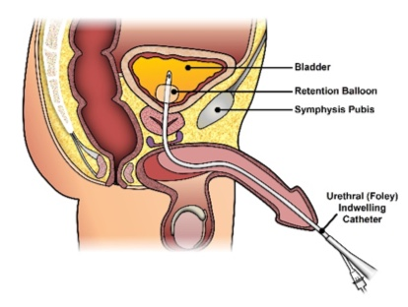
- Female indwelling catheter  - Lubricate catheter tip with water-soluble gel 1-2 inches.  h. Open swab sticks.  - Cleanse urinary meatus with antiseptic solution.  - Separate labia with fingers of non-dominant hand to fully expose urinary meatus.  - Maintain position of non-dominant hand until catheter has been inserted, careful to keep labia apart.  - **Clean the labia and urinary meatus from the clitoris toward the anus. Use one cotton ball or swab per stroke.  - **Do not cross sterile field with soiled cleaning materials.  - Gently insert catheter into urinary meatus advancing catheter slowly 2-3 inches or until urine flows and then one additional inch. Stop if there is resistance and notifyprescriber.  **Do not break sterile technique. | 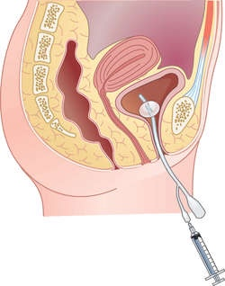
- Male or female completion of catheterization
  - Hold the catheter securely at the meatus with your non-dominant hand. Use your dominant hand to inflate balloon.
  - Allow bladder to empty fully, unless institution policy restricts maximum output, typically to 1000 ml.
  - Secure catheter to upper thigh with Statlock, allowing slack to prevent tension.
  - Position drainage bag lower than bladder by attaching it to non-moving part of patient’s bed, not side rails.
  - Ensure drainage bag is no more than one half full.
- Before leaving room
  - **Reposition patient for comfort and safety
  - ** Lower bed
  - **Raise appropriate side rails
  - **Leave call light and belongings inreach
  - ** Perform hand hygiene
  - Dispose of used equipment
Evaluation  15. Observe urine in drainage bag for amount, color and clarity. | 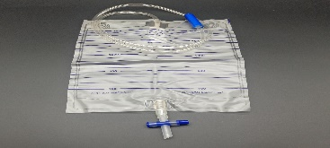
16. Document catheterization, output, assessment findings, and patient’s response to procedure in patient medical record.

Suprapubic catheter
