Full Name: ……………………………………………………………………. Student ID No.: ………………………..
Sample A
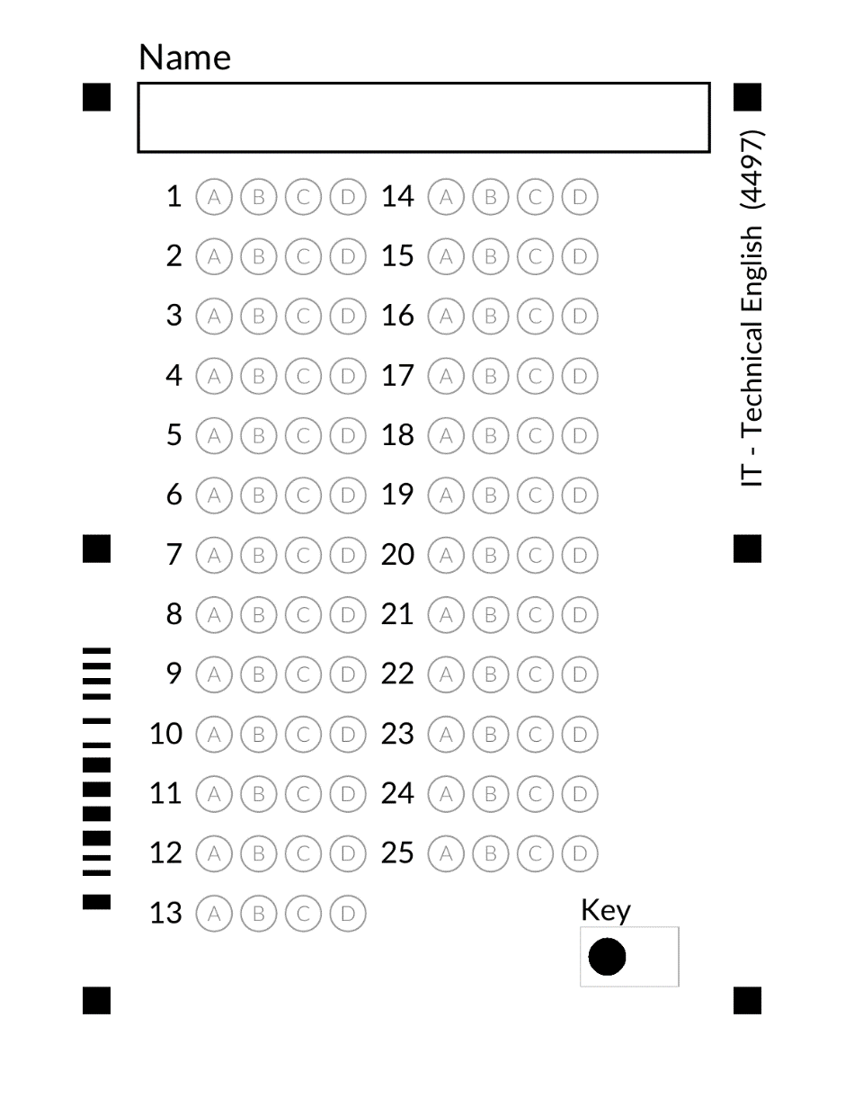

Part A: _____ / 50
Part B: _____ / 18
Part C: _____ / 16
Part D: _____ / 16
TOTAL: _____ / 100

- CHOOSE THE BEST ALTERNATIVE. (2 marks each)

- What is the primary concern of information security in IT?
A) Speeding up data processing
B) Preventing unauthorized access, use, disclosure, disruption, modification, inspection, recording, or destruction of information
C) Installing software updates
D) Providing technical support for users
- What is a handheld PC primarily designed for?
A) Heavy-duty data processing
B) Desktop publishing
C) Portability and ease of use
D) Server hosting
- What role does a fan play on a computer?
A) To store files
B) To provide power to peripherals
C) To cool down internal components
D) To connect to the internet
- What is the primary function of an input device in a computer system?
A) To display output
B) To process data
C) To enter data or commands into the computer
D) To store data
- Which of the following is an example of a pointing device?
A) Keyboard
B) Printer
C) Mouse
D) Scanner
- Which of the following is used to display visual output from a computer?
A) Keyboard
B) Printer
C) Monitor
D) Scanner
- What is a network in IT?
A) A single computer
B) A software application
C) A group of interconnected computers and devices that can communicate with each other
D) A type of peripheral device

- What does HTML stand for in web development?
- Hyper Text Manipulation Language
- High-Throughput Messaging Language
- Hypertext Markup Language
- Hierarchical Task Management Language
- What is the main purpose of a scanner in a computer system?
A) To print documents
B) To capture images or text from physical documents and convert them into digital format
C) To cool down internal components
D) To provide power to peripherals
- What is an icon in the context of computing?
A) A small picture or symbol representing a file, program, or function
B) A type of font style
C) A computer virus
D) A hardware component

- Choose a word from the box to complete the sentences. (2 marks each)
processor encoding peripheral hardware code server USB workstation mainframe
- ___________________ is a set of words and signs that give instructions to a computer.
- The act of changing data so that no one can read it until it is changed again is ___________________.
- ___________________ refers to the physical parts of a computer.
- A ___________________ is a very powerful computer that can process large amounts of data.
- A computer that connects many computers to hardware is ___________________.
- A ___________________ is a very fast computer that runs powerful work programs.
- A ___________________ carries out the instructions of computer programs.
- A device that can be connected to a computer is ___________________.
- ___________________ is a commonly used type of connection or port to connect a peripheral to a computer.
- Choose a word from the box to complete the sentences. (2 marks each)
DHCP GUI format router cycle compatibility folder IP address
- To ___________________ a device on a network means to turn it off and then turn it on again or to unplug it from its power source.
- The system for computer networks to receive IP addresses and other configuration information is the ___________________.
- An ___________________ is a group of numbers that identify a computer on a network.
- A device that allows more than one computer to connect to a network at the same time is __________________.
- A ___________________ holds and organizes files and documents on a computer.
- An operating system that uses icons to represent programs and files and allow users to access to them is ___________________.
- ___________________ is the ability of one program or file to work with a different program.
- A ___________________ is a file's type. Different files might not work in different programs.
- Choose a word from the box to complete the sentences. (2 marks each)
http hyperlink domain-name expansion-card POP3 STMP macro quality assurance
- A short keystroke that performs a predetermined action is ___________________.
- A ___________________ is a set of words and letters that identify a company or address on the Internet.
- A method that allows computer users to receive email from a server is ___________________.
- A ___________________ is a method that allows computer users to send emails to other users.
- A part of an Internet address that allows a computer to connect to the site is ___________________.
- A ___________________ is a word or image on a web page that you can click on to go to a different web page.
- A ___________________ is an extra circuit board that is used to increase the functions of a computer.
- ___________________ is the act of checking products for problems.

