Tishk International University

Faculty of Nursing
Laboratory and Clinical Education

Procedure Evaluation Document (PED)
PROCEDURE: Foetal Heart Rate Assessment
No. | Preparation | Rational | 3 | 2 | 1 |  | 0
1 | Assemble equipment and supplies:  - Client’s medical record  - Hand rub gel  - Non sterile gloves  - Sonic aid device or Doppler machine if available  - Antiseptic solution  - 2 Gauze pieces  - Doppler or fetoscope | For easy access and time efficiency while conducting the examination ensuring that we can render quality service care to both mother and child
 | Procedure
2 | Identified client using two identifiers. | To ensure patient safety and avoid misidentification, because similar names or conditions may exist.
3 | Explain to the lady what you are going to do, why it is necessary, and how she can cooperate. | To gain consent, cooperation and promote sense of comfortability.
4 | Provided privacy. | To maintain the client's dignity and comfort, and to comply with ethical and professional standards of care.
5 | Wash hands and observe other appropriate infection control procedures. | Reduce transfer of microorganism
6 | Put on gloves. | To prevent cross-contamination and protect both the client and healthcare provider from infection
7 | Ask the client to empty her bladder. | For comfortability and accurate assessment
8 | Cleaned the device with an antiseptic gel and gauze. | To ensure the device is free from contaminants and safe for use on the client’s skin
9 | Place the ultrasonic gel on the diaphragm of the Doppler | To aid in maintaining contact with the maternal abdomen and enhances conduction of sound
10 | Placed the device over the convex portion of the foetus closest to the anterior uterine wall. | This position will aid us to hear and know the condition of fetal heart rate between the umbilicus and symphysis and in the midline.
11 | Check the woman's pulse against the fetal sounds you hear. If the rates are the same, reposition the Doppler | To know whether the fetal sounds are accurately from the fetus because if the rate is the same, you're probably hearing the mother's heart sounds.
12 | If the rates are not similar, count the FHR for 1 full minute. | To detect deviation from normal for further interventions needed. The Normal fetal heart rate is 110 to 160 beats per minute
13 | Auscultate the FHR between, during and for 30 seconds following a uterine contraction. | During uterine contractions, the head of the fetus is pressed. When the pressure in the uterus is increased, this might cause the fetal heart rate to slow down.
14 | Dried the abdominal area with gauze. | To remove excess gel and ensure client comfort after the procedure.
15 | Restored client to a comfortable position. | This provides for the well-being of the client
16 | Removed gloves. | To safely conclude the procedure and prevent contamination after patient contact.
17 | Document the fetal heart rate count. | For baseline data, medical record and future comparison.
18 | Cleaned the device with an antiseptic gel and gauze. | To disinfect the equipment post-use, ensuring it’s ready and safe for future procedures.
19 | Performed hand hygiene using correct technique. | To prevents the spread of infection
20 | Returned equipment to the dedicated area. | To maintain organization, ensure equipment availability for others, and uphold infection control standards.
21 | Reported abnormal findings to the appropriate health care provider (student reported this action verbally). | To initiate timely medical intervention and ensure continuity of care based on clinical findings
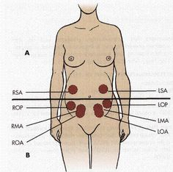
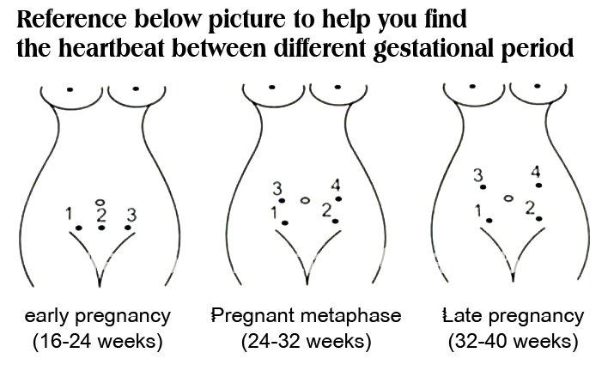

Raw Score (R) based on the student’s performance:
3 - Satisfactory Demonstrates required level in a consistent and efficient manner
2 - Borderline Performs with minimal error or omission (1-2 mistakes)
1 - Unsatisfactory Performs with numerous errors or omissions (3 and more mistakes)
0 - Poor Procedure is not done
Total Raw Score/Total No. of Points X weigh in % = _____/_____ X ____% = _________
Comments: --------------------------------------------------------------------------------------------------------------------
Student Signature: __________________ Instructor Signature: _______________________

