TISHK INTERNATIONAL UNIVERSITY
Faculty of Science – Department of Information Technology
Course Code: IT 211
Course Title: Data Structures and Algorithms

LAB TASK 1:

Objective
To understand how the Bubble Sort algorithm works by implementing it step-by-step and observing how the array elements are sorted after each pass.

Task 1 – Counting Swaps
Instruction:
Write a Python program that sorts a list using Bubble Sort and counts how many swaps occur in each pass.
Sample Output (What you should get):
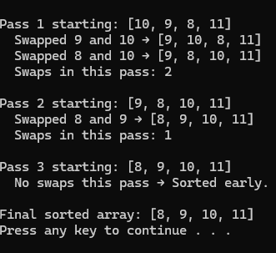
Your Task: Type and run your own code to produce the same result.

Task 2 – Step-by-Step
Instruction:
Write a Bubble Sort program that prints every step of the process — each comparison and each array update.
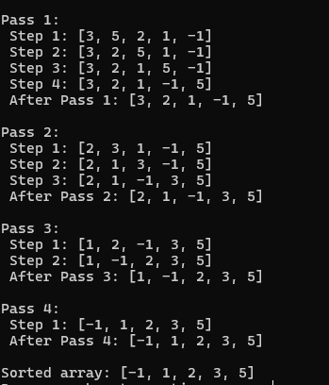
Your Task: Write your own version of this code using at least 5 numbers and observe how the array changes.

Task 3 – Detailed Summary Version
Instruction:
Create a program that shows each comparison, tells whether a swap happened, and prints the array after each pass.
Sample Output:
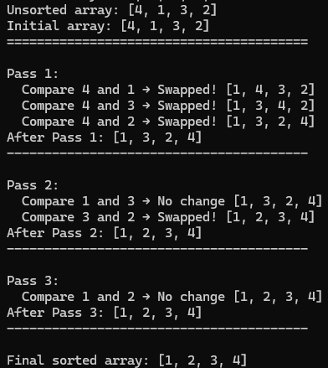
Your Task: Reproduce this output format with your own list of numbers and make sure your program clearly shows when swaps occur.

Submission Requirements
1. Write your own Python code for all three tasks.
2. Run each program and capture the output (screenshot or copy-paste).
3. Submit one Word or PDF file containing:
- Your name and student ID
- The code for each task
- The output for each task

