Instructions:
- Create a folder with your full name on the desktop.
- Create 15 Text Documents in the folder and name them as Q1, Q2 ... Q15.
- Save your code inside the Text Documents.

Q1. Declare variables of the following types: int, float, double, char, string, bool and initialize each variable with a value.

Q2. Declare an integer variable, name it as firstNumber and initialize it with a value of 25. Q3. Modify (Q2) and let the user enter the value by using cin.
Q4. Write a C++ program that declares a variable name as cityName, and ask the user to enter a city name.

Q5. Write a C++ program that asks the user to enter their name and surname, then the program should output the details.
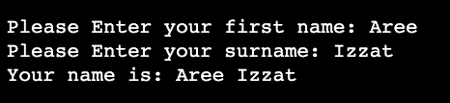

Q6. Write a program that asks your first name and your age. The output should be as follows.
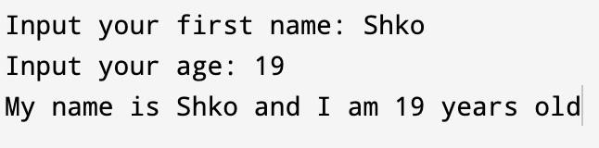

Q7. Write a program in C++ to enter your name, then the program should bring your name into a square shape.
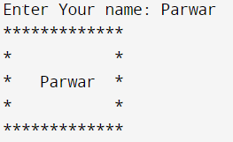

Q8. Write a program to let the user enter his/her name and age, then the program should print the name and the year he/she was born.
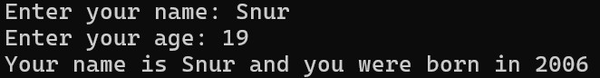

Q9. Write a program that allows the user to enter the profiles of two students, then prints the information as shown in the example below.
Enter Info for student 1. Enter ID: 13
Enter Name: Ahmad
Enter Age: 20
Enter Gender: M

Enter Info for student 2. Enter ID: 21
Enter Name: Sara Enter Age: 17 Enter Gender: F

Student 1 Info: Your ID is 13, your name is Ahmed, your age is 20 and your gender is M. Student 2 Info: Your ID is 21, your name is Sara, your age is 17 and your gender is F.

Q10. Write a C++ Program to Calculate Area of Square. The length of the side should be entered by the user.
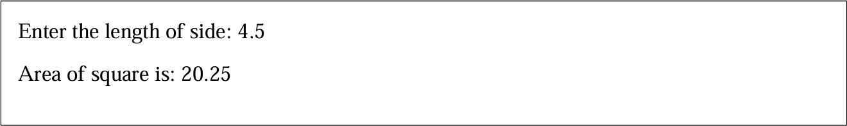

Q11. Let the user enter a GPA and print it, then change the GPA and print it again! Note: Use only 1 variable.
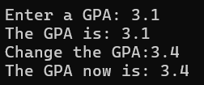

Q12. Modify (Q11) to change the double variable to a constant type, and run it again, to see if you get any error. why?

Q13. Write a program to let a user create an account by entering his/her first name, last name, age, email and password, then the user should be able to login to the account.
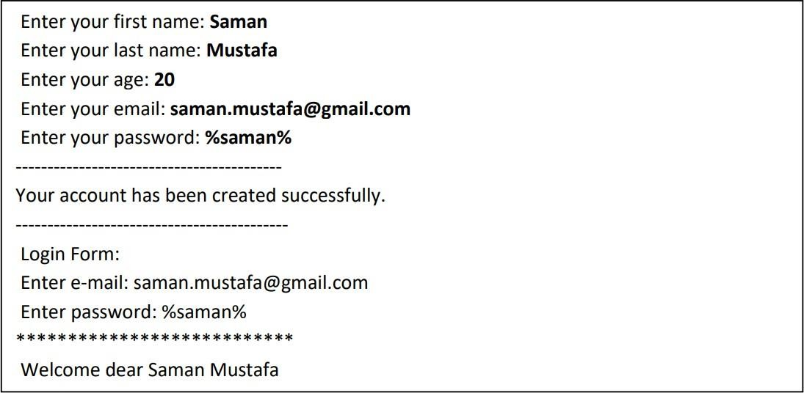

Q14. Create an application that converts the amount of day into hours, minutes, seconds and milliseconds. The user will insert the day amount, then the program calculates hours, minutes, seconds that are valid in that amount of time.
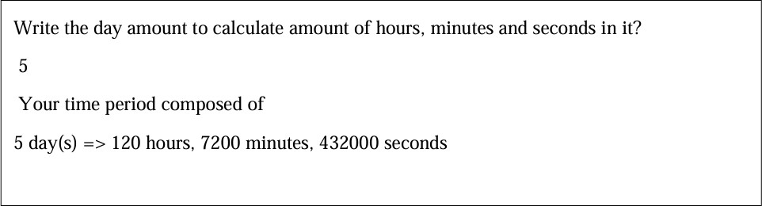

The below question is for legends!! ● “● “
Q15. Write a program that takes the prices of three items from the user and outputs the total price, then let the user enter a discount rate and print the total after discount.
Enter 1st item price: 50 Enter 2nd item price: 40 Enter 3rd item price: 20 Total is: 110
Enter the discount: 15
Total after discount is: 93.5

