Instructions:
- Create a folder with your full name on the desktop.
- Create 10 Text Documents inside the folder and name them Q1, Q2 ... Q10.
- Save your codes inside the Text Documents.
Q1. Write a C++ program that asks the user to input three numbers, calculates their average, and prints it. Then check if the average is greater than or less than 10.

Please enter first number: 9 Please enter second number: 4 Please enter third number: 21

The average is: 11.33

The average is greater than 10.
Please enter first number: 5 Please enter second number: 2 Please enter third number: 9

The average is: 5.33

The average is less than 10.

Q2. Write a C++ program that asks the user to input two numbers and solves the following equation:

Where 𝑦 ≠ 0.
𝑥2

𝑦

Enter value for x: 3
Enter value for y: 5

The result is: 1.8
Enter value for x: 8
Enter value for y: 0

y value must NOT be zero!

Q3. Write a C++ program that asks the user to input a number and checks whether it is odd or even.
Enter a number: 8

It’s an even number
Enter a number: 3

It’s an odd number

Q4. Write a C++ program to input two integers and check if the first integer is greater than the second one. If it is, print “First number is greater”, otherwise, print “Second number is greater”.
Enter first number: 23
Enter second number: 17

The first number is greater
Enter first number: 42
Enter first number: 81

The second number is greater

Q5. Write a C++ program to determine if a user-input character is a vowel (a, e, i, o, u). Compare the entered character with each vowel and display whether it is a vowel or not.
Enter a character: k

The character k is not vowel!
Enter a character: E

The character E is vowel!

Q6. Write a C++ program that lets the user enter two numbers. If one of the numbers is greater than 10, the program should display “I am greater than 10”, otherwise, it should display “I am smaller than 10”.
Enter first number: 9
Enter second number: 2

I am smaller than 10
Enter first number: 12
Enter first number: 7

I am greater than 10

Q7. Write a C++ program that allows the user to enter a city name and its population, then checks if the given city and its population meet certain criteria. If the city is “Erbil” and the population is greater than or equal to 1 million, display “City approved”, Otherwise, display “City not approved”.
Enter the city name: Duhok
Enter the population: 1200000

City not approved
Enter the city name: Erbil
Enter the population: 1400000

City approved

Q8. Write a C++ program that lets the user enter 3 numbers and outputs the largest and smallest number.
Enter first number: 57 Enter second number: 102 Enter third number: 91

The largest number is: 102 The smallest number is: 57
Enter first number: 23 Enter second number: 11 Enter third number: 73

The largest number is: 73 The smallest number is: 11
Q9. Write a C++ program that lets the user enter an exam mark (integer) and prints out its equivalent letter grade, which is assigned based on the following scheme.

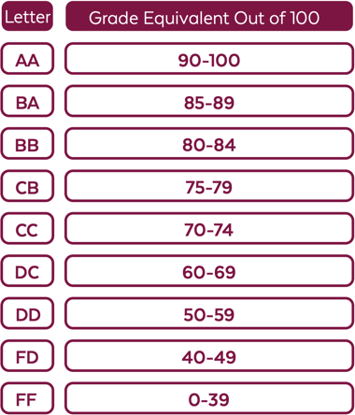
Q10. Write a C++ program that allows a user to create an account by entering their username, email, password, and confirm password. If the password and confirm password do not match, it should print “Passwords do not match”, otherwise, the user should be able to log in to the account if the username and password are correct and the “Welcome” message should display.
Enter an exam mark: 23
Equivalent letter grade is FF
Enter an exam mark: 65
Equivalent letter grade is DC
Enter an exam mark: 82
Equivalent letter grade is BB
Enter username: ako.20
Enter email: ako20@yahoo.com
Enter password: banana123
Enter confirm password: banana213
-----------------------------------
Password and confirm password do not match!
Enter username: sazan18
Enter email: sazan18@gmail.com
Enter password: cat#22
Enter confirm password: cat#22
-----------------------------------
Your account has been created successfully.
-----------------------------------
Login Form:
Enter email: sazan18@gmail.com
Enter password: cat222
-----------------------------------
Email or Password is incorrect!

