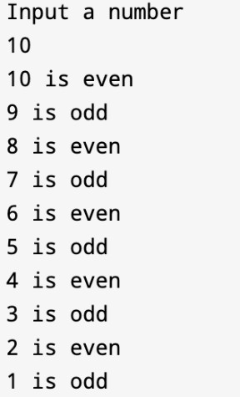
Q1. Write a C++ program that asks the user for a positive integer x. Use a do while loop to count down from x to 1. For each number, check if it is even or odd and print 'even' or 'odd' accordingly.

Q2. Modify the Q1 and the program should print 10 random numbers between 1 to 25 and check which one is even and odd.

Q3. Write a program that uses a for loop to print the following shape of asterisks (*) to the console.
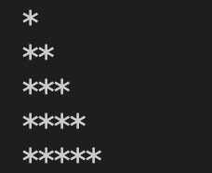

Q4. Modify Q4 to print a shape like this:
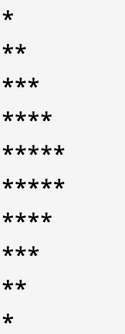
Q5. Write a C++ program that uses a for loop to print the following shape on the console. &
*&
**&
***&
****&

Q6. Write a program that uses a for loop to print the following shape of dollar signs ($) on the console.
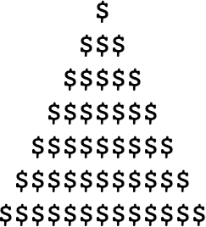

Q7. Write a C++ program that generates the following numbers:

1 | 2 | 3 | 4 | 5 | 6 | 7 | 8 | 9 | 10
2 | 4 | 6 | 8 | 10 | 12 | 14 | 16 | 18 | 20
3 | 6 | 9 | 12 | 15 | 18 | 21 | 24 | 27 | 30
4 | 8 | 12 | 16 | 20 | 24 | 28 | 32 | 36 | 40
5 | 10 | 15 | 20 | 25 | 30 | 35 | 40 | 45 | 50
6 | 12 | 18 | 24 | 30 | 36 | 42 | 48 | 54 | 60
7 | 14 | 21 | 28 | 35 | 42 | 49 | 56 | 63 | 70
8 | 16 | 24 | 32 | 40 | 48 | 56 | 64 | 72 | 80
9 | 18 | 27 | 36 | 45 | 54 | 63 | 72 | 81 | 90
10 | 20 | 30 | 40 | 50 | 60 | 70 | 80 | 90 | 100

Q8. Write a C++ program using nested loops to calculate and display the multiplication table for numbers 1 to 10 (up to 10).
1 x 1 = 1
1 x 2 = 2
1 x 3 = 3
1 x 4 = 4
1 x 5 = 5
1 x 6 = 6
1 x 7 = 7
1 x 8 = 8
1 x 9 = 9
1 x 10 = 10

2 x 1 = 2
2 x 2 = 4
…

Q9. Write a C++ program that asks the user for the lowest number, highest number, and the number of times to repeat. The program should then display the numbers from the lowest to the highest that many times.
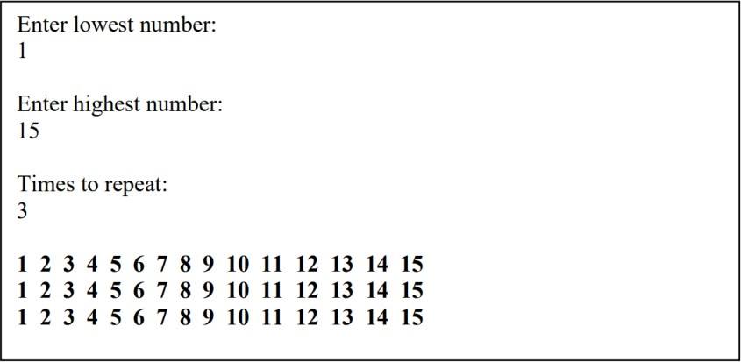

Q10. Write a C++ program that prints the following shape of numbers: (Homework):
