
Database Administration Security
Cybersecurity Department
Course Code: CBS 214
Practical Lecture 7: Authentication & Authorization
Practical Lab Exercise: Authentication & Authorization
Block 1: Switch to master and drop existing database (clean start)
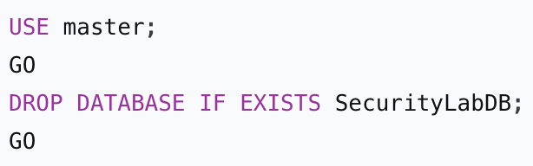
Execute the drop command.
Batch separator; executes all commands up to this point.

Block 2: Create a new database
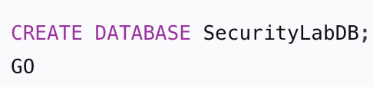

Block 3: Switch to the new database and create tables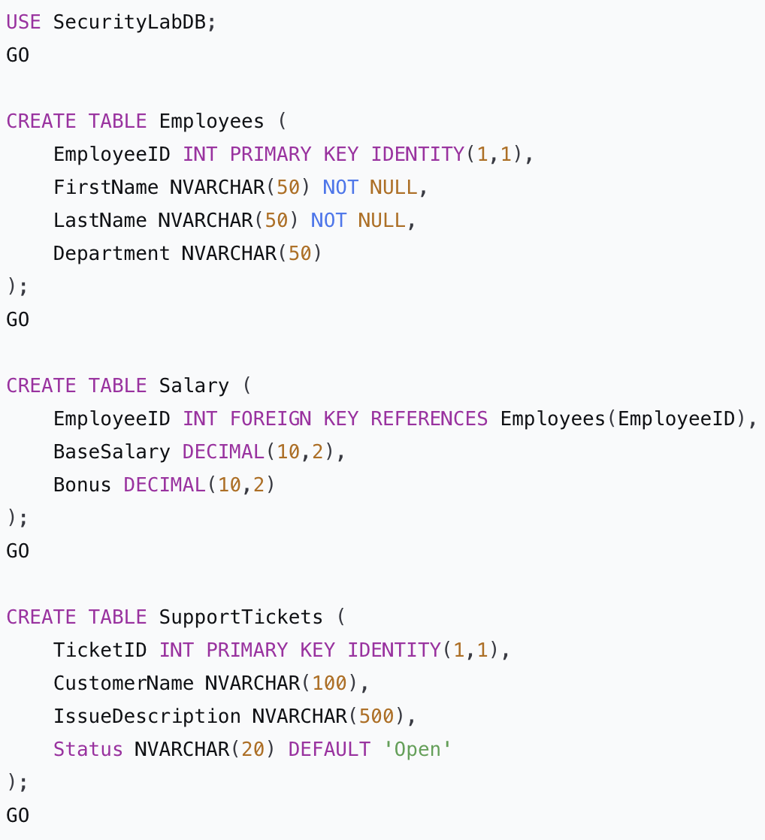

Block 4: Insert sample data
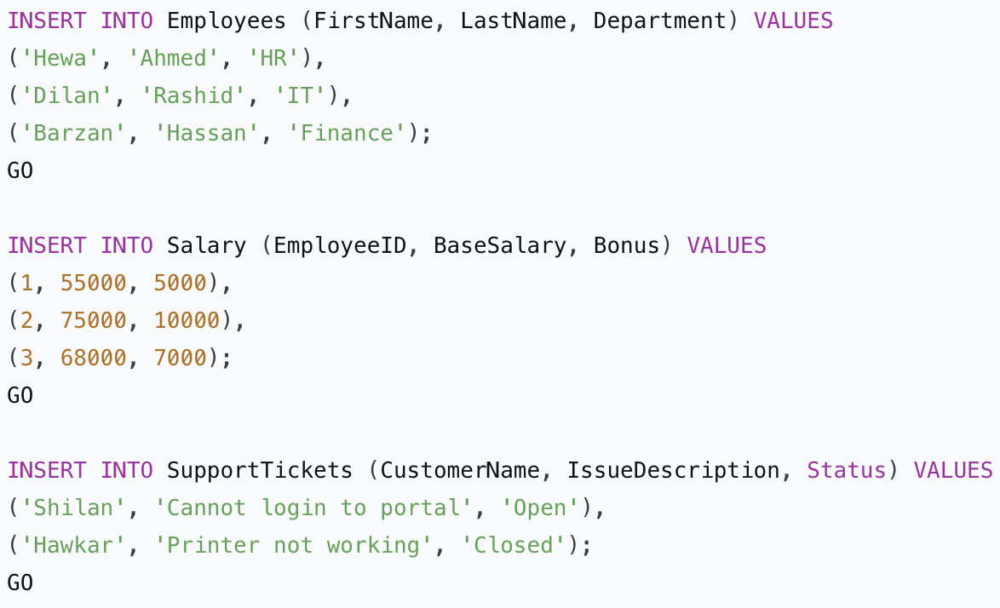

Block 5: Create SQL Server logins (server level)
Creates a principal at the server level that can authenticate to the SQL Server instance.

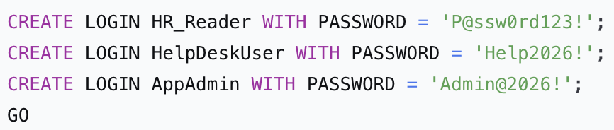

Sets the password for SQL Server authentication. (In production use stronger passwords.)

- HR_Reader - login name for an HR user who will only read employee data.
- HelpDeskUser - login for helpdesk staff.
- AppAdmin - login for an application administrator.
- GO - Executes all three CREATE LOGIN statements.

Block 6: Create database users mapped to the logins
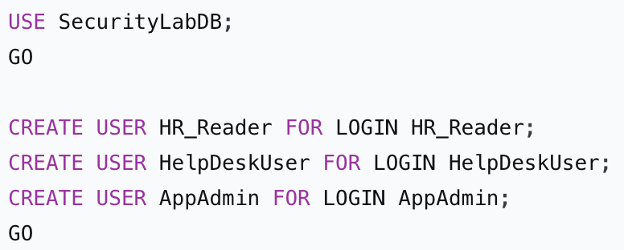
Creates a user in the current database and maps it to an existing server login. A login alone cannot access database objects; it needs a user in each database.

Ensure we are inside the target database.

- HR_Reader - user name (usually same as login name for clarity) mapped to login HR_Reader.
- Similarly for HelpDeskUser and AppAdmin.
- Now these three principals exist inside SecurityLabDB.

Block 7: Create custom database roles
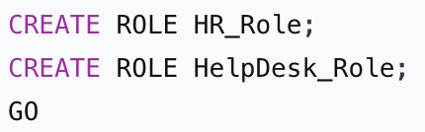
- CREATE ROLE - Creates a database-level role that can hold permissions. Roles simplify permission management: grant permissions to the role, then add users to the role.
- HR_Role - Role intended for HR department members.
- HelpDesk_Role - Role intended for helpdesk staff. No permissions yet; they will be granted next.

Block 8: Grant and deny permissions to roles
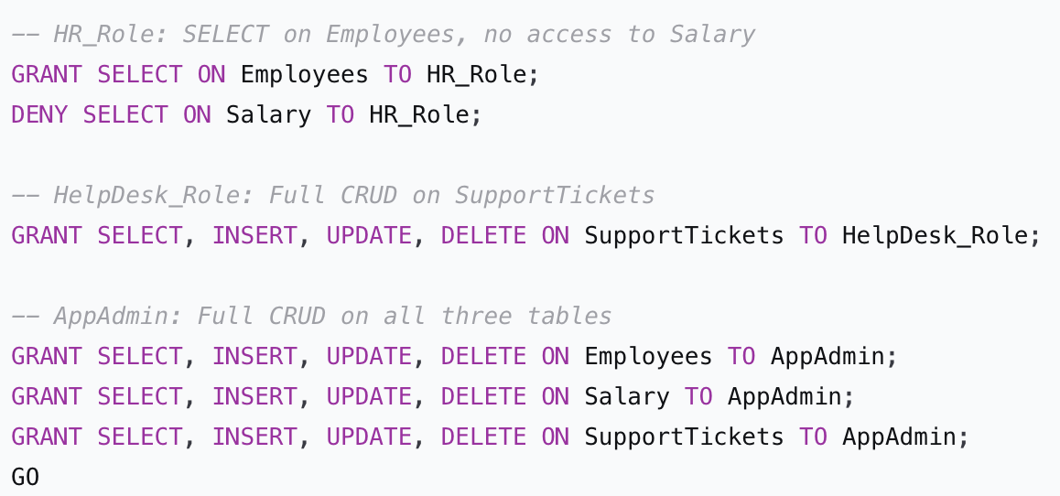
- GRANT SELECT ON Employees TO HR_Role; - Allows any member of HR_Role to read (SELECT) rows from the Employees table.
- DENY SELECT ON Salary TO HR_Role; - Explicitly forbids reading the Salary table. This overrides any GRANT that might come from other roles (e.g., public). Even if a user is added later to another role that has SELECT on Salary, this DENY takes priority.
- GRANT SELECT, INSERT, UPDATE, DELETE ON SupportTickets TO HelpDesk_Role; - Gives full data manipulation rights on the SupportTickets table to helpdesk staff.
- For AppAdmin, we grant all four data permissions on all three tables. (In a real system, you might just make them db_owner.)
- The role still has no permissions on other objects (like Salary for HelpDesk_Role), which is equivalent to a DENY by default.

Block 9: Assign users to roles
Adds a database user to a database role.

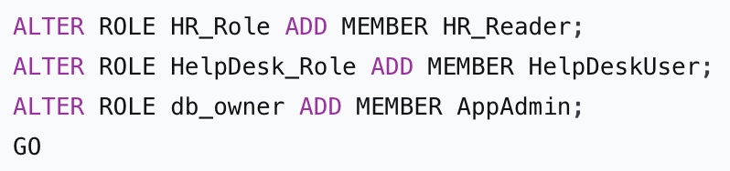
- HR_Reader user becomes a member of HR_Role. Now HR_Reader inherits all permissions of HR_Role (SELECT on Employees, DENY on Salary).
- HelpDeskUser becomes member of HelpDesk_Role → gains full CRUD on SupportTickets.
- ALTER ROLE db_owner ADD MEMBER AppAdmin; – Adds AppAdmin to the fixed database role db_owner, which gives full control over the entire database (similar to sysadmin at server level). This is the simplest way to give absolute power.
- After this, each user has permissions based on their role memberships.

Block 10: Test permissions - HR_Reader
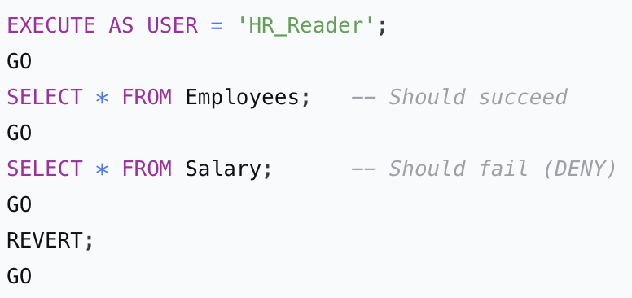
- EXECUTE AS USER = 'HR_Reader'; - Switches the execution context to that user without needing to log in separately. This allows testing what the user can see/do.
- SELECT * FROM Employees; - Because HR_Reader is in HR_Role and the role has GRANT SELECT on Employees, this query runs successfully and returns all rows.
- SELECT * FROM Salary; - The role has DENY SELECT on Salary, so SQL Server returns an error: "SELECT permission denied...". The user cannot see this sensitive table.
- REVERT; - Switches back to the original privileged user (the one running the script, usually sa or a sysadmin).

Block 11: Test permissions – HelpDeskUser
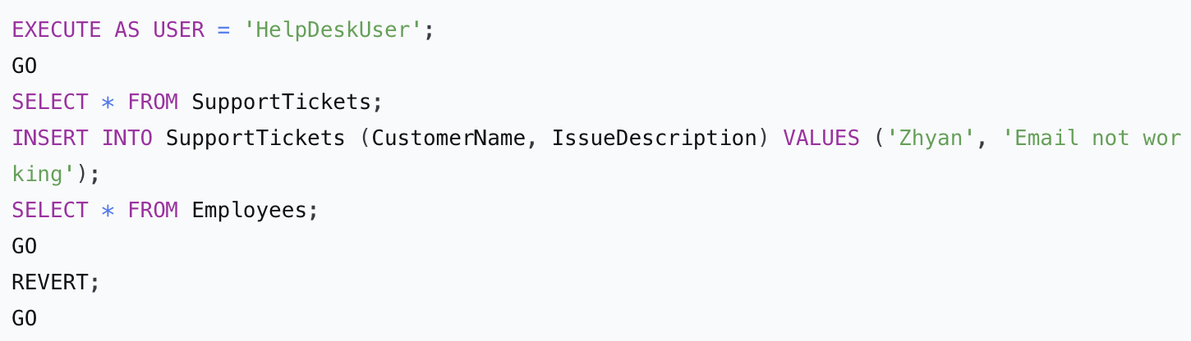
- EXECUTE AS USER = 'HelpDeskUser'; - Switch to helpdesk user.
- SELECT * FROM SupportTickets; - Allowed because HelpDesk_Role has SELECT.
- INSERT INTO SupportTickets ... - Allowed because the role has INSERT.
- SELECT * FROM Employees; - No GRANT on Employees for HelpDesk_Role and no explicit DENY. By default, no permission = implicit DENY. This query fails.
- REVERT; - Return to original context.

Block 12: Schema-level permissions (optional advanced)
Creates a new schema (a logical container for objects). Schemas help organise and manage permissions in bulk.

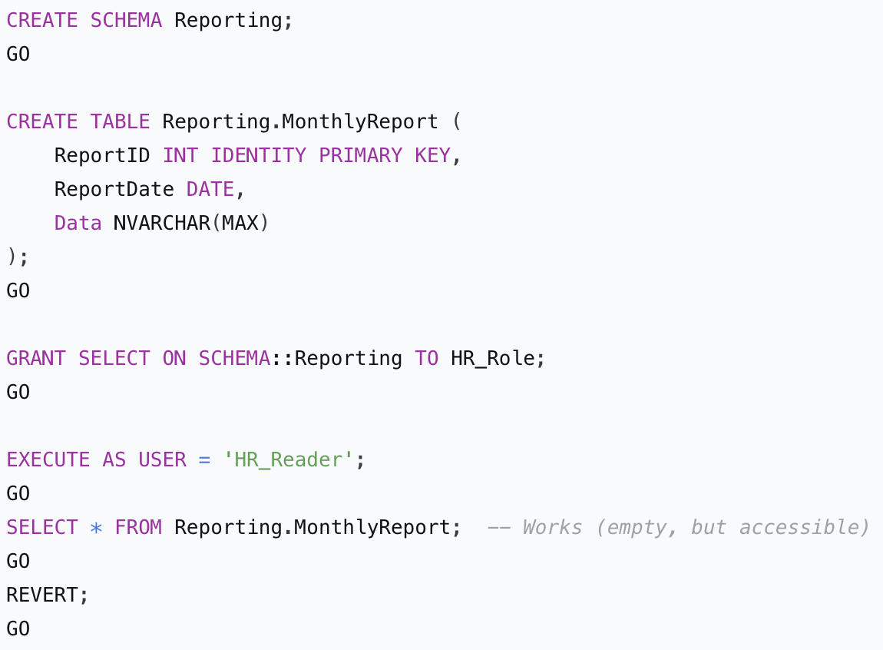
Creates a table inside the Reporting schema.
Switch to HR_Reader
Switch back
- GRANT SELECT ON SCHEMA::Reporting TO HR_Role; - Grants SELECT permission on all current and future tables within the Reporting schema to HR_Role. This is efficient instead of granting on each table individually.
- SELECT * FROM Reporting.MonthlyReport; - Succeeds because the role has schema-level SELECT. Even though the table is empty, the permission is granted.

Block 13: Demonstrate REVOKE (removing a permission)
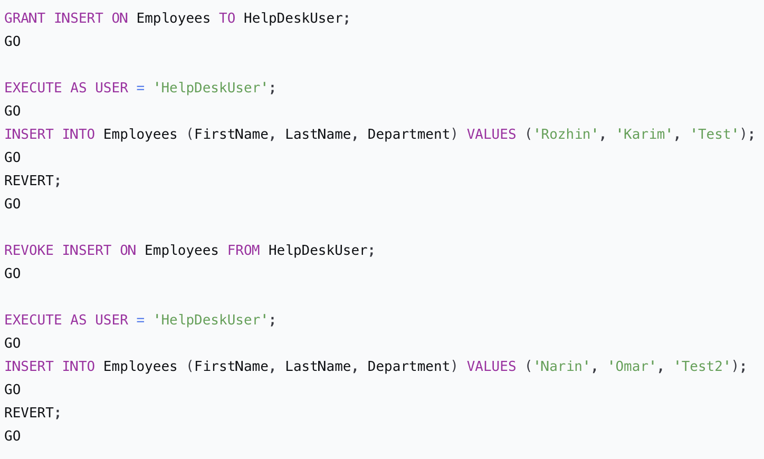

- GRANT INSERT ON Employees TO HelpDeskUser; - Gives the user (not the role) the ability to insert into Employees. This is a direct grant.
- EXECUTE AS USER = 'HelpDeskUser'; - Switch to the user.
- INSERT INTO Employees ... - Succeeds because of the direct grant.
- REVERT;
- REVOKE INSERT ON Employees FROM HelpDeskUser; - Removes the previously granted insert permission.
- Switch to HelpDeskUser again and try the same insert - now it fails because the permission is gone. REVOKE simply takes away the GRANT; it does not add a DENY.

Block 14: View current permissions (diagnostic queries)
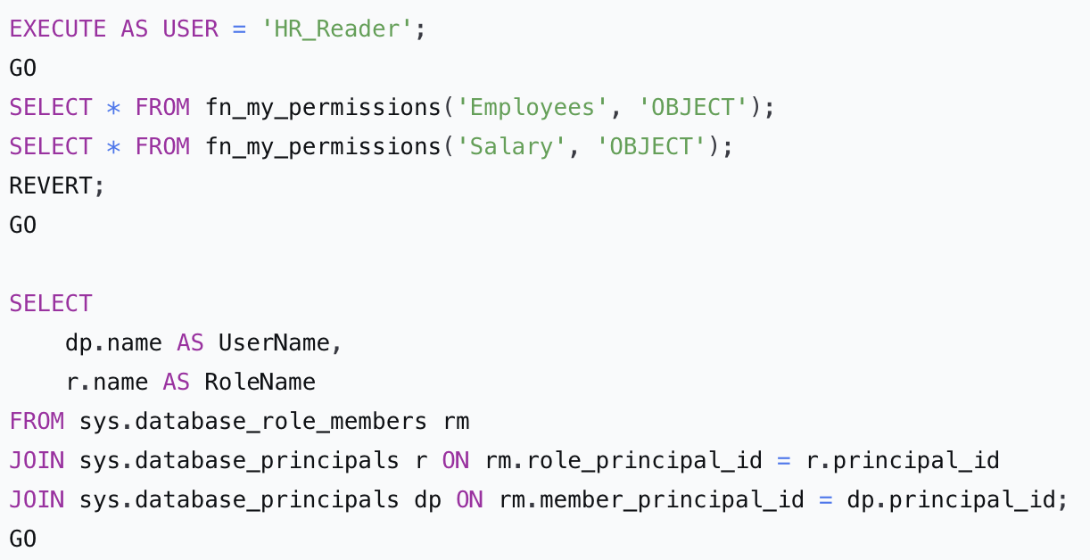
- EXECUTE AS USER = 'HR_Reader';
Temporarily changes the execution context to the database user HR_Reader.
This allows us to see exactly what permissions HR_Reader has when they run queries, without needing to log out and log back in as that user.
- fn_my_permissions('Employees', 'OBJECT')
A system function that returns a list of effective permissions (e.g., SELECT, INSERT, UPDATE, DELETE) that the current user has on the specified object – here the Employees table.
Because we just switched to HR_Reader, the function shows the permissions that HR_Reader has inherited from roles (e.g., GRANT SELECT from HR_Role).
- Same function, but now for the Salary table.
For HR_Reader, this will return no rows because the role has DENY SELECT on Salary (or at least no granted permission). An empty result set means the user has no permissions on that table.
- REVERT;
Switches back to the original privileged user (the one who ran the script, usually sa or a sysadmin). This ensures that the next commands run with full administrative rights.
- sys.database_role_members – A system view that stores which database users (members) belong to which database roles.
  - rm.role_principal_id = the ID of the role.
  - rm.member_principal_id = the ID of the user (member) inside that role.
- sys.database_principals – A system view that holds information about all users, roles, and other security principals in the current database.
- The query joins these views twice to get human-readable names:
  - First join: get the role name (r.name).
  - Second join: get the user name (dp.name).
- The result is a clean list showing which user belongs to which role – very useful for auditing.

Block 15: Cleanup (optional – run at the end)
